Cloud Computing
Practical Journal

Siddharth Kutty
MSc CS Part-1 Sem-2
44030725030

Submitted to Ananya Ma'am
Academic Year: 2025-26

Index
Sr. No | Topics
1 | KVM
2 | XEN
3 | Web Feeds
4 | Cognitive A.I
5 | Power BI
6 | SQL Analysis
7 | Connection between 2 VMs on cloud
8 | Creating an instance
9 | AI/ML
10 | Container (Docker)
11 | - Own Cloud  - Storage Blob
12 | Web Hosting
13 | Web Development

Practical 1 - KVM
Step 1: Open Ubuntu using VMWare
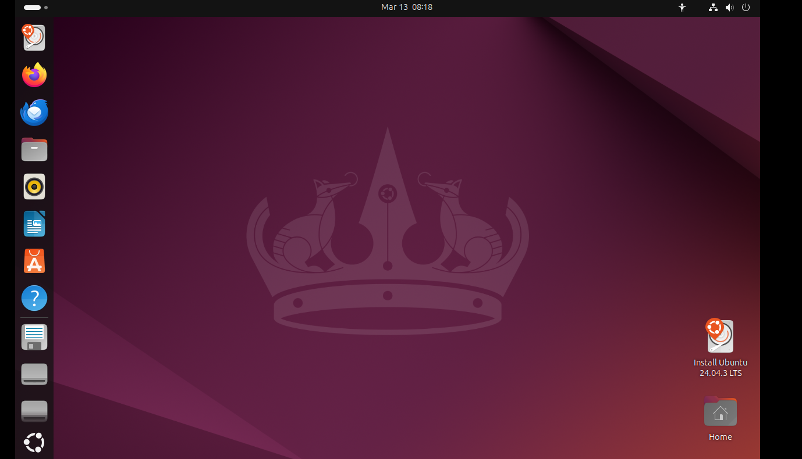
Step 2: Install the "virt-manager" package
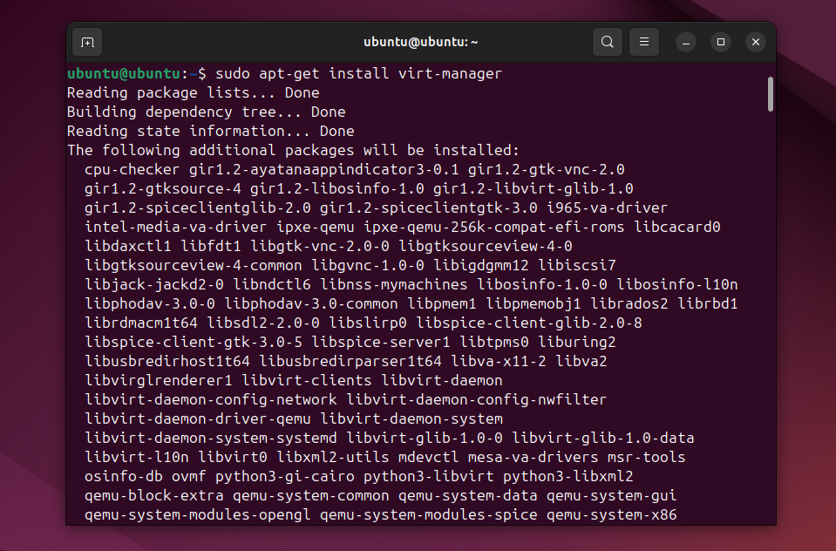

Step 3: Open virt-manager using the command: virt-manager
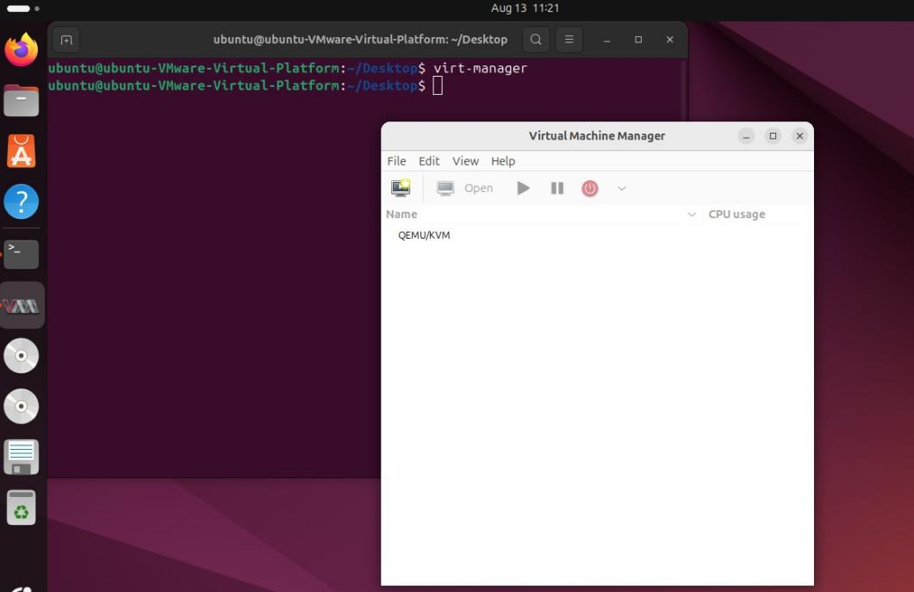
Step 4: Select "QEMU/KVM" then choose "New Virtual Machine".
Then select "Local Media" and select "Forward"
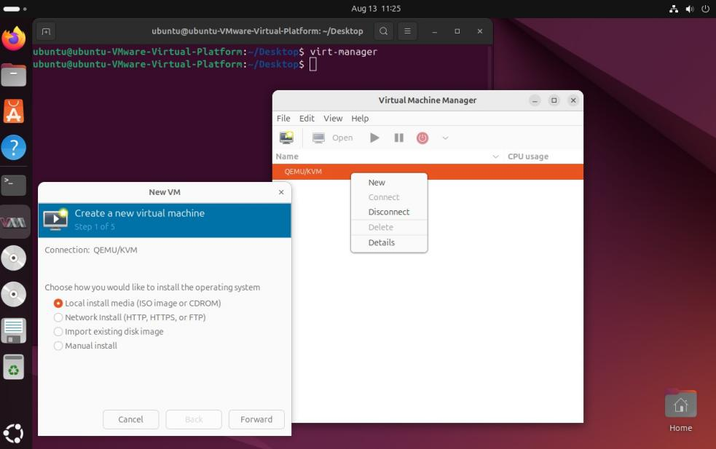

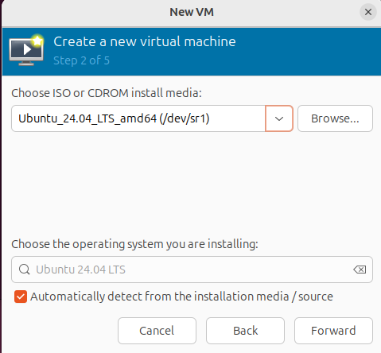

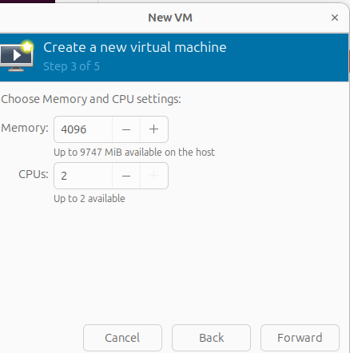

Step 5: Ensure to keep everything as default and proceed.
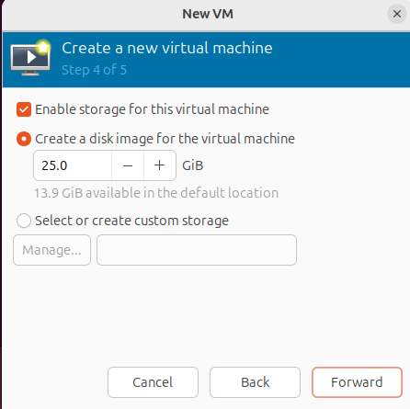

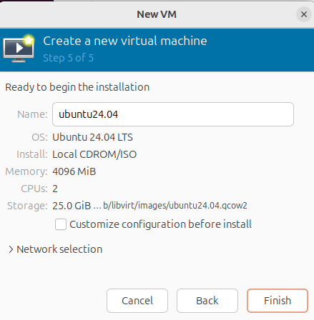

Step 6: Ubuntu should start now. Select the option to "Install Ubuntu" and proceed.
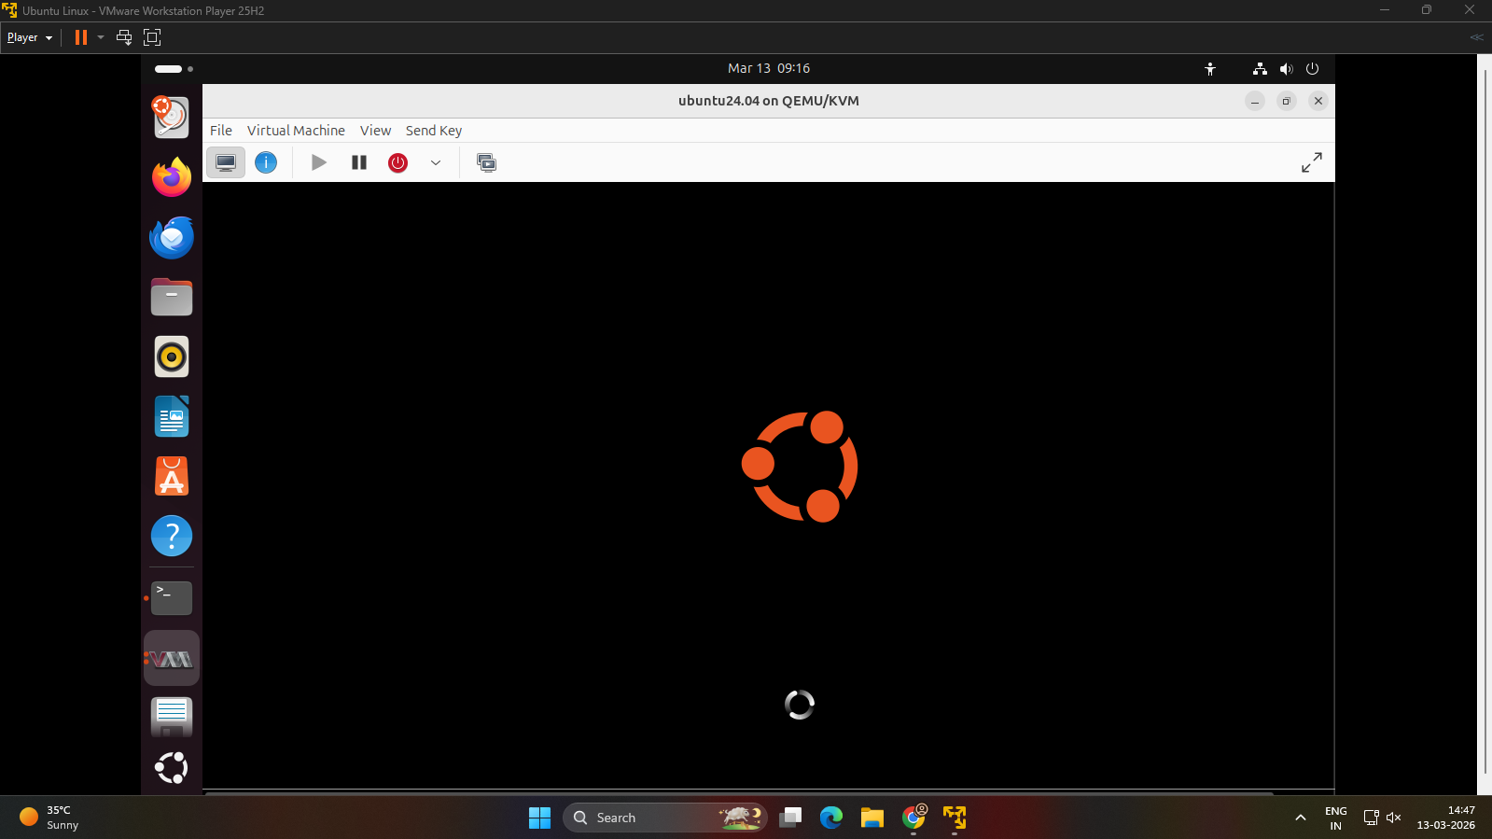
Step 7: Come out of the Ubuntu VM, back to the VMWare Ubuntu. This panel should display
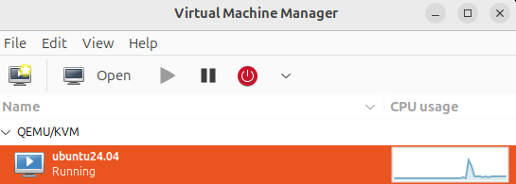
Step 8: Now "Force off" (shut-down) the Ubuntu VM by right clicking on it, in the virt-manager. After that, right click on the Ubuntu VM again and select the "clone" option.

Practical 2 - Xen
Step 1: Install XenServer and XenCenter.
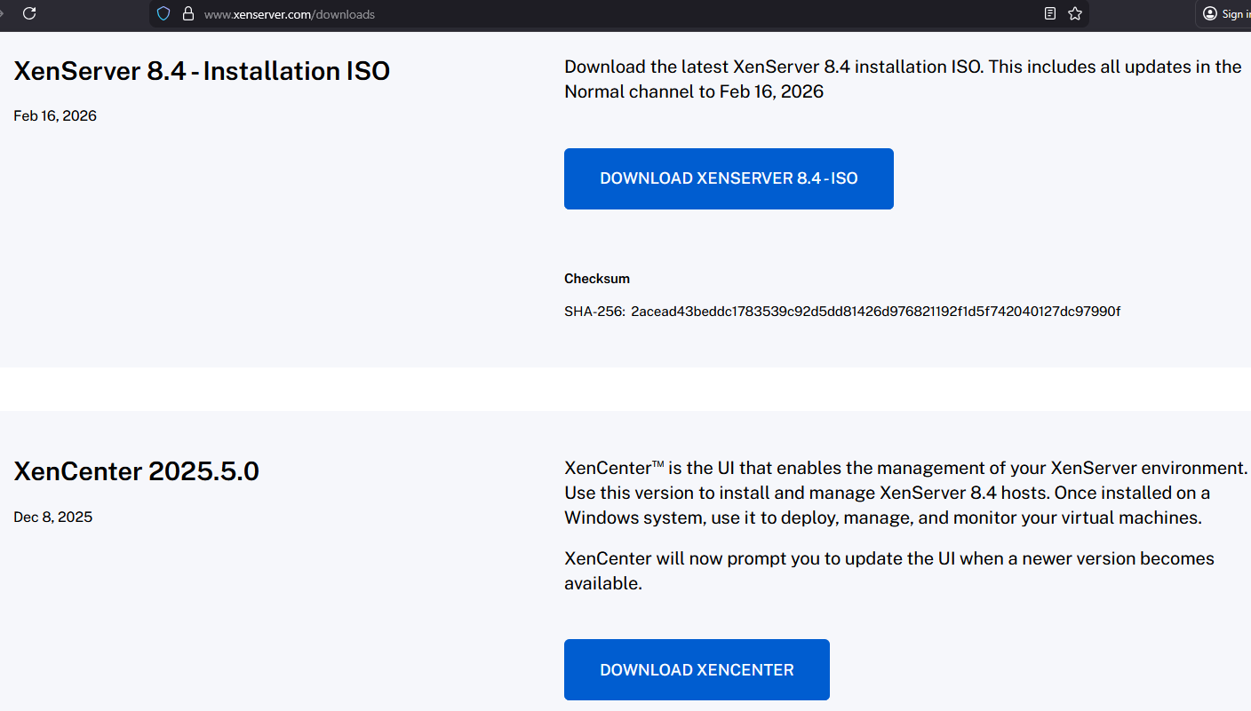
Step 2: Open VMWare and import the XenCenter ISO file.
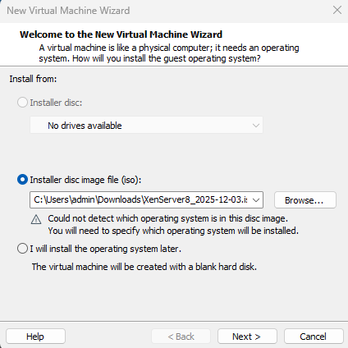
Step 3: Select the Guest OS as Other and version as Other 64-bit.
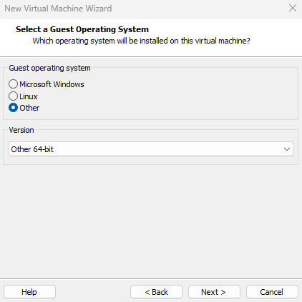
Step 4: Select the place to store the VM (typically, select the D drive).
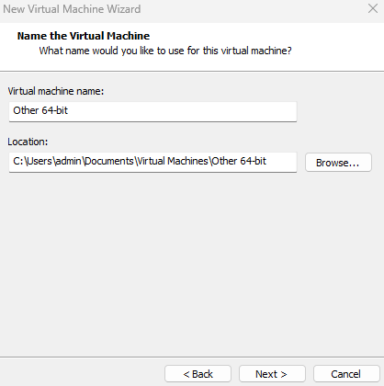

Step 5: Set the disk space to 50GB or more.
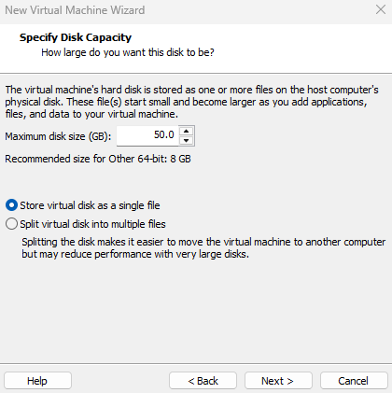
Step 6: Finish the installation.
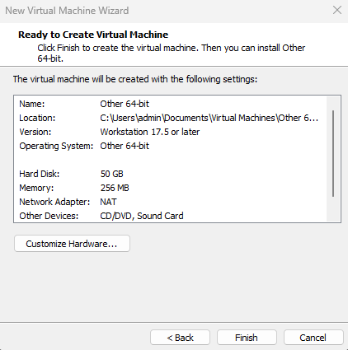

Step 7: Click on edit virtual machine settings and set the RAM to 4GB or more, and processors to 4.
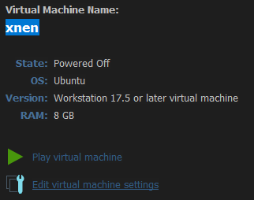
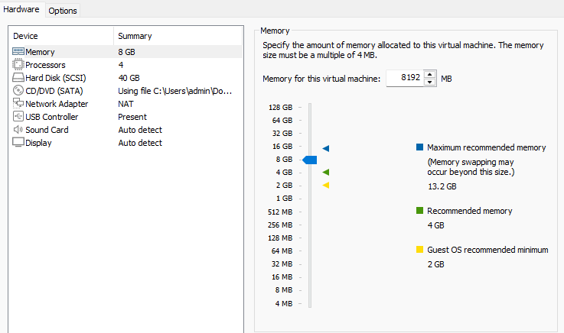

Step 8: Proceed with the XenServer bootup and installation.
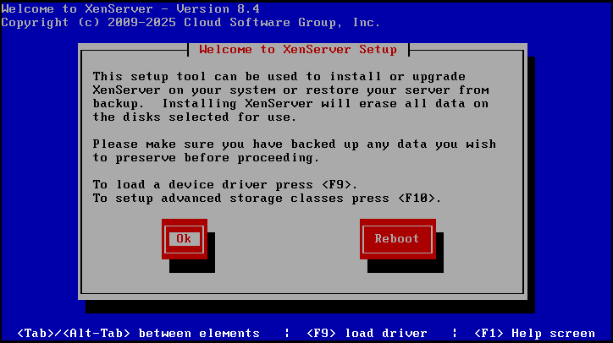
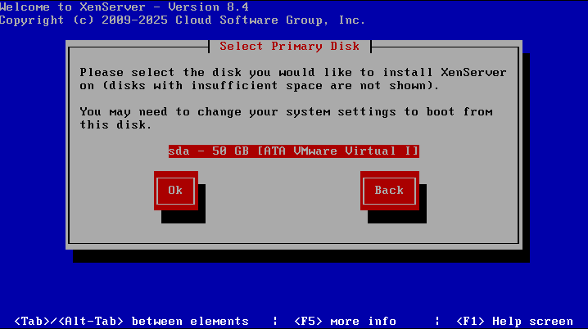
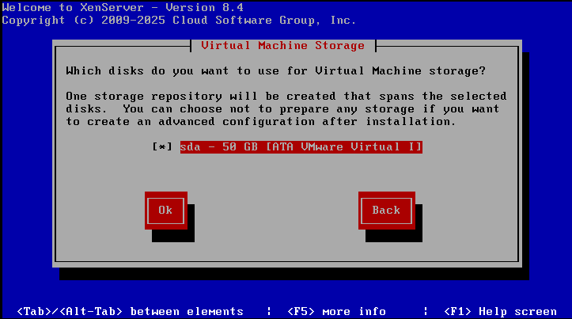
Don't enable thin provisioning.
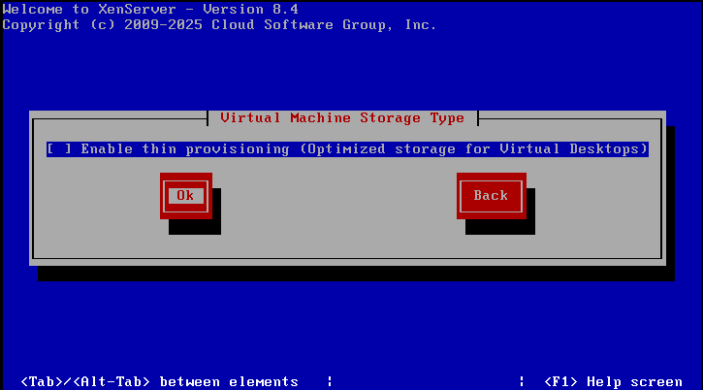

Select "Local media".
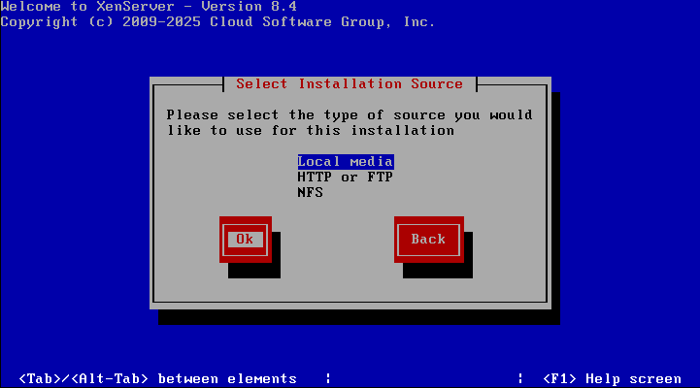
Optional: you can either skip or verify installation source.
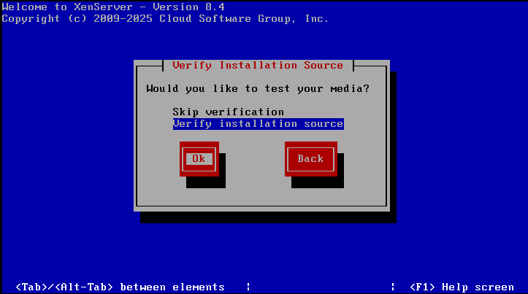

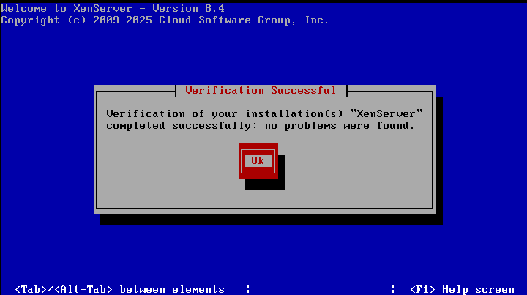
Enter the password, but make sure to remember it.
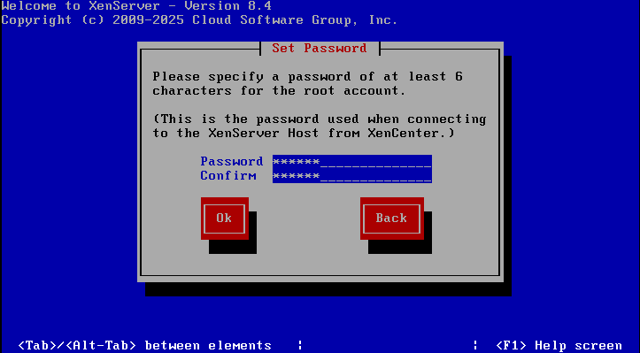

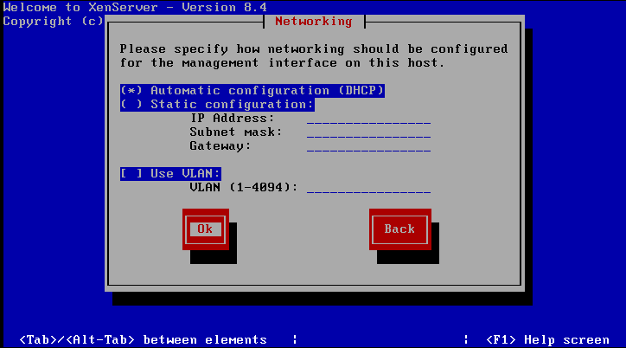
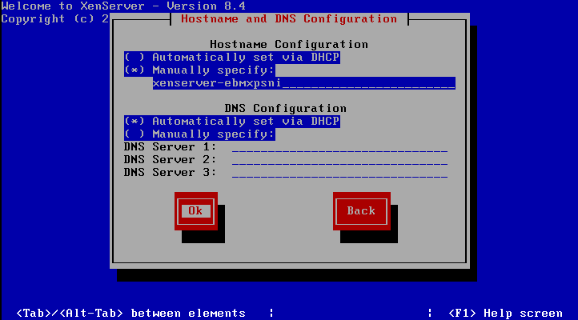
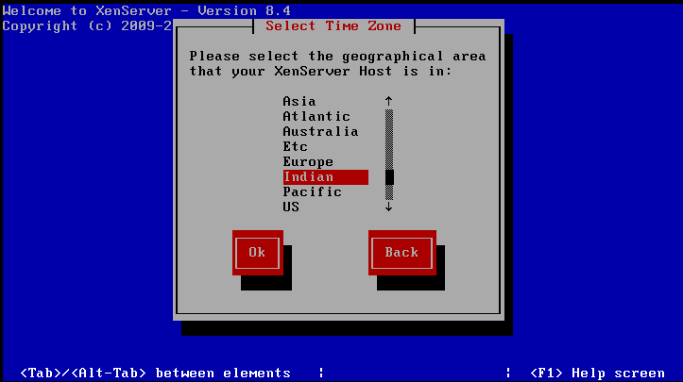
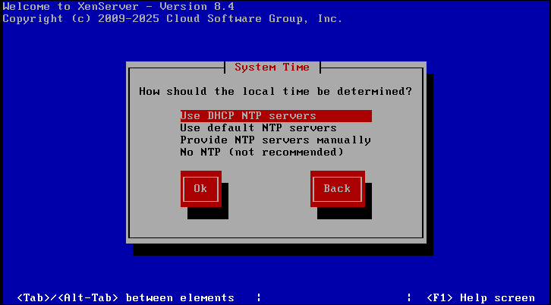
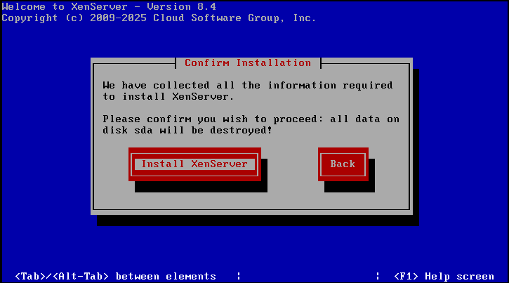
After installation:
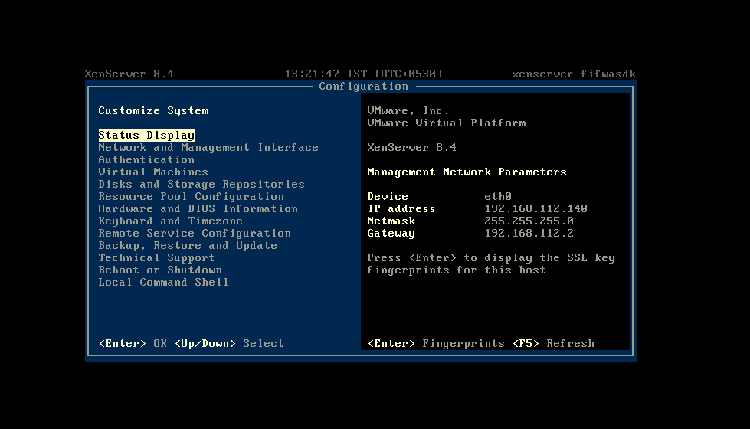

Step 9: Open XenCenter and add new server.
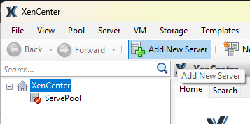

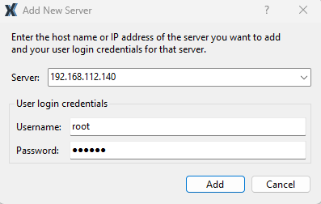
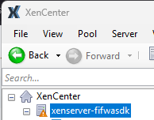

Practical 3 – Web Feed
Step 1: Download the XAMPP application
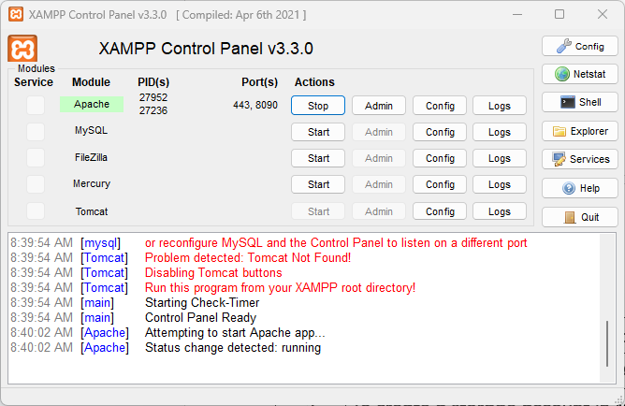
Step 2: Create a php and html file containing the code
HTML Code:
ccprachtml.html
<html>
<head>
<script>
function showRSS(str){
if(str.length == 0)
{
document.getElementById("output").innerHTML="";
return;
}
if(window.XMLHttpRequest)
{
xmlhttp=new XMLHttpRequest();
}
else{
xmlhttp = new ActiveXObject("Microsoft.XMLHTTP");
}
xmlhttp.onreadystatechange = function()
{
if(xmlhttp.readyState ==4 && xmlhttp.status == 200)
{
document.getElementById("output").innerHTML = xmlhttp.responseText;
}}
xmlhttp.open("GET","ccpracphp.php?q="+str,true);
xmlhttp.send();
}
</script>
</head>
<body>
<p>Please Select an Option to get RSS:</p>
<form>
<select onchange ="showRSS(this.value)">
<option value="">Select an RSS-feed:</option>
<option value="cnn">CNN</option>
<option value="bbc">BBC News</option>
<option value="pcw">PC World</option>
</select>
</form>
<br>
<div id = "output">RSS-feeds</div>
</body>
</html>

PHP Code:
ccpracphp.php
<?php
$q = isset($_GET["q"]) ? $_GET["q"]:"";
$xml = "";
if($q == "cnn"){
$xml = "http://rss.cnn.com/rss/cnn_topstories.rss";
}
elseif($q == "bbc"){
$xml = "http://newsrss.bbc.co.uk/rss/newsonline_world_edition/americas/rss.xml";
}
elseif($q == "pcw"){
$xml = "http://www.pcworld.com/index.rss";
}
if($xml !== ""){
$xmlDoc = new DOMDocument();
if($xmlDoc->load($xml)){
$channel = $xmlDoc->getElementsByTagName('channel')->item(0);
$channel_title = $channel->getElementsByTagName('title')->item(0)->childNodes->item(0)->nodeValue;
$channel_link = $channel->getElementsByTagName('link')->item(0)->childNodes->item(0)->nodeValue;
$channel_desc = $channel->getElementsByTagName('description')->item(0)->childNodes->item(0)->nodeValue;
echo("<p><a href='".$channel_link."'>".$channel_title."</a></p>");
echo("<p>".$channel_desc."</p>");
$x = $xmlDoc->getElementsByTagName('item');
for($i = 0; $i <= 2; $i++){
$item_title = $x->item($i)->getElementsByTagName('title')->item(0)->childNodes->item(0)->nodeValue;
$item_link = $x->item($i)->getElementsByTagName('link')->item(0)->childNodes->item(0)->nodeValue;
echo("<p><a href='".$item_link."'>".$item_title."</a></p>");
}
}
else{
echo "Failed to load XML";
}
}
else{
echo "No RSS feed selected";
}
?>
Step 3: Create a folder containing the php and html files.
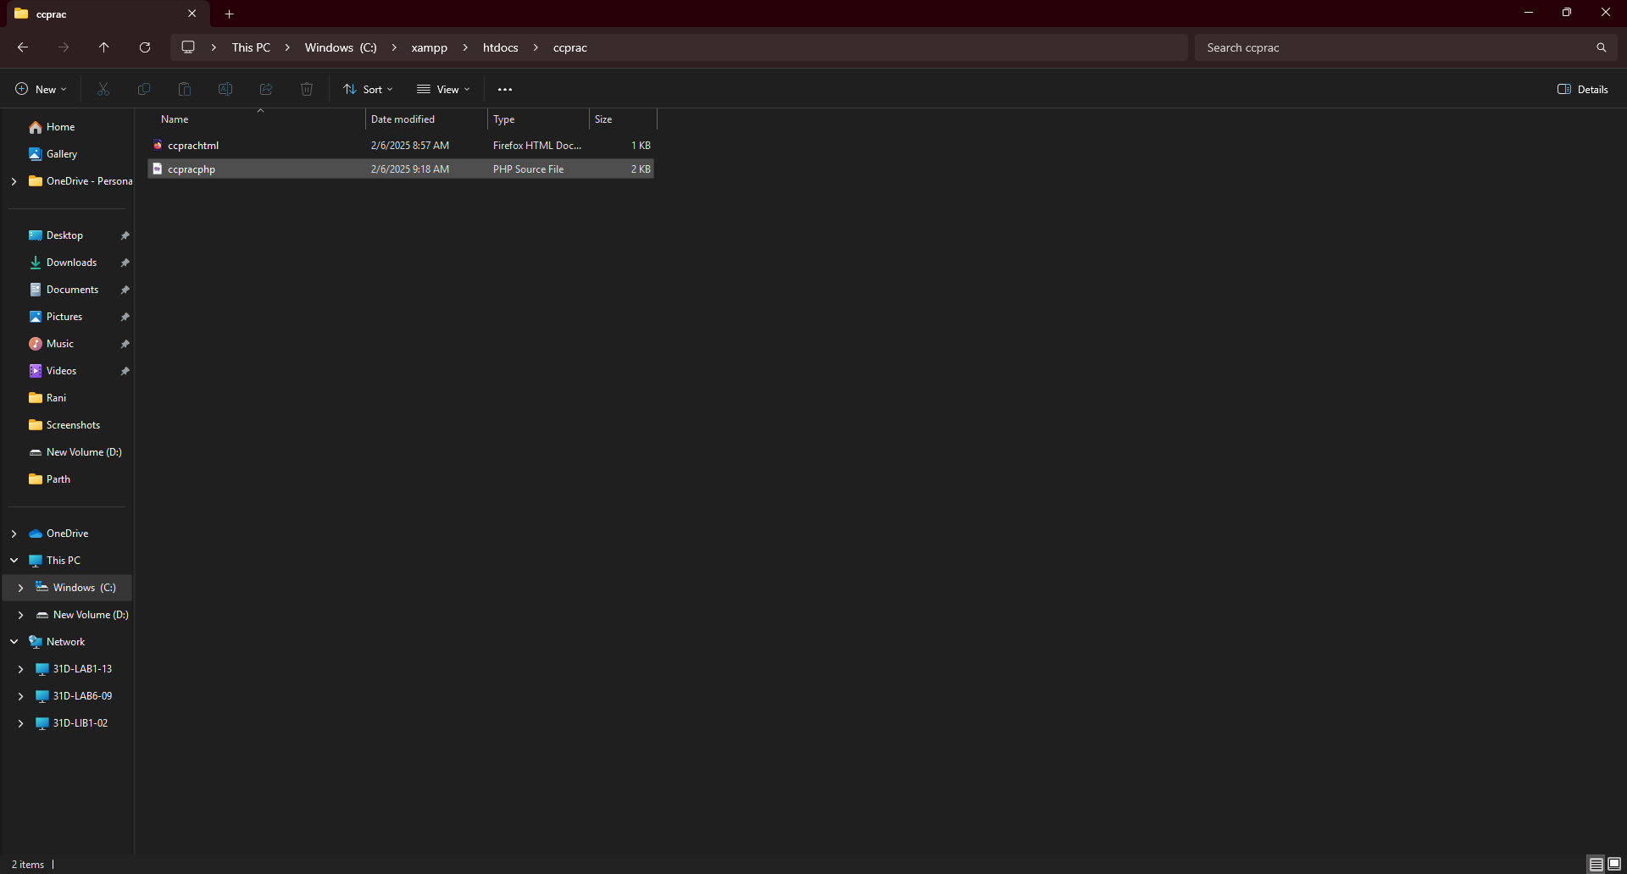

Step 4: In the browser, navigate to localhost/foldername/htmlfile.html (here it is localhost/ccprac/ccprachtml.html).
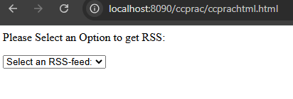
Step 5: Select any of the options and the RSS feed will be displayed.
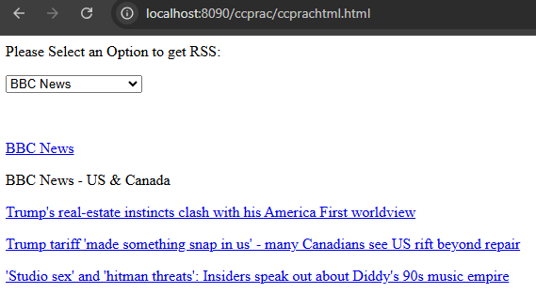

Practical 4 – Cognitive AI
4A: Text to Speech
Step 1: Click on Create a Resource.
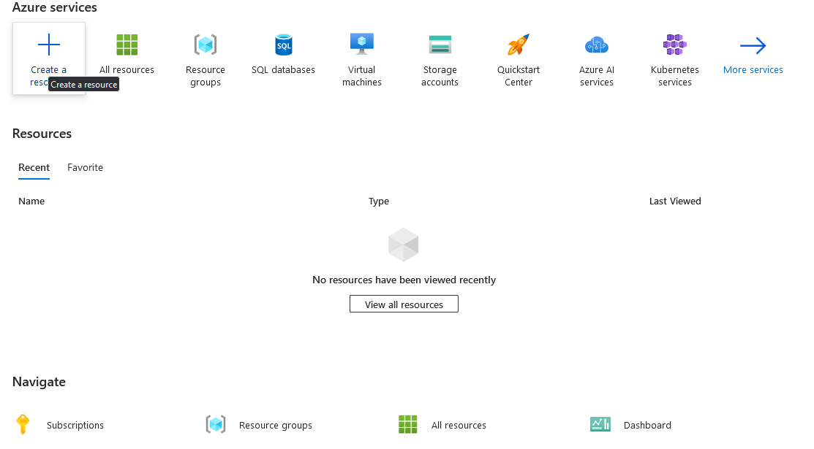

Step 2: Click on AI + Machine Learning.
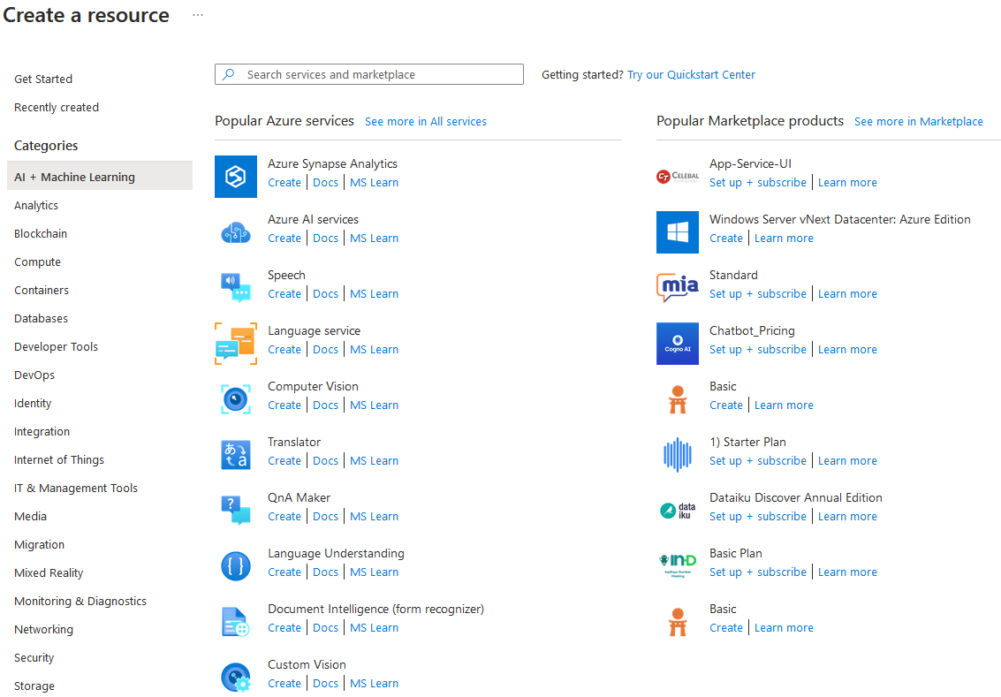

Step 3: Click on Create Speech.


Step 4: Enter the credentials and click on Review + Create -> Create
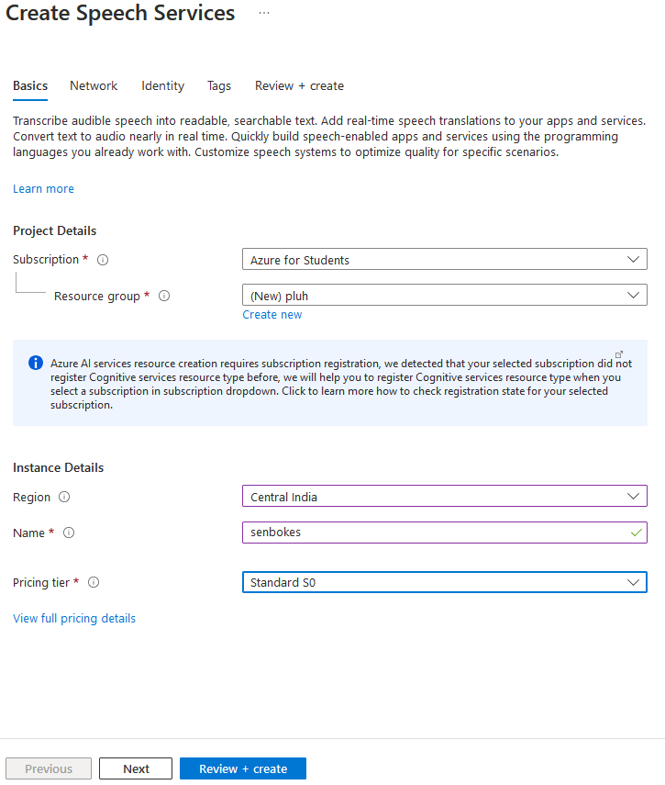

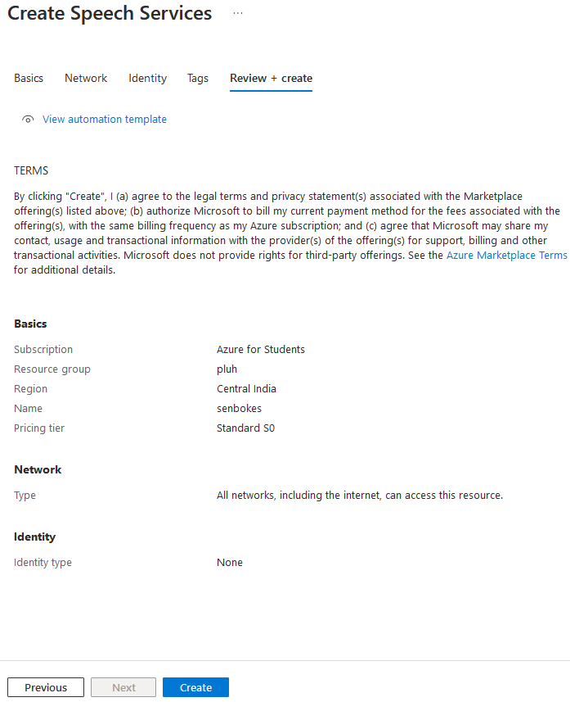
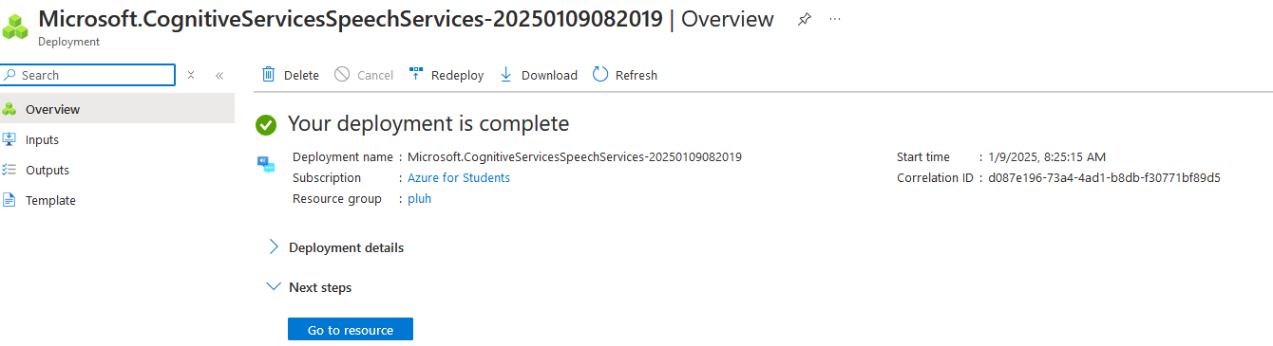

Step 5: Go to Speech Studio.
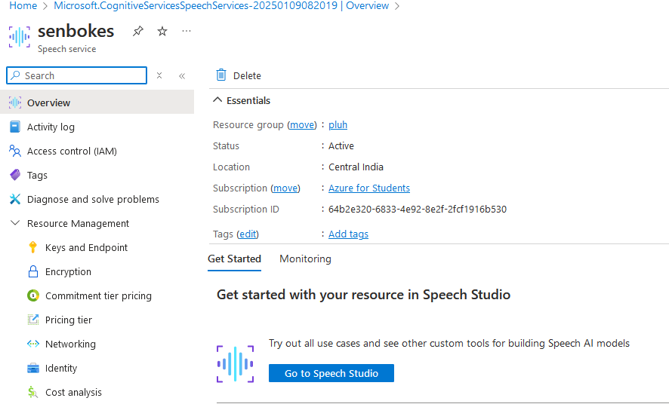

Step 6: Scroll down and select Voice Gallery.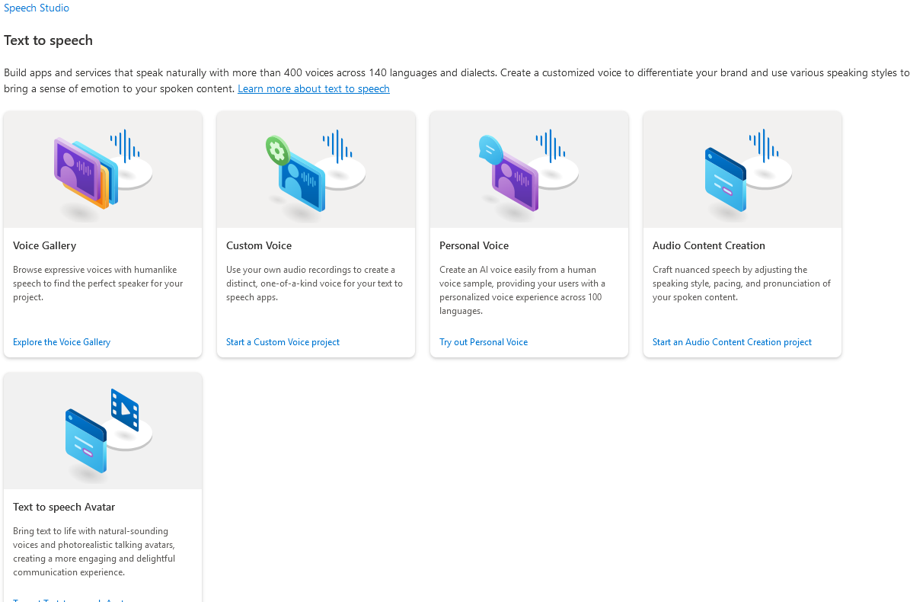

Step 7: Select a Voice.
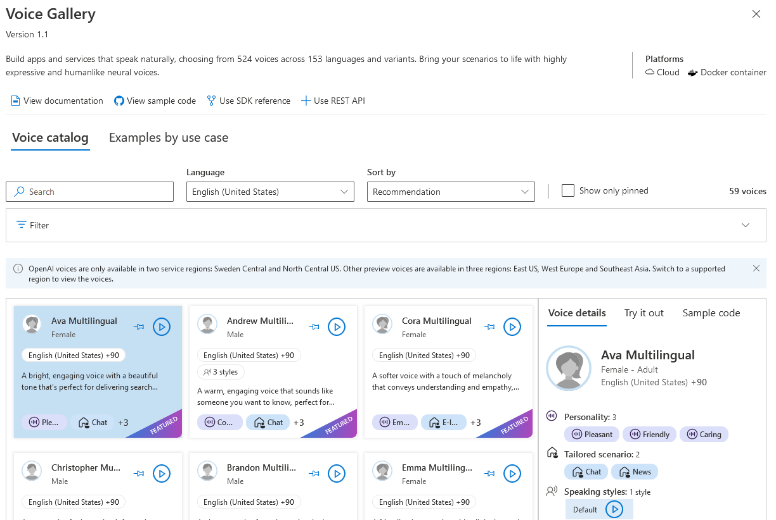

Step 8: Click on Audio Content Creation.
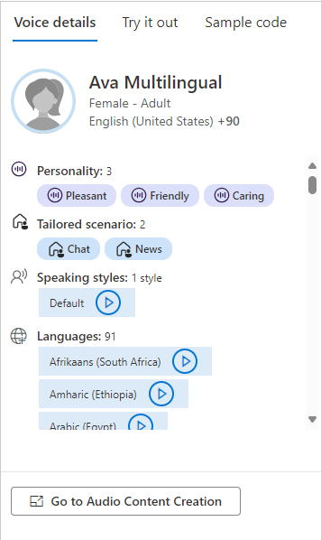

4B: Speech to Text
Step 1: Click on Create a Resource.


Step 2: Click on AI + Machine Learning.


Step 3: Click on Create on Speech.


Step 4: Enter the credentials and click on Review + Create -> Create.





Step 5: Go to Speech Studio.


Step 6: Scroll down and select "Batch speech to text"
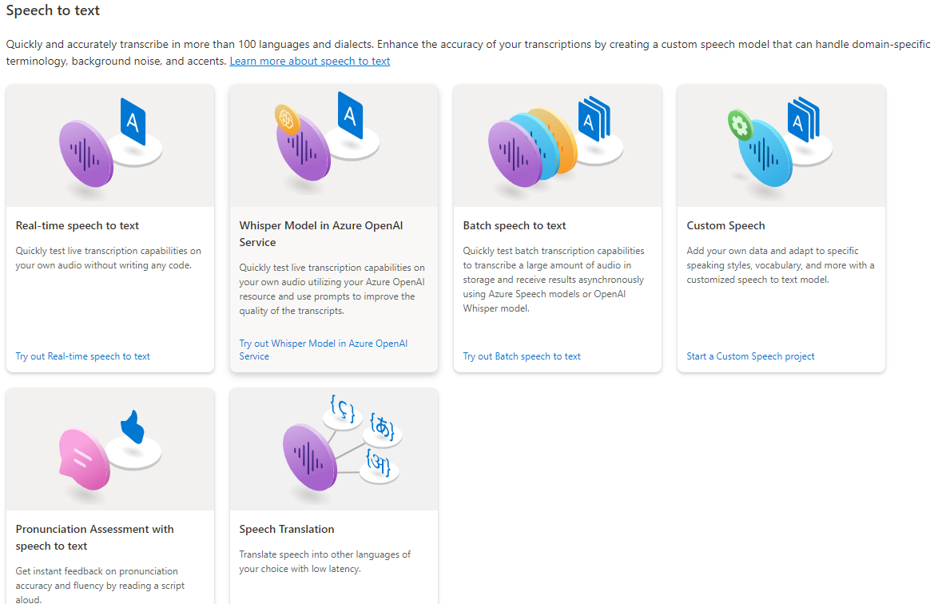

Step 7: Upload an audio file.
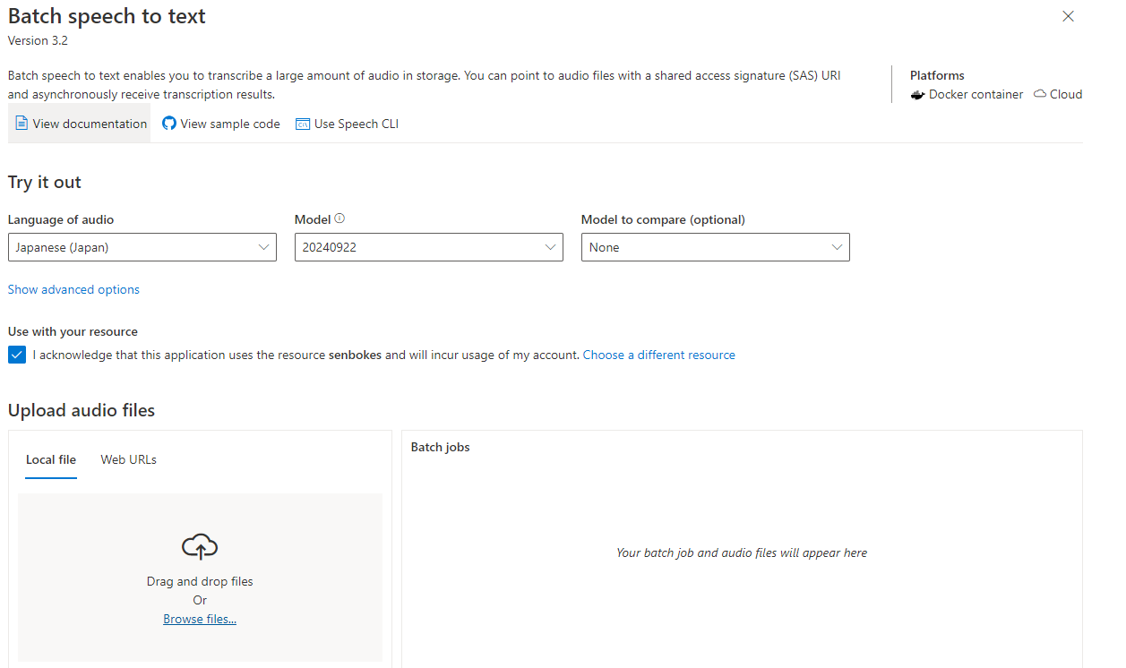

4C: Computer Vision
Step 1: Click on Create a Resource.


Step 2: Click on AI + Machine Learning and then click on create Computer Vision.
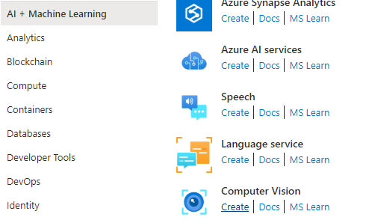

Step 3: Enter the credentials and then review + create -> create.
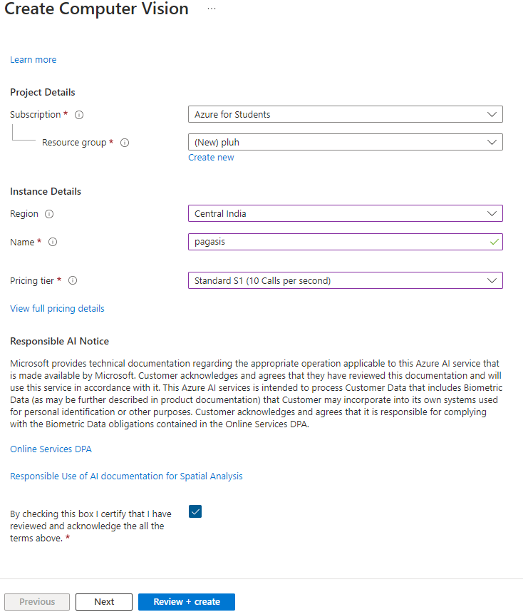

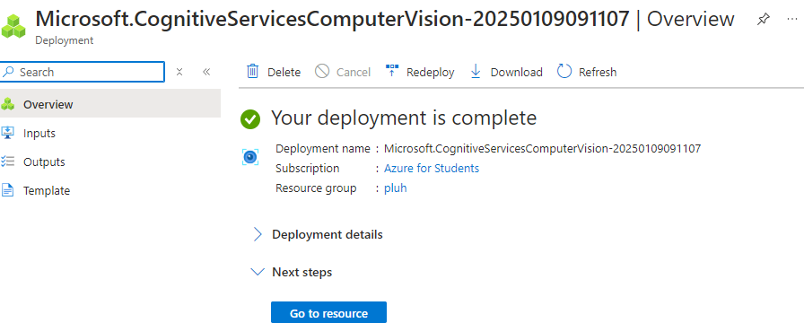
Step 4 : Click on go to Vision Studio.
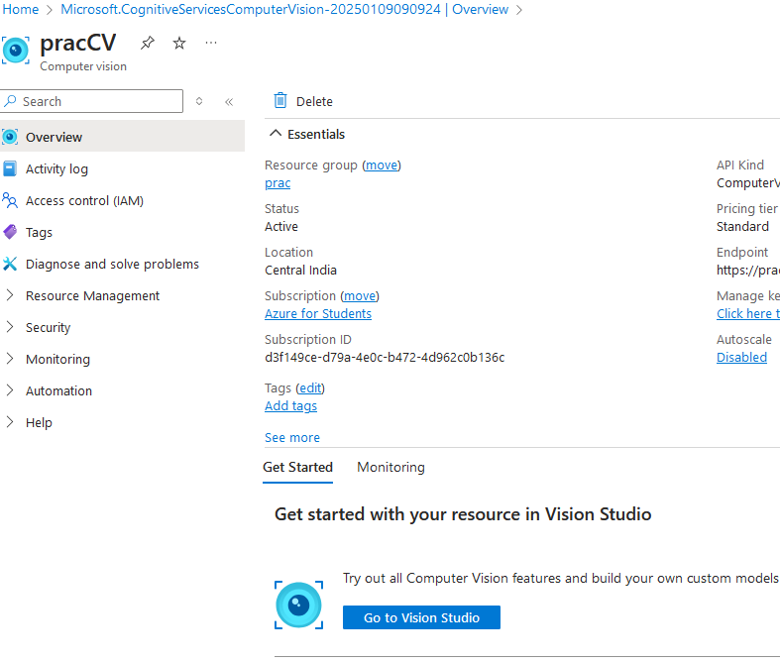
Step 5: Click on Video Retrieval and Summary.
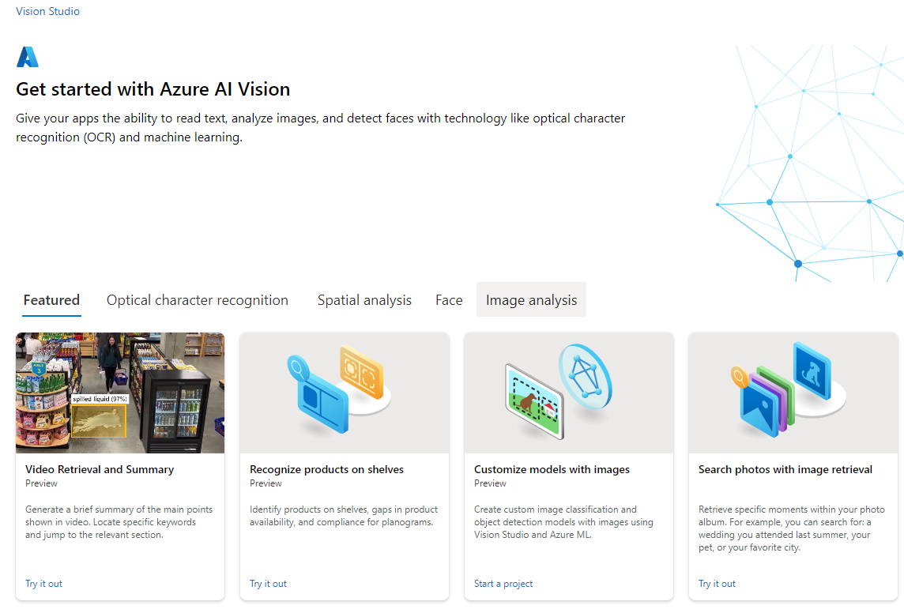

Step 6: Click on Retail.
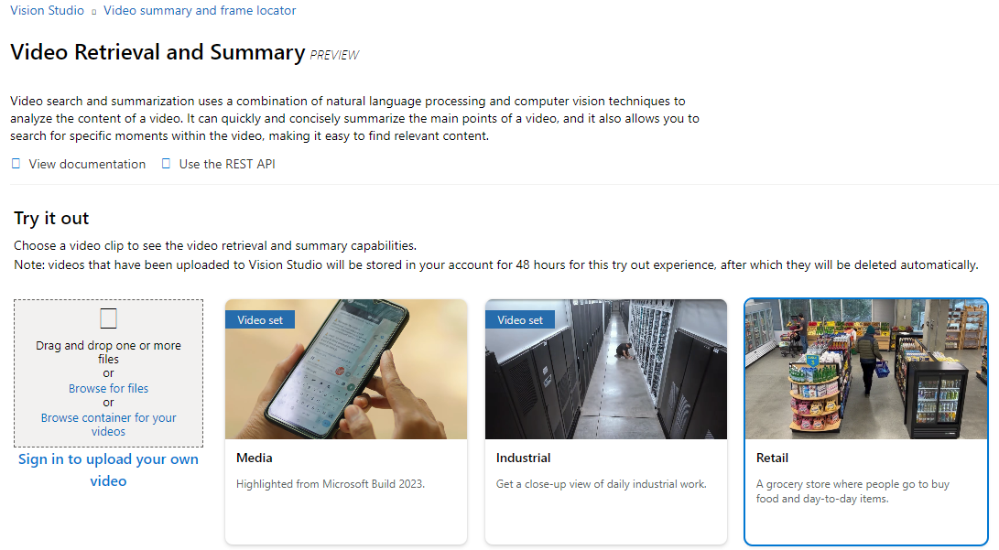
Step 7: Click on Summarize and then search the frames in the video for a specific moment.
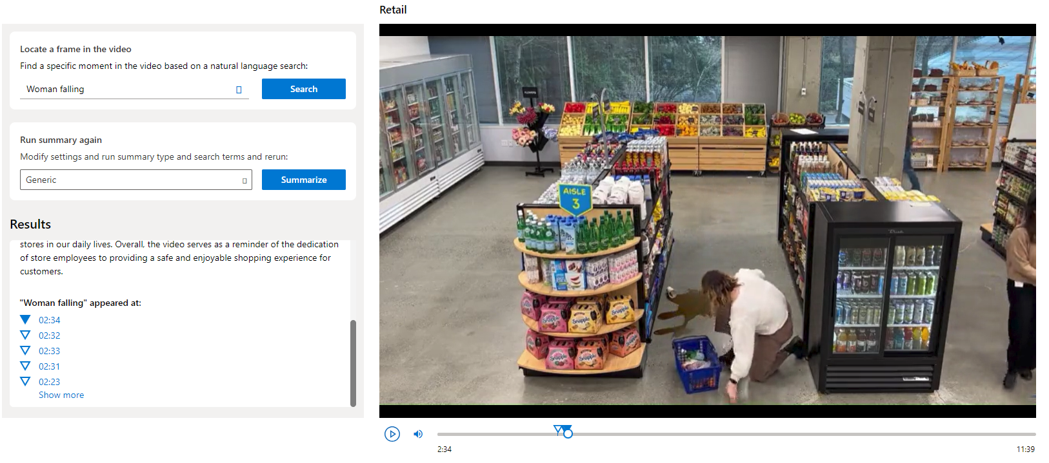

Practical 5 – Power BI
Step 1: Click on Create a Resource.


Step 2: Click on Analytics -> Click on Analytics Services.
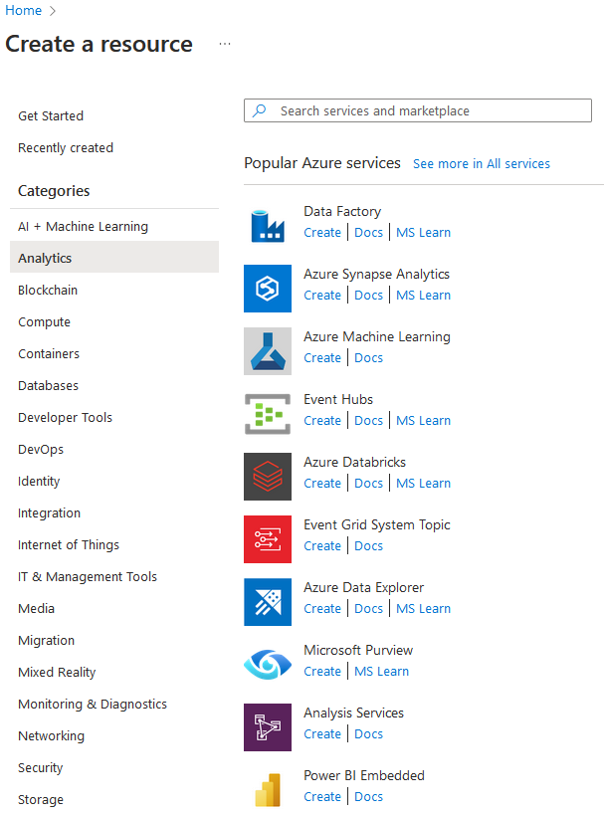


Step 3: Enter the required details and click on Create. (if Administrator is not shown, click on ‘Select’ and select the appropriate administrator)
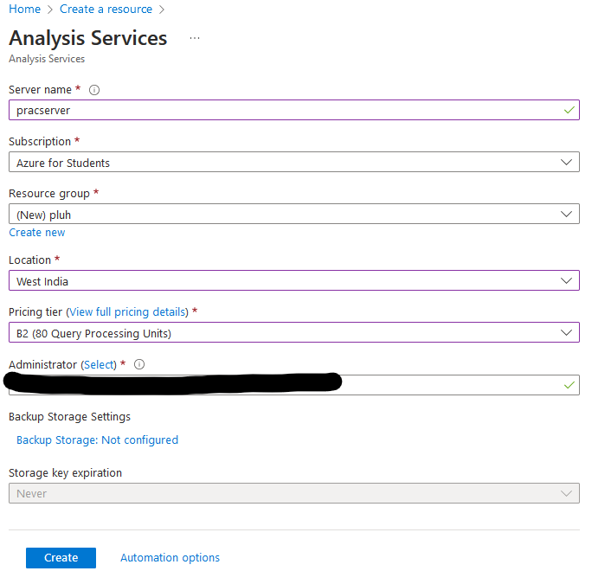

Step 4: After the deployment is complete, Click on go to resource.
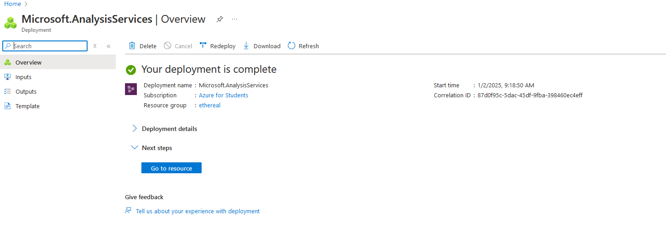

Step 5: Click on new model.
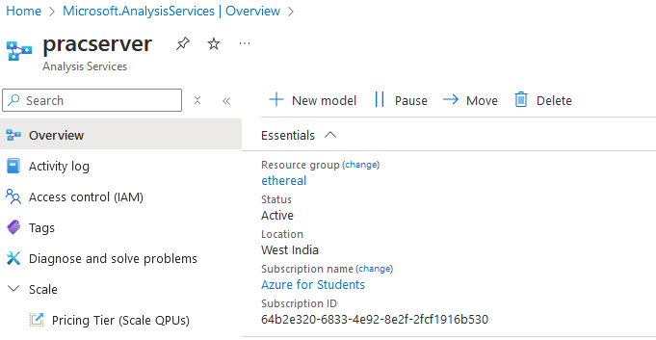
Step 6: Choose sample data and click on Add
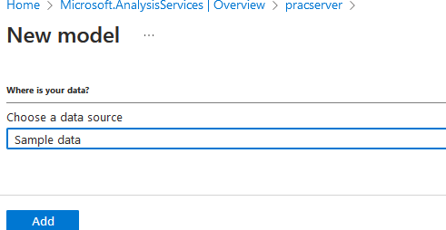

Step 7: After the model is created, click on the three dots, and select open in PowerBI
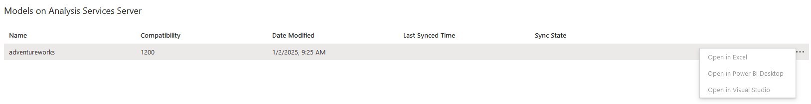
Step 8: After the file is downloaded, open it

Step 9: Click on Microsoft account and sign in with your azure credentials
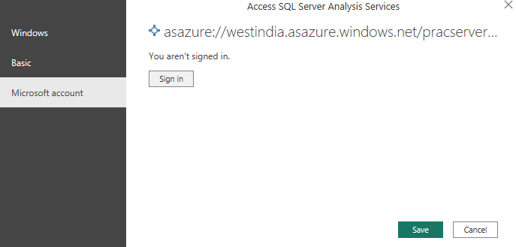

Practical 6 – SQL Analysis
Step 1: In the home page, click on SQL Database.
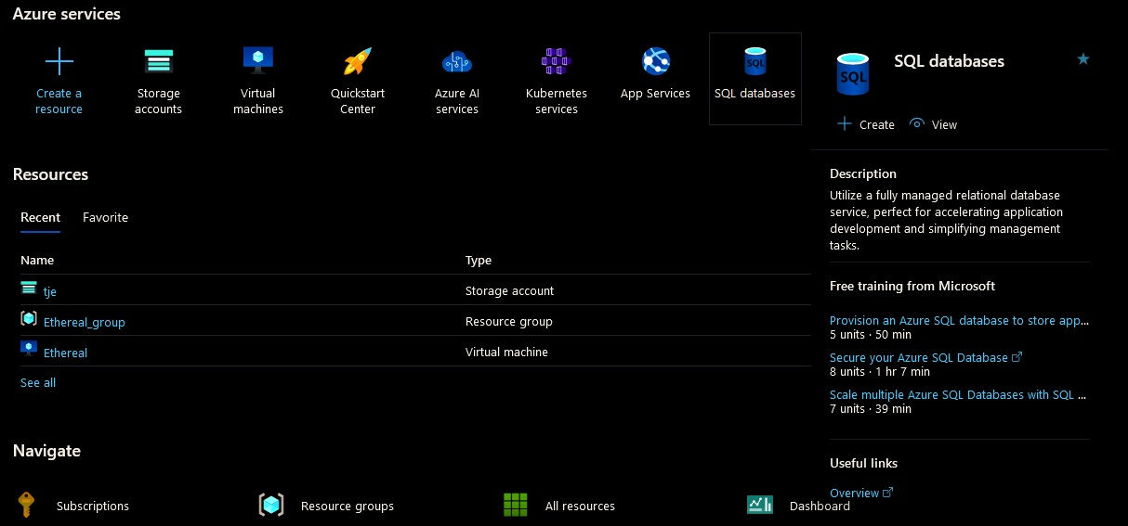
Step 2: Click on create Database
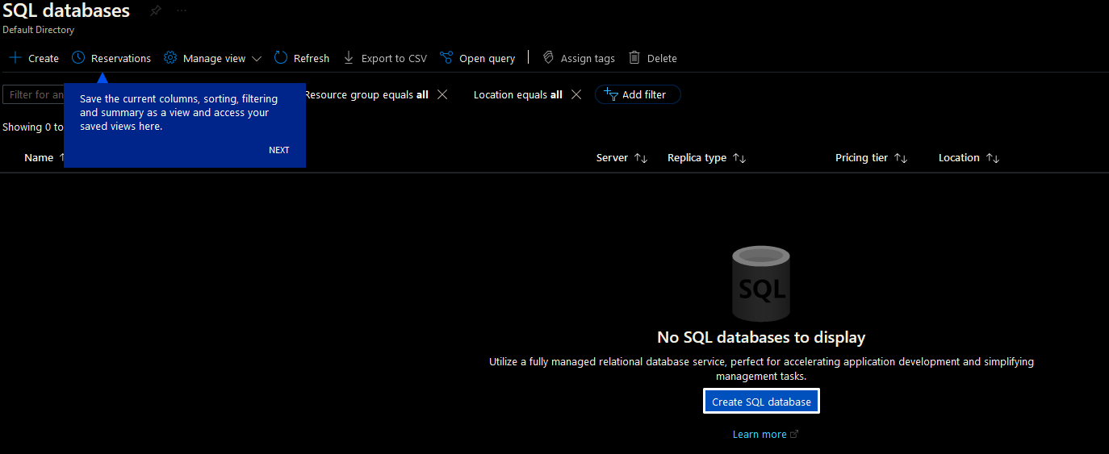

Step 3: Fill the required information
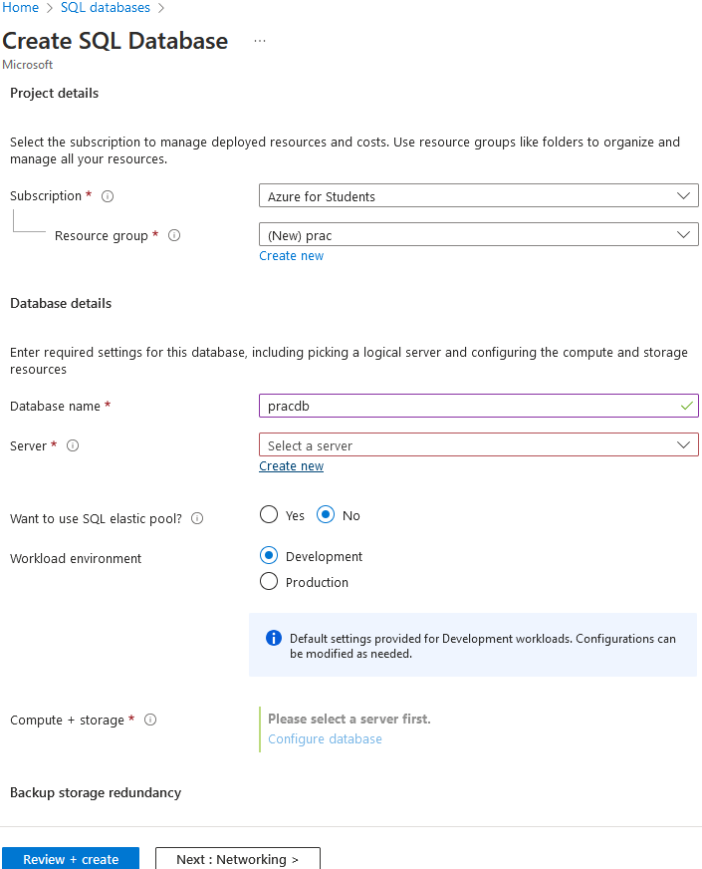

Step 4: Create new SQL Database Server
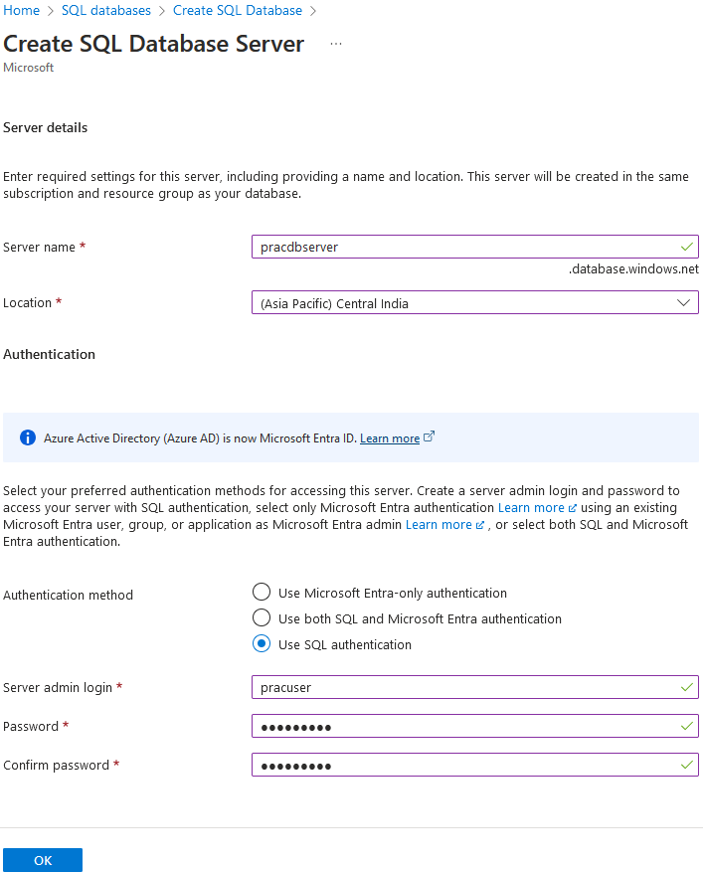

Step 5: Click on "Review + Create" -> "Create". The database will be deployed. Click on "Go to resource".
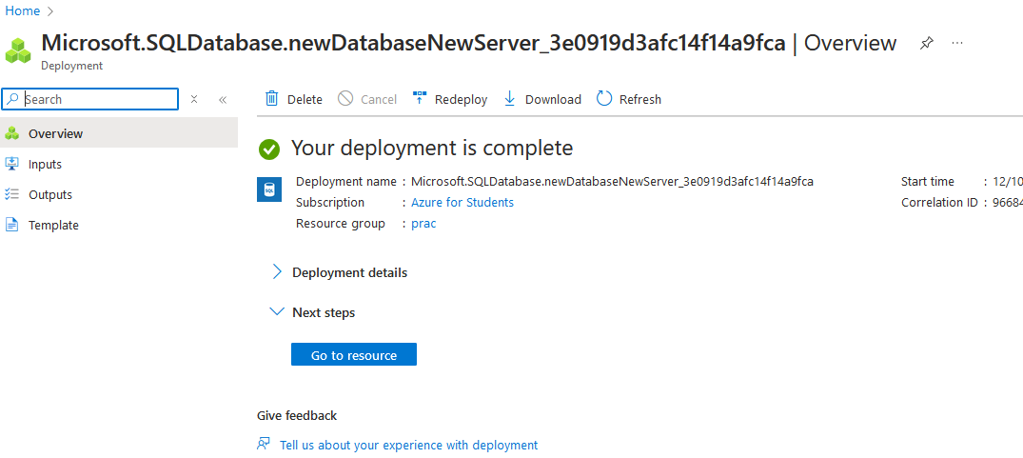
Step 6: Click on "Set server firewall".
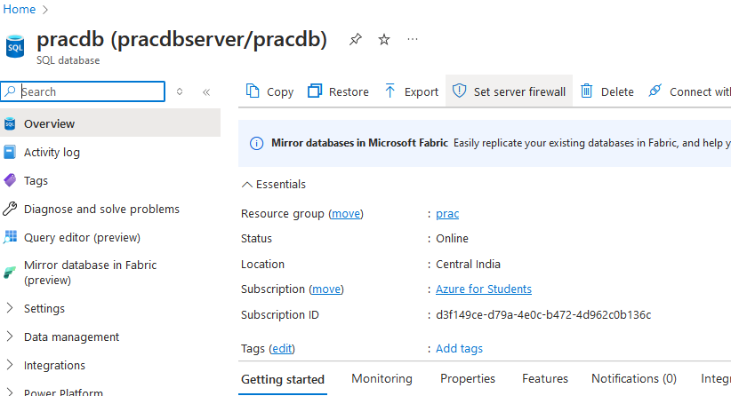

Step 7: Choose "Selected networks", in Firewall Rules add your client IP and click "Save".
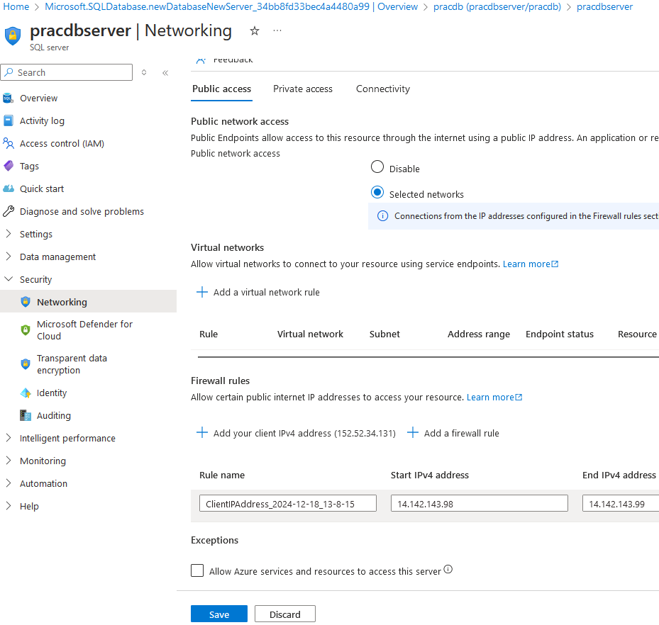
Step 8: Open SSMS and enter details
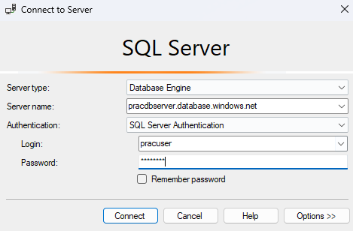
Step 9: Open "Options>>".
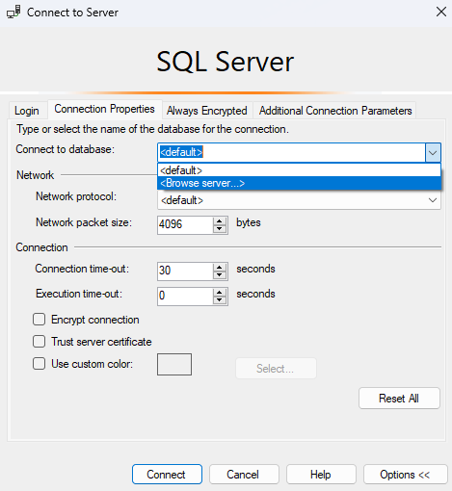
Step 10: Select your database and click on "Connect".
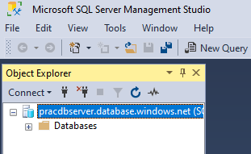

Step 11: Create Table
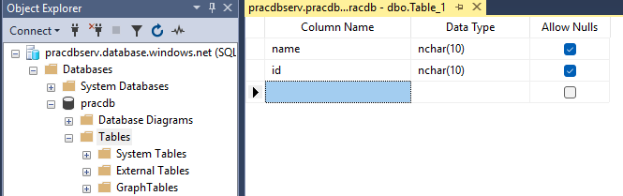
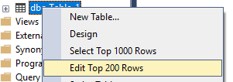
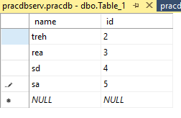
Step 12: In Excel, click on Data Tab and click on Get Data -> From Azure -> From Azure SQL Database
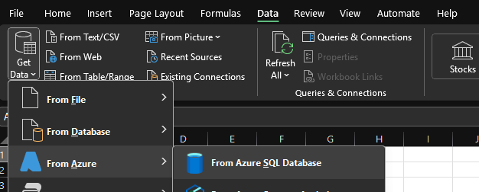

Step 13: Enter the server name and database name and click OK
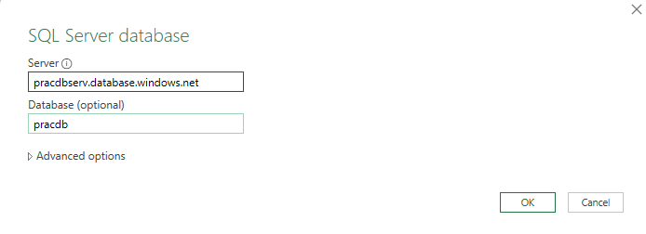
Step 14: Click on Database and enter the credentials and click on Connect
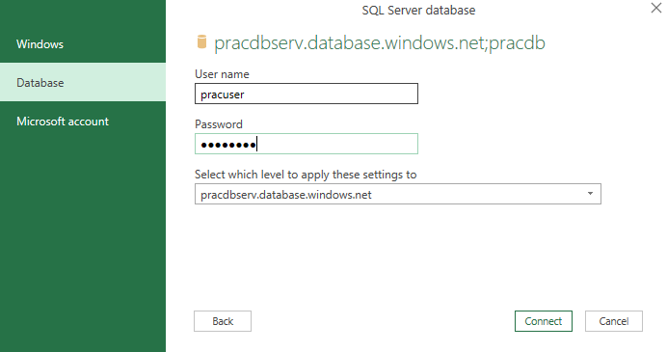

Step 15: Select the created table and click on load
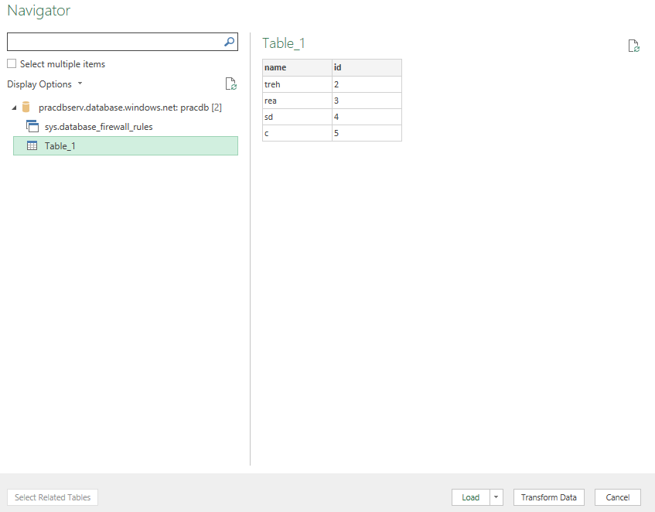
Result:
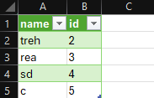

Practical 7 – Communication between 2 VMs over Cloud
Step 1: Create a Virtual Machine
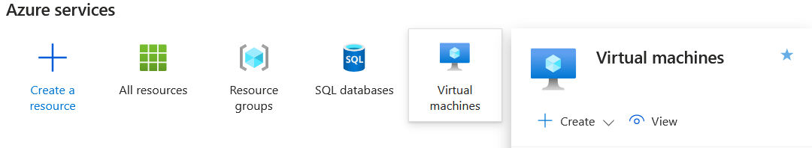
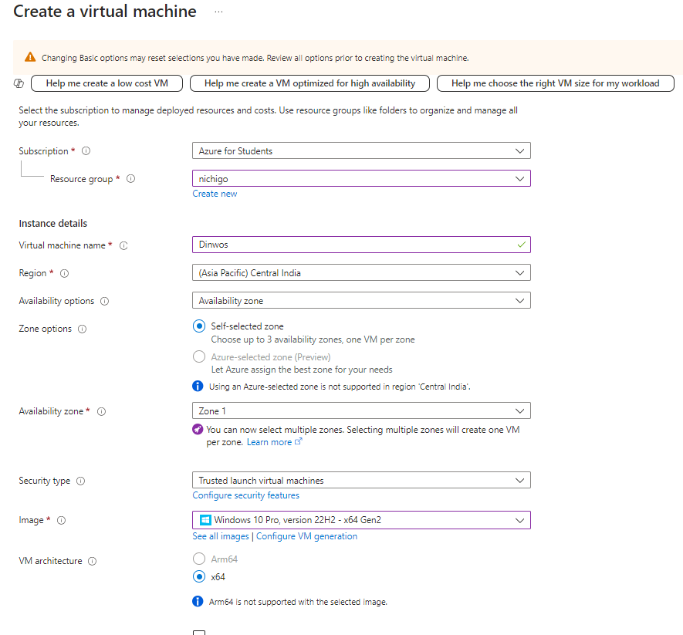
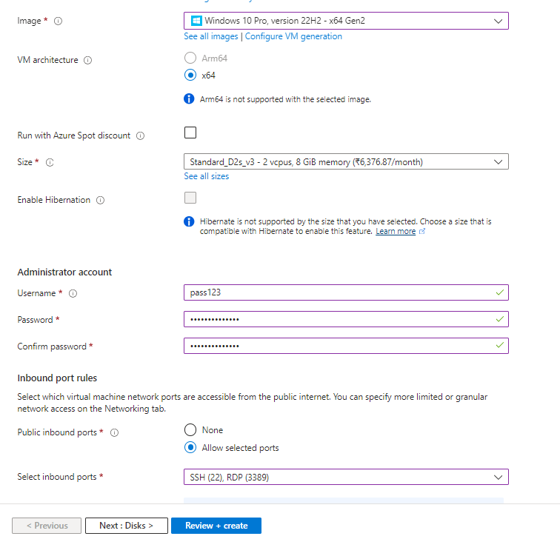

Step 2: Click on "Review + create" -> "Create"-> "Go to resource"
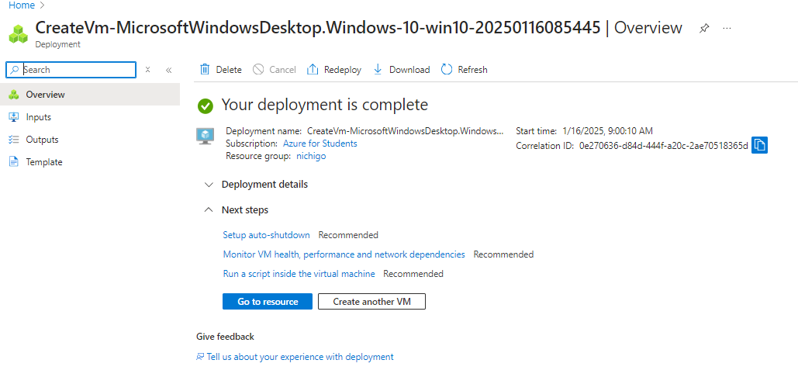

Step 3: Download RDP. Open RDP and click on Connect
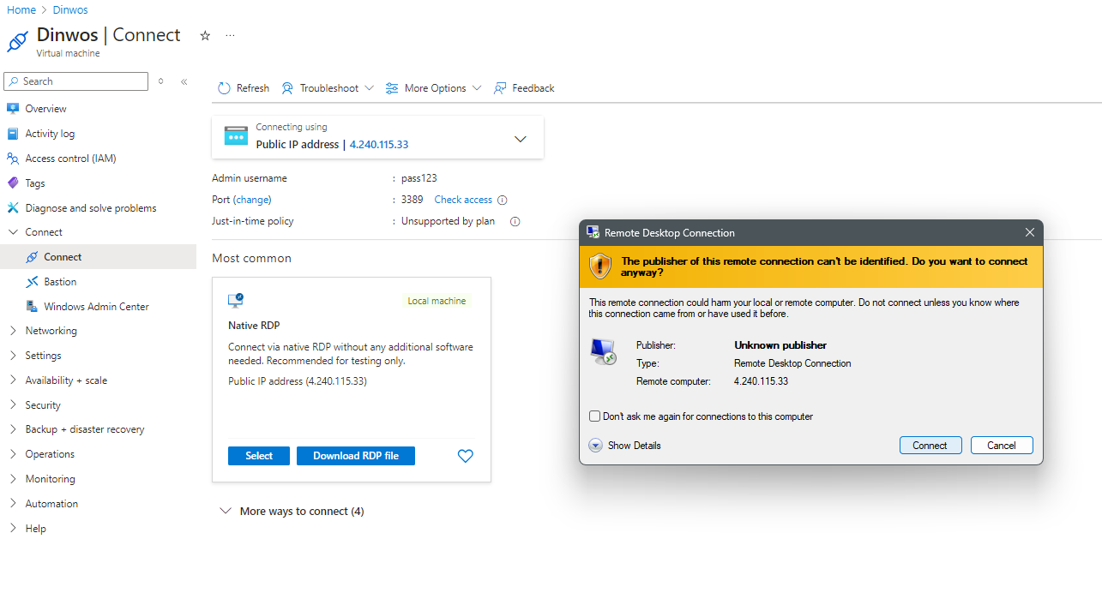
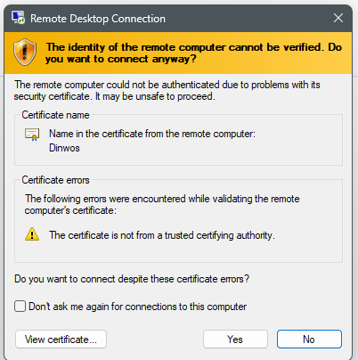

Step 4: Create a second VM

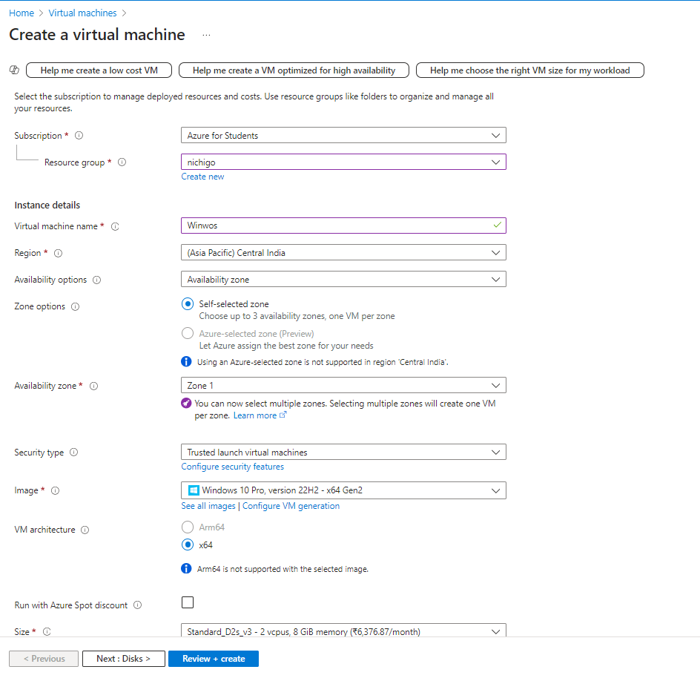
Step 6: In both the VMs, search for ‘Windows Defender Firewall’.
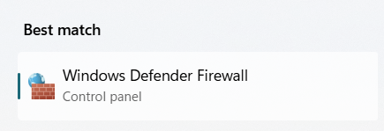
Step 7: Click on advanced settings in the defender.
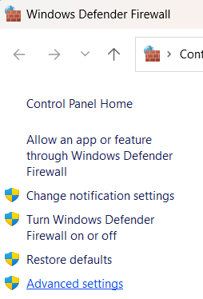
Step 8: Click on outbound rules, and enable the first 4 icmp protocols.
Step 9: Open CMD in one VM and ping the IP address of the other VM. Both VMs are able to communicate.
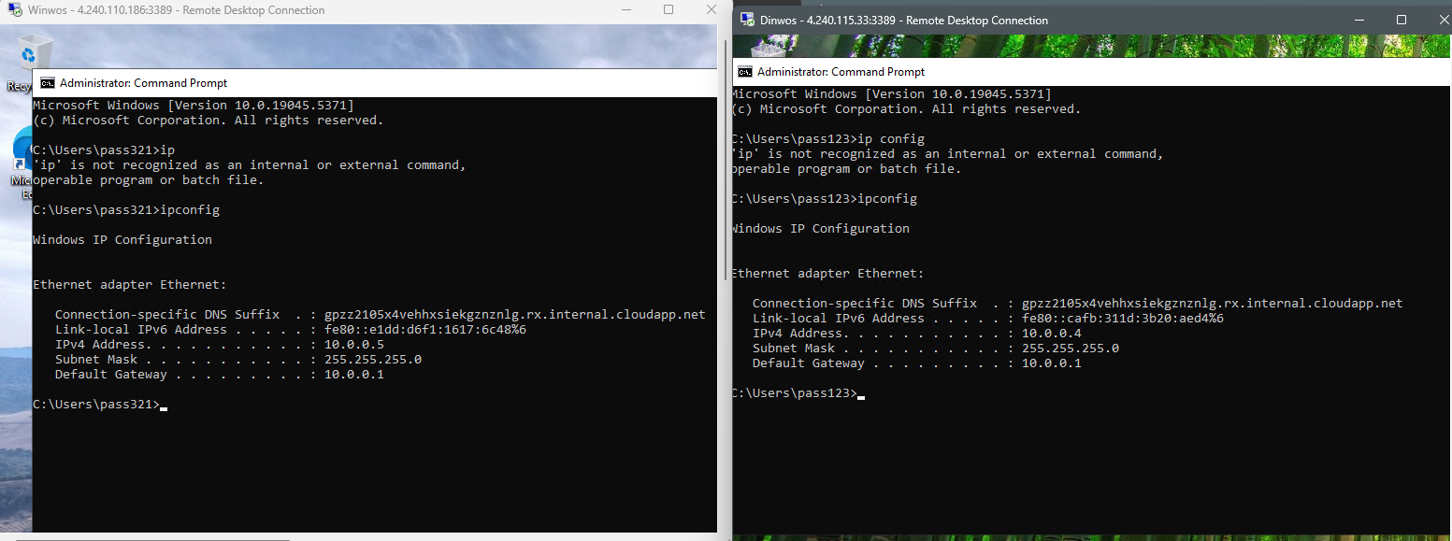
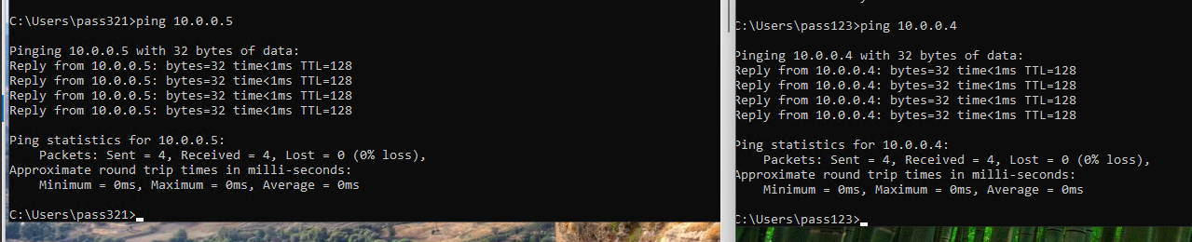

Practical 8 – Creating an Instance
Step 1: Click on create Virtual Machine
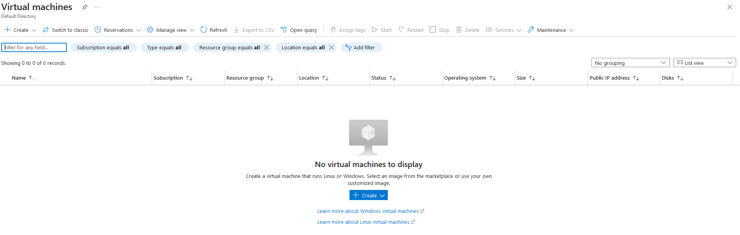

Step 2: Click on Create Virtual Machine
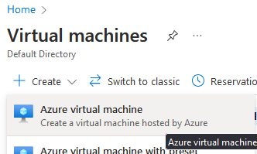

Step 3: Enter the details of the virtual machine:
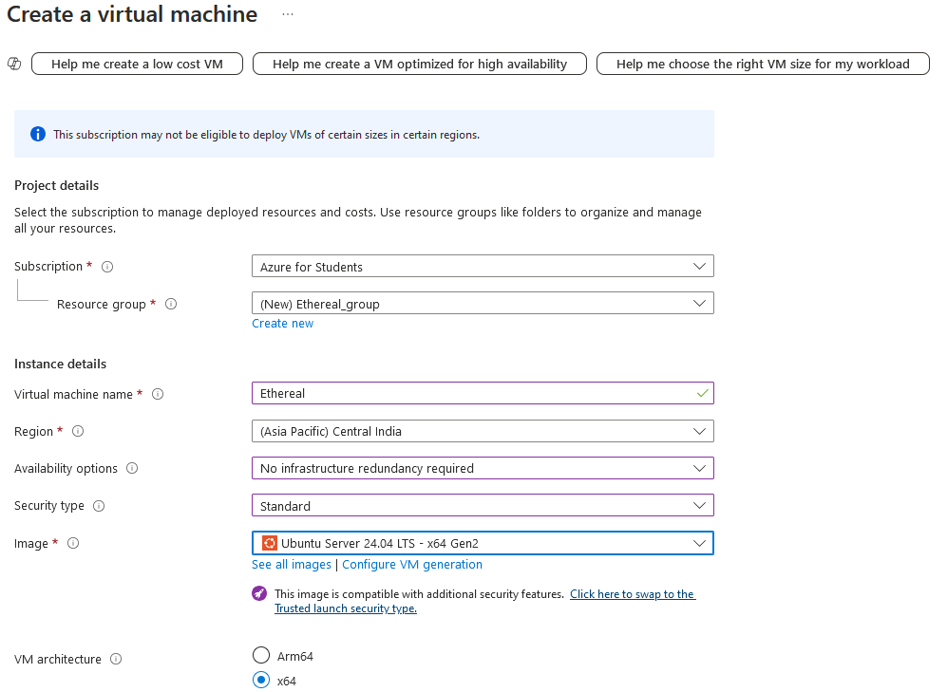
Step 4: Click on review + create
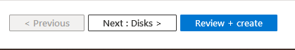

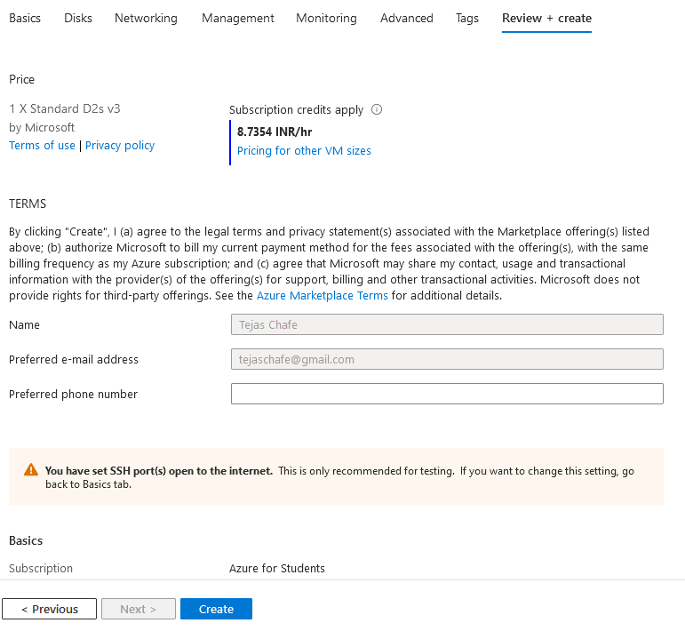
Step 5: Click on download private key:
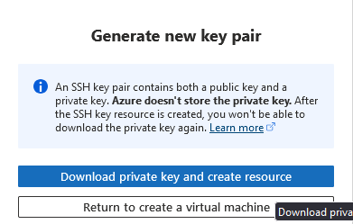

Virtual Machine is created:
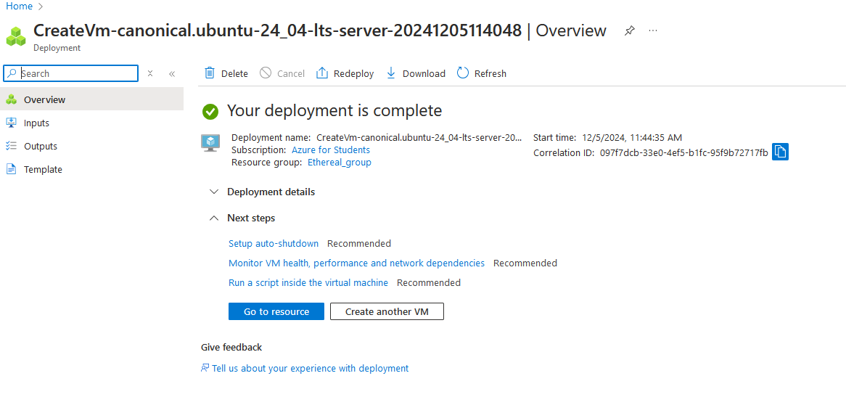

Practical 9 – AI/ML
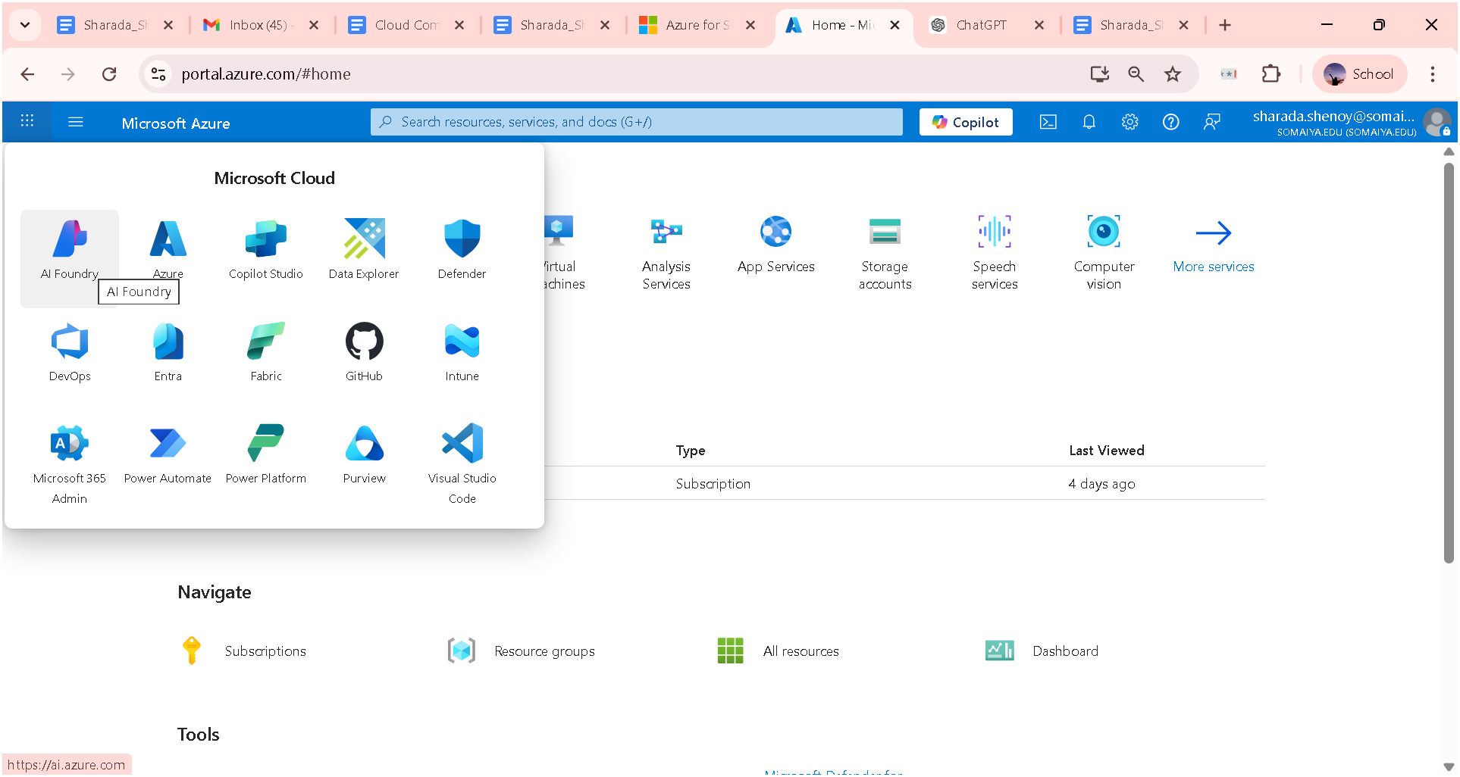

ml.azure.com
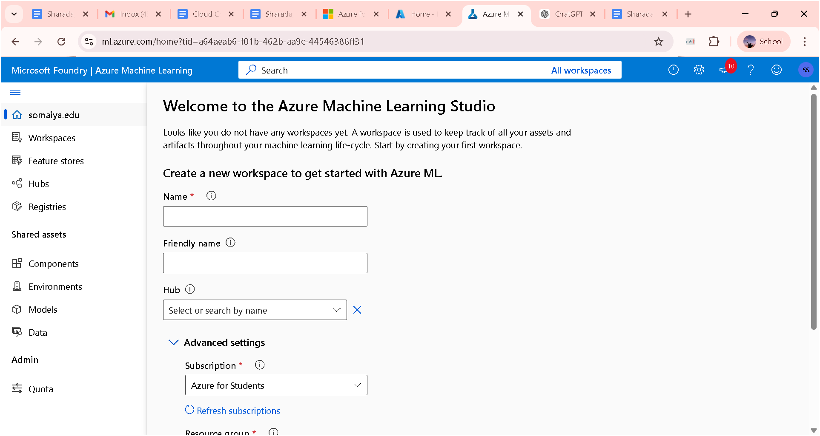

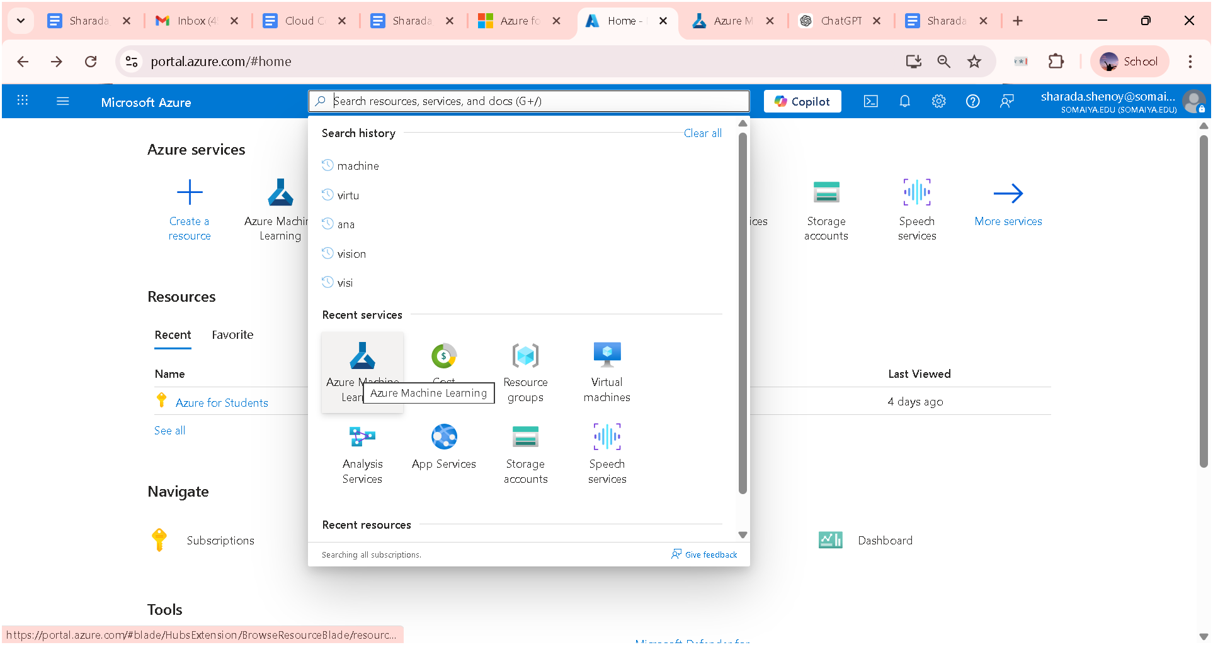
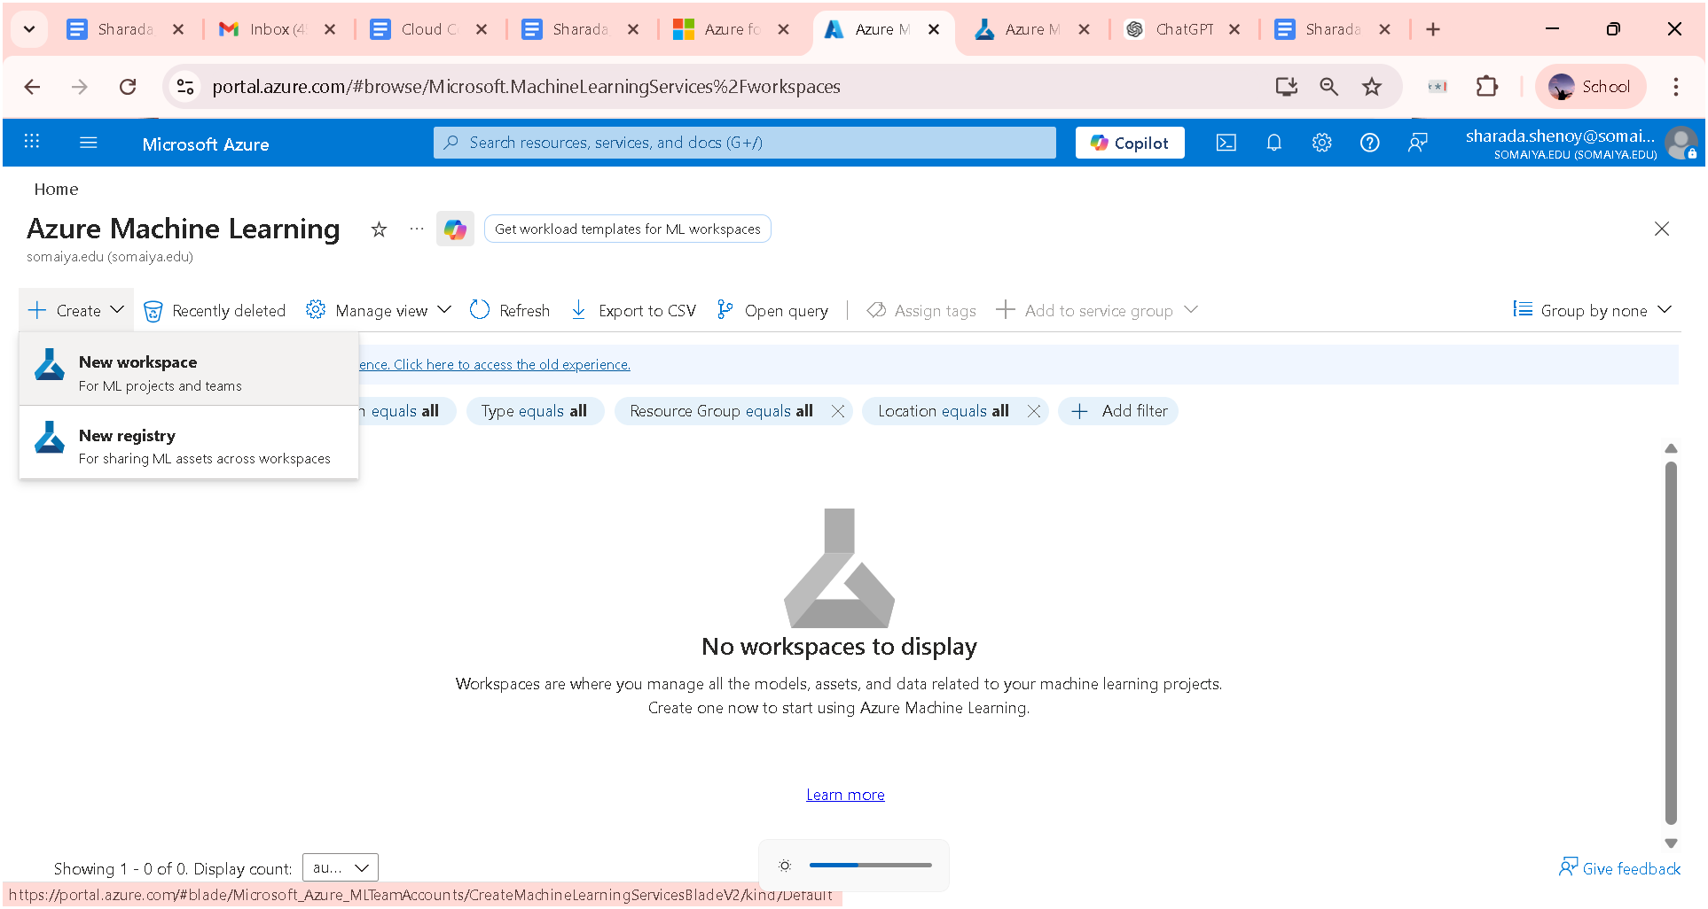
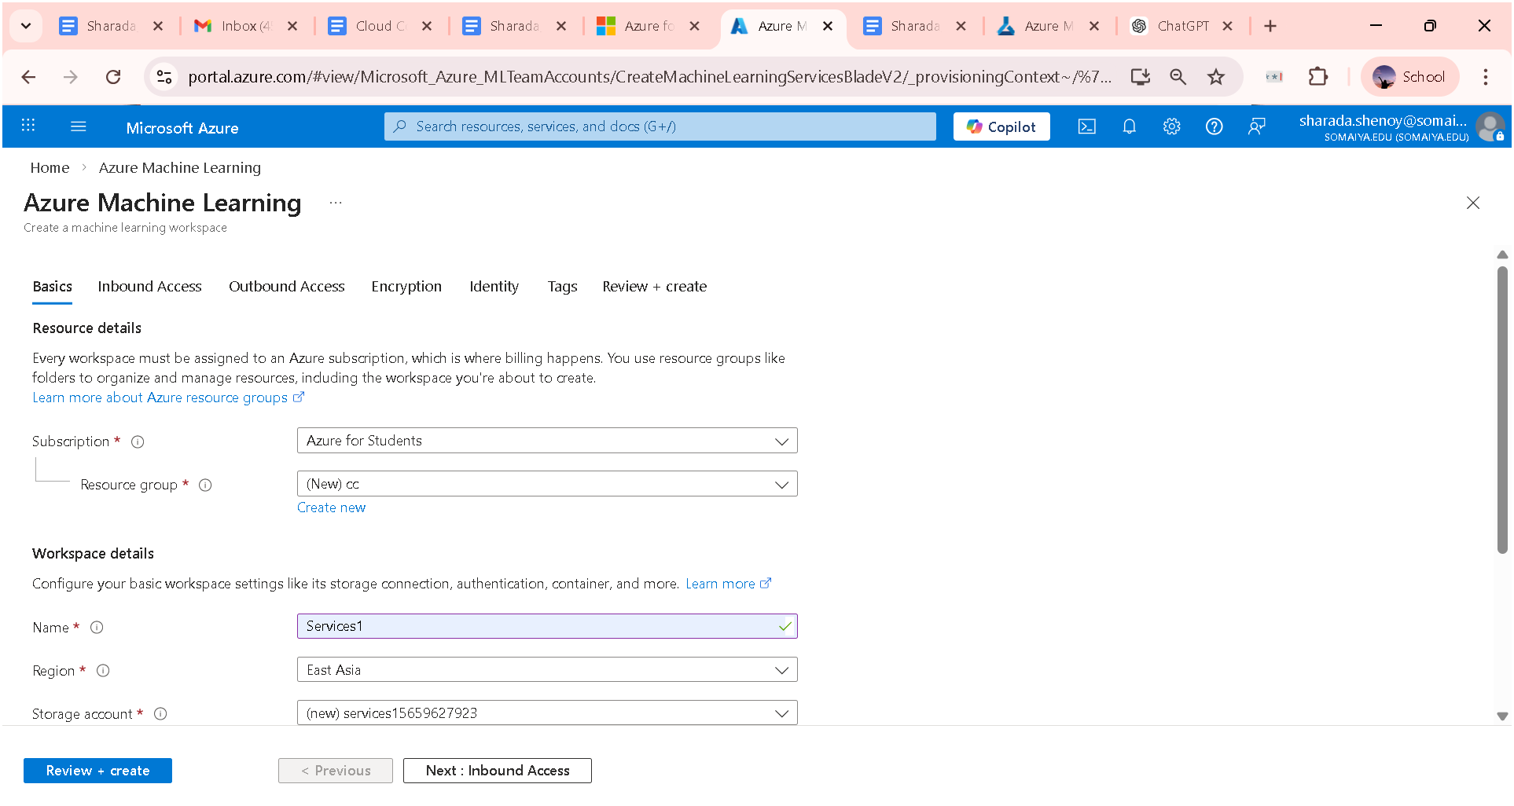

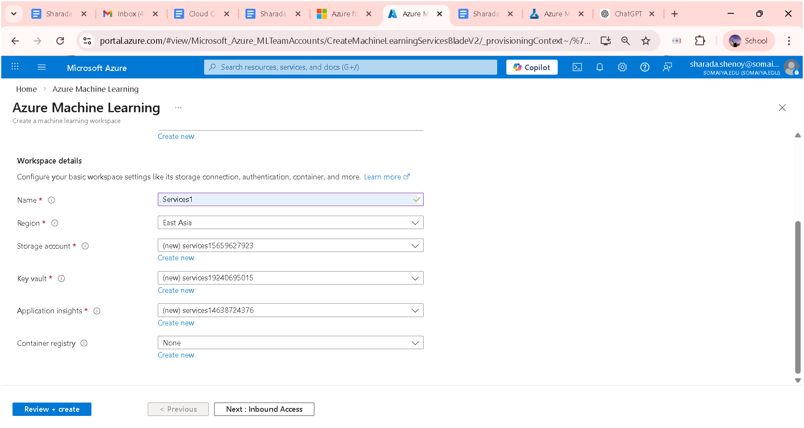

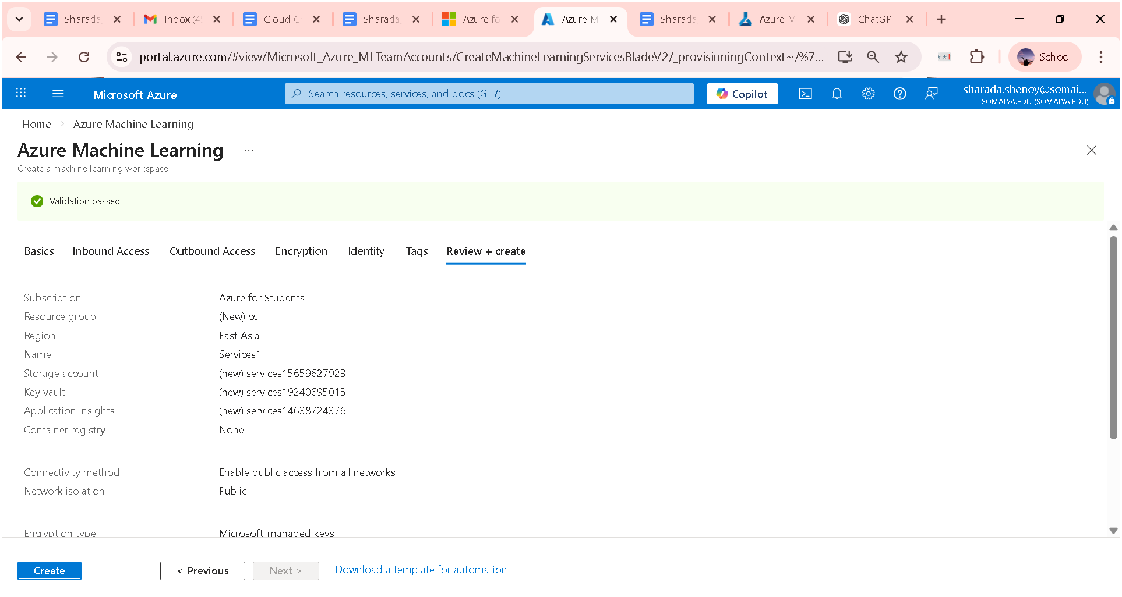

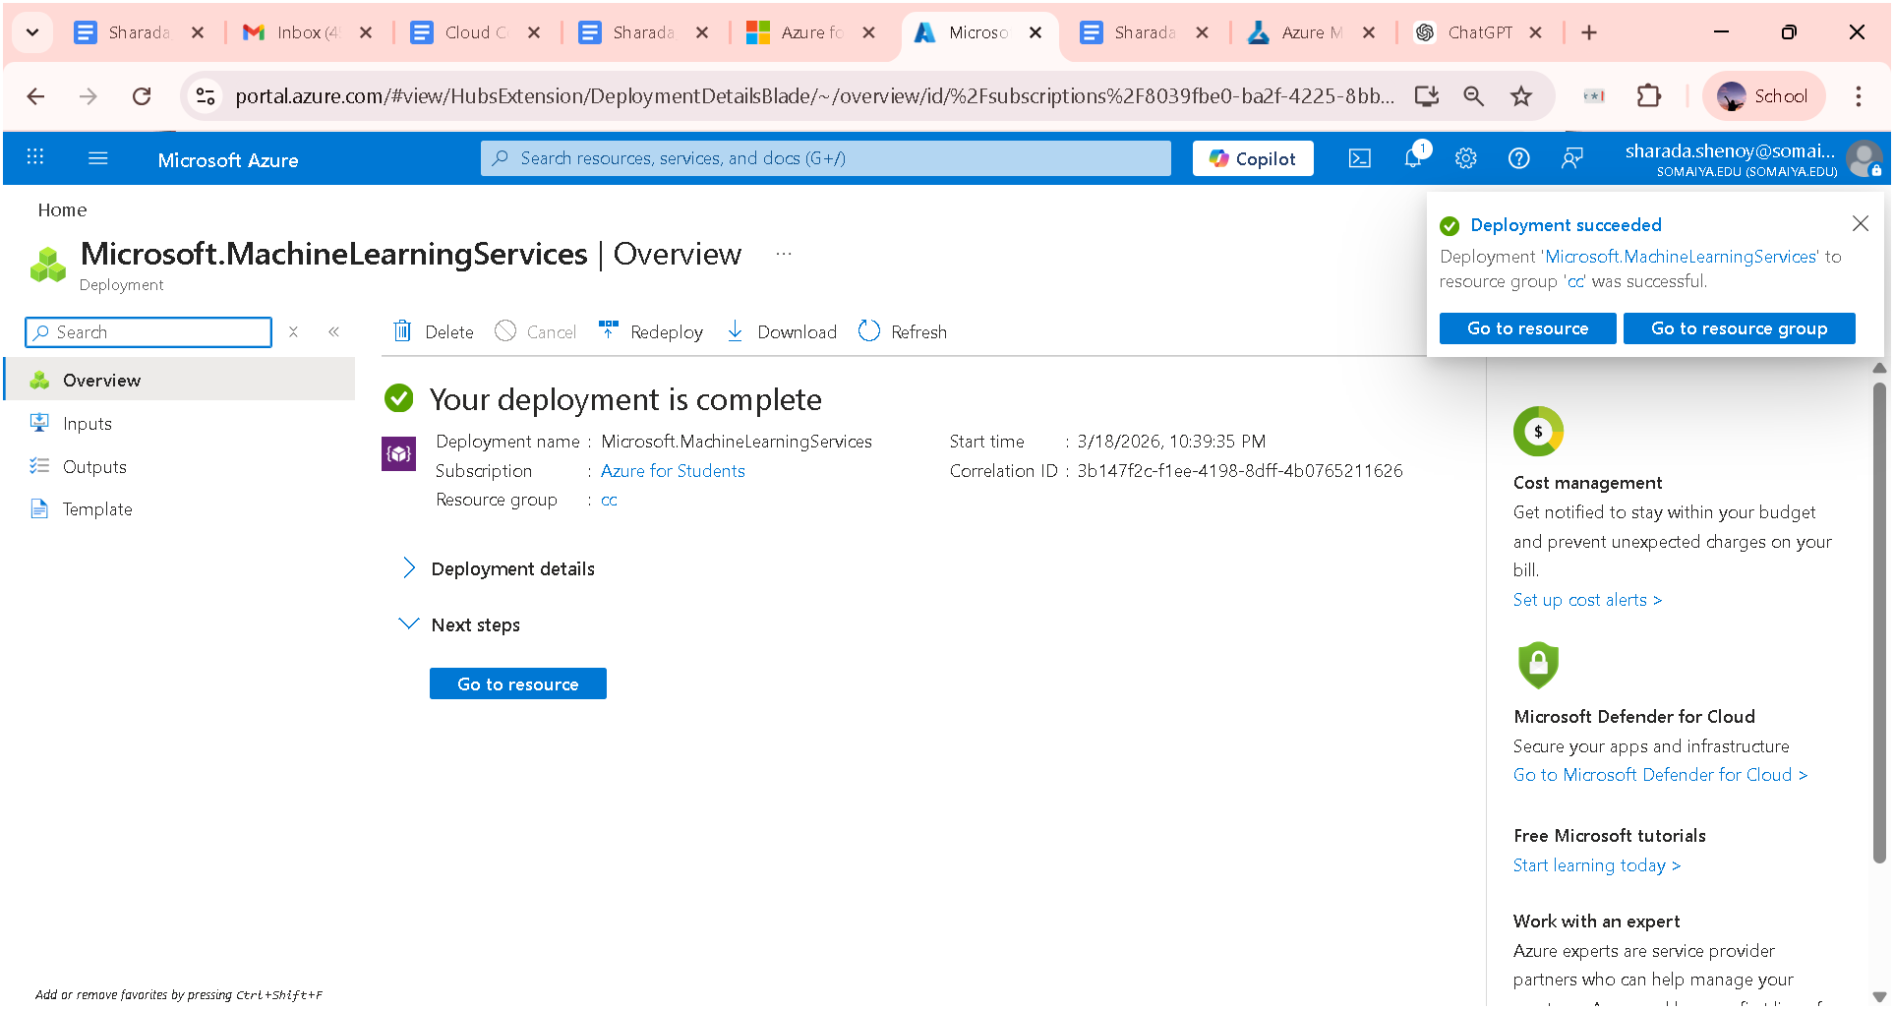

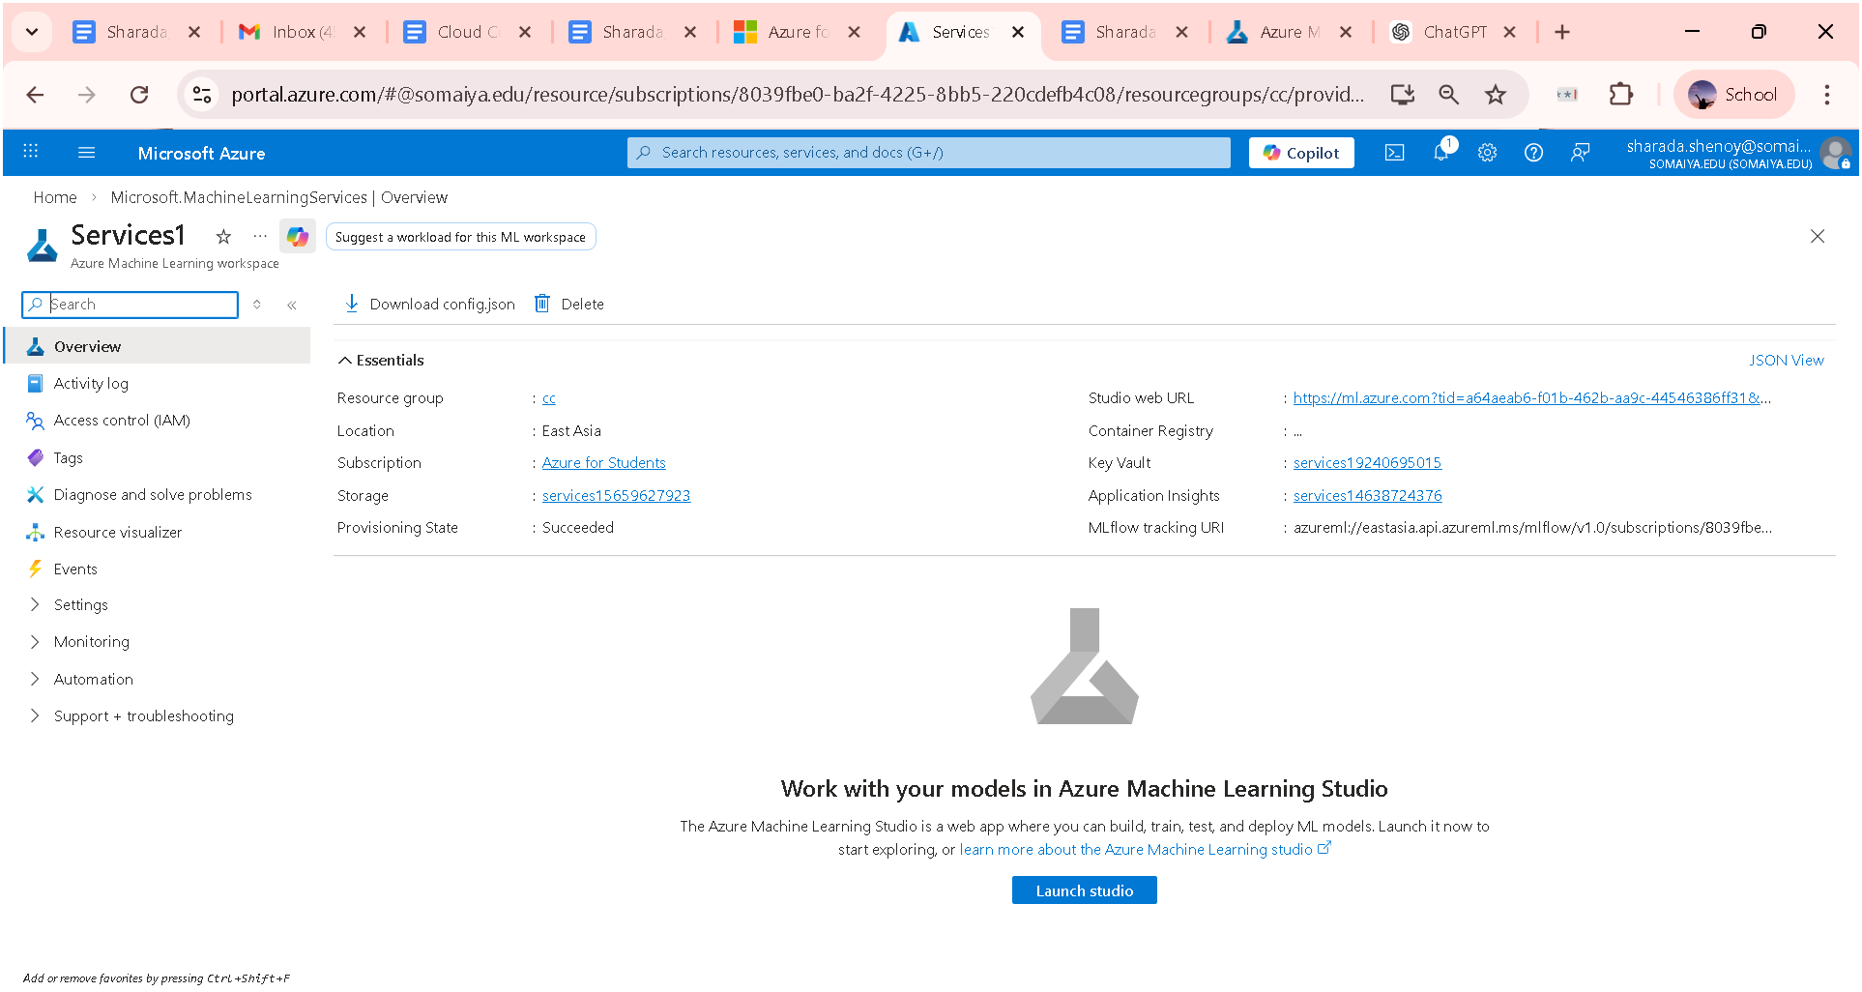

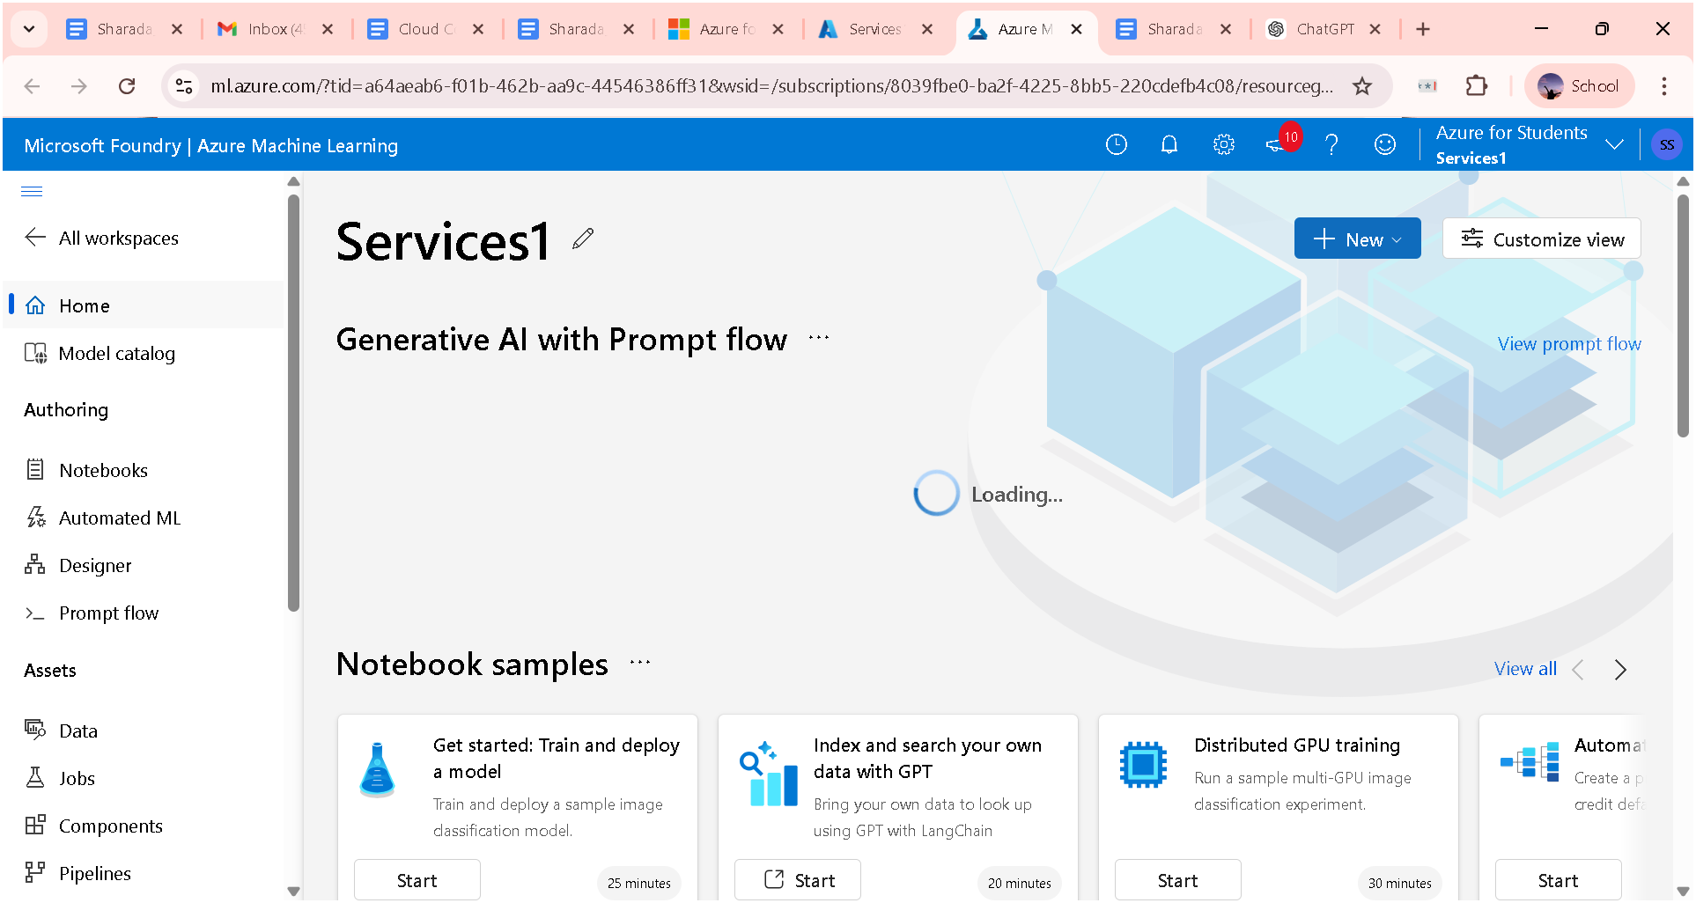

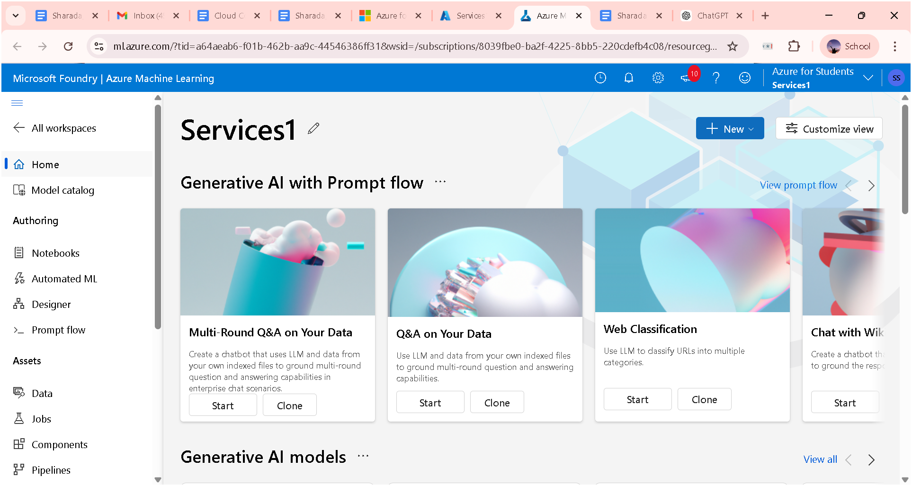

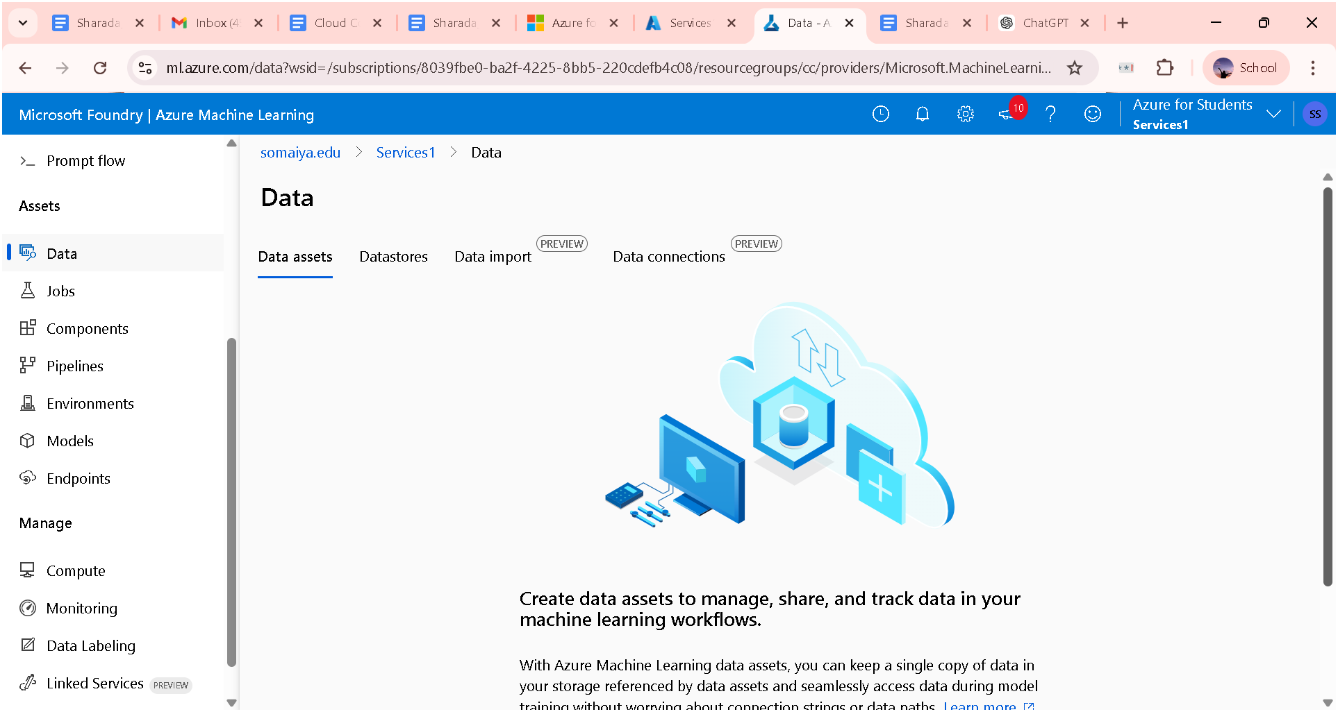

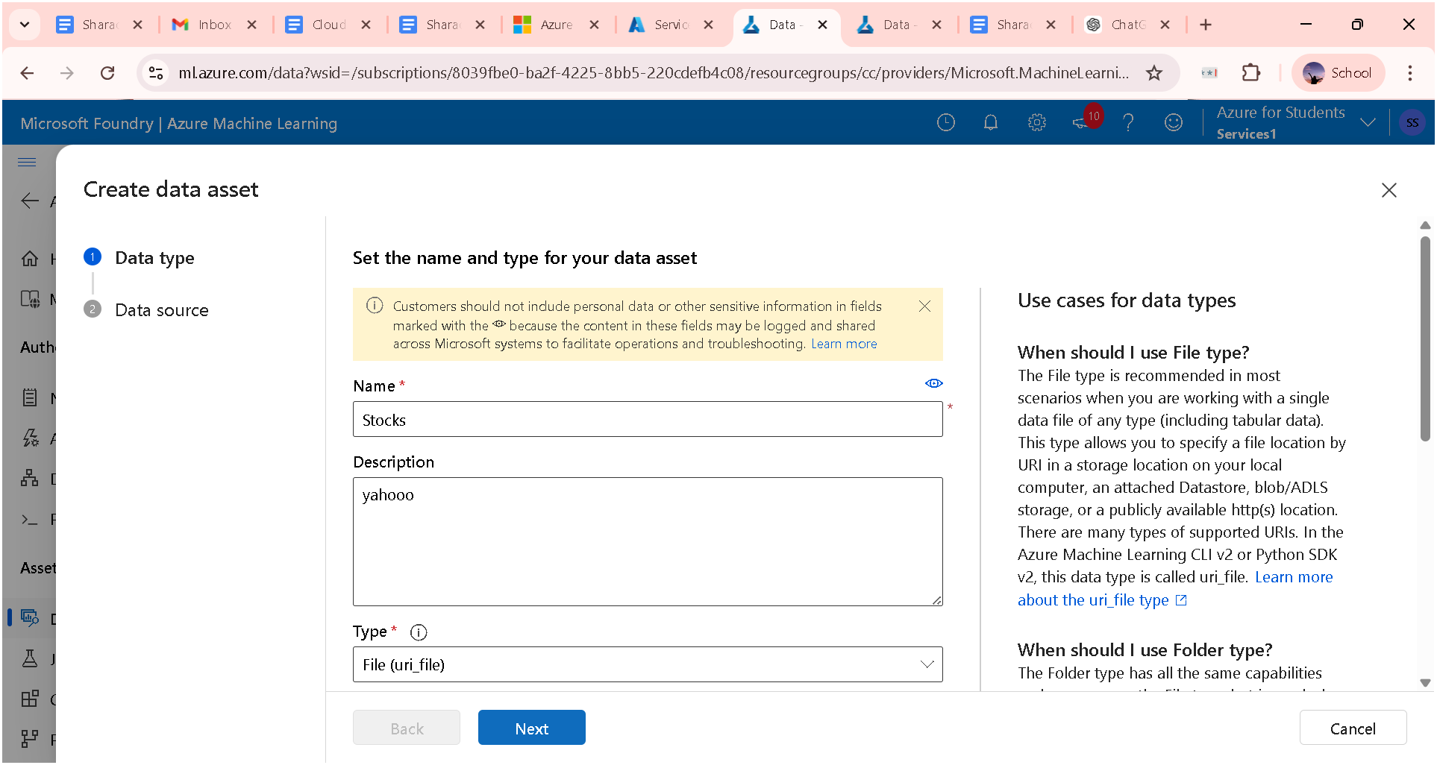
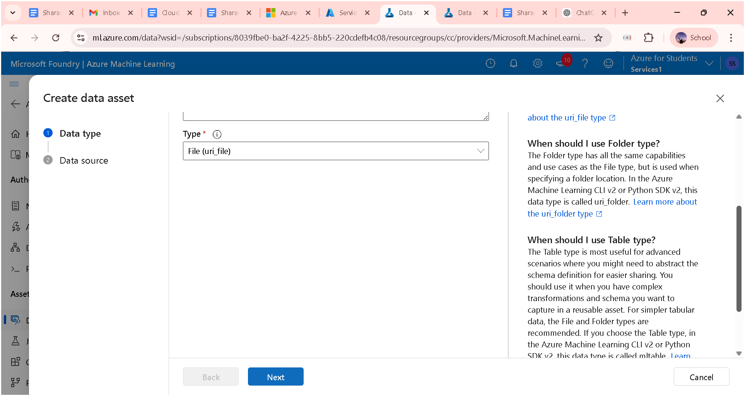

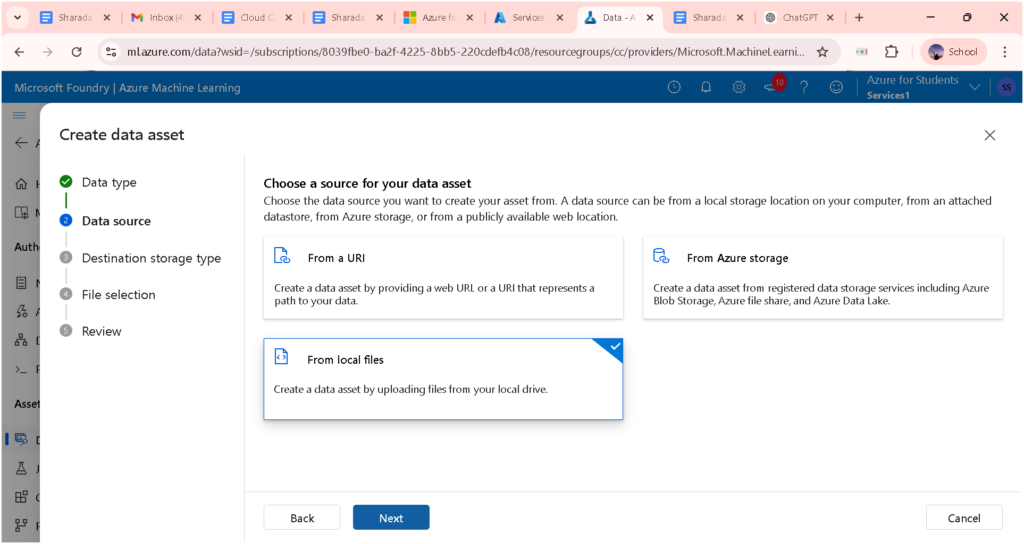

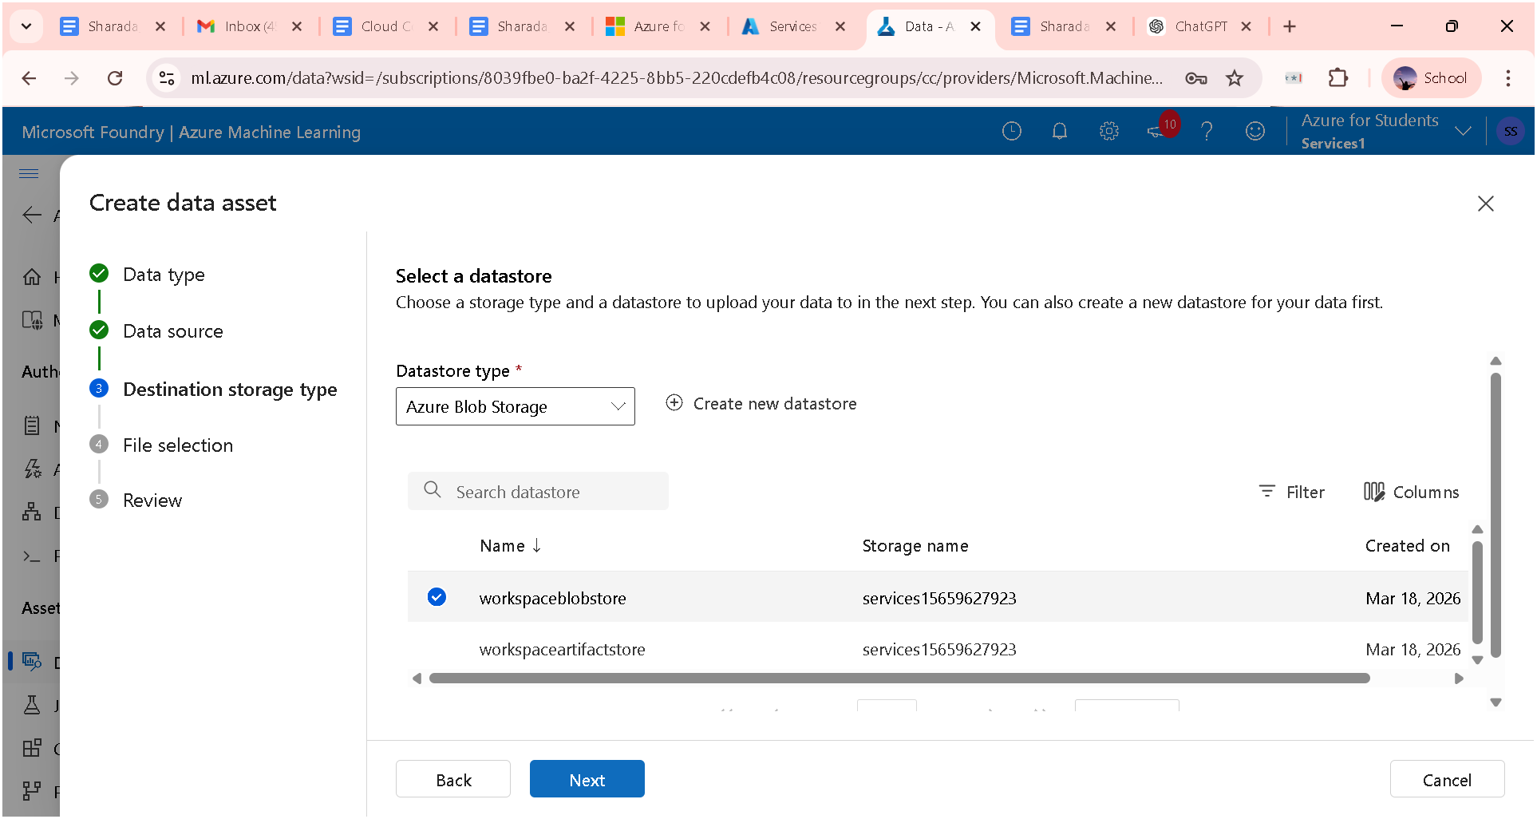

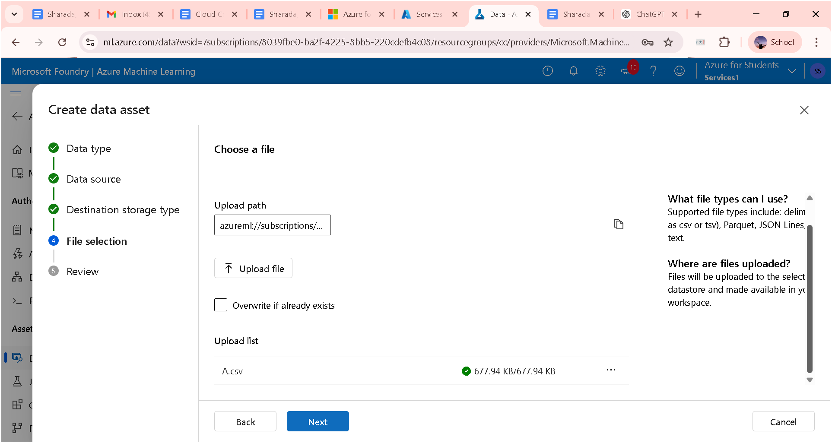
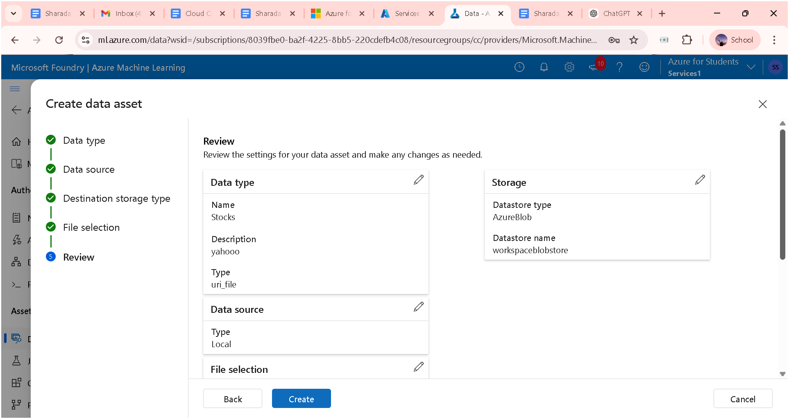

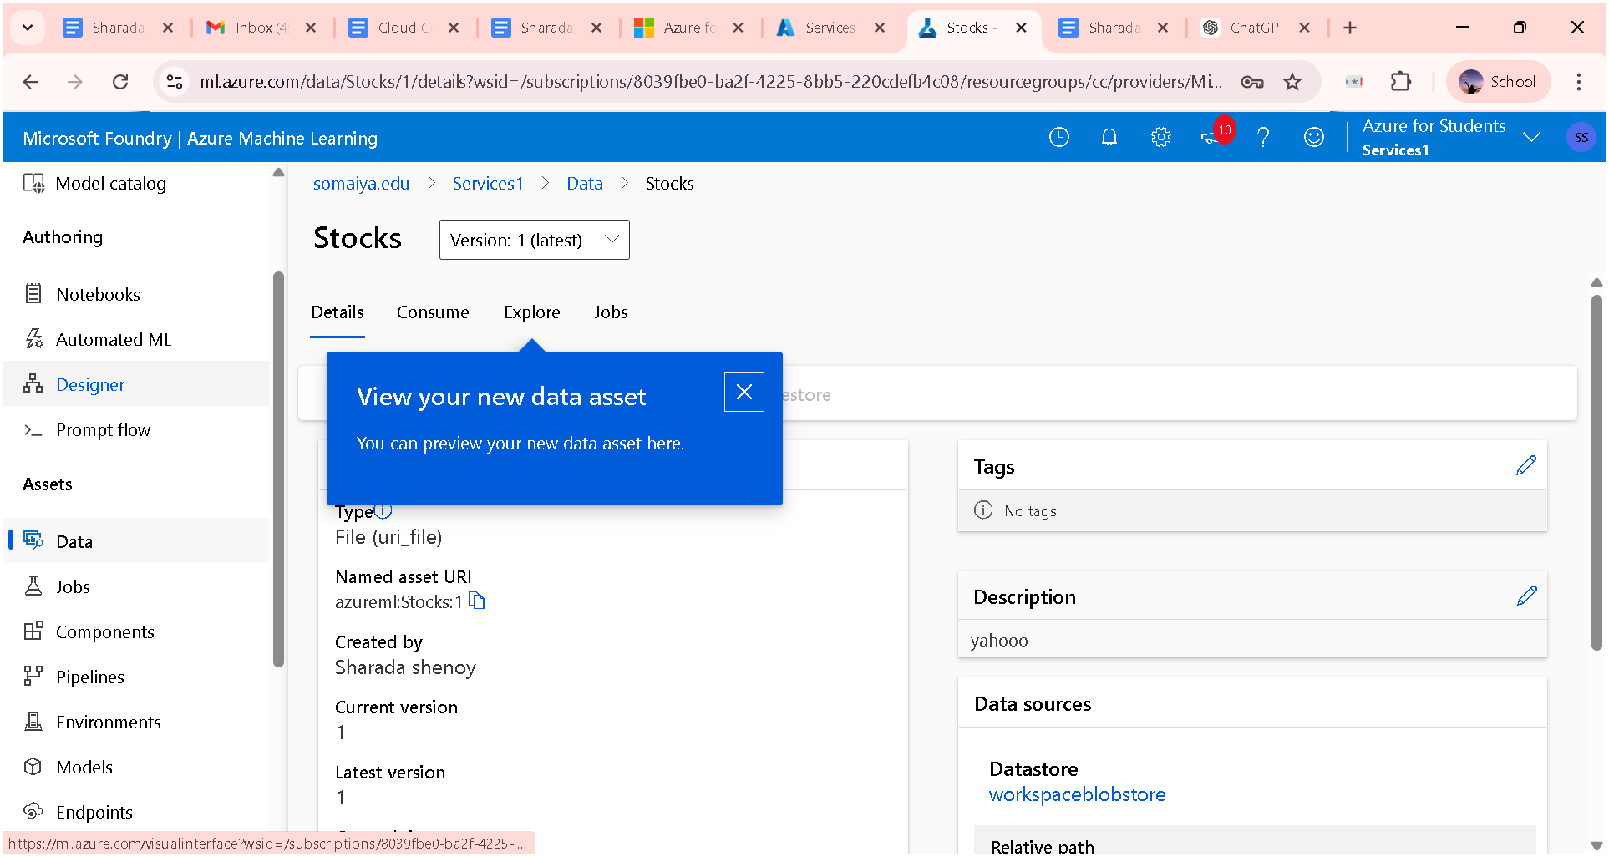

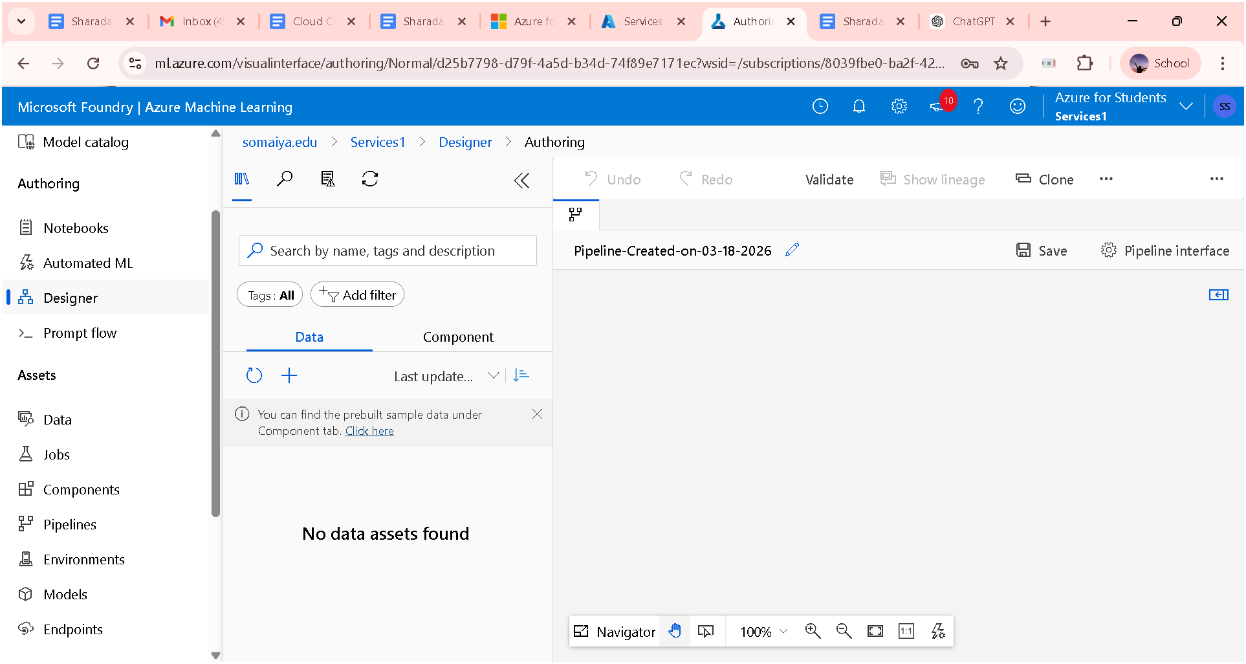

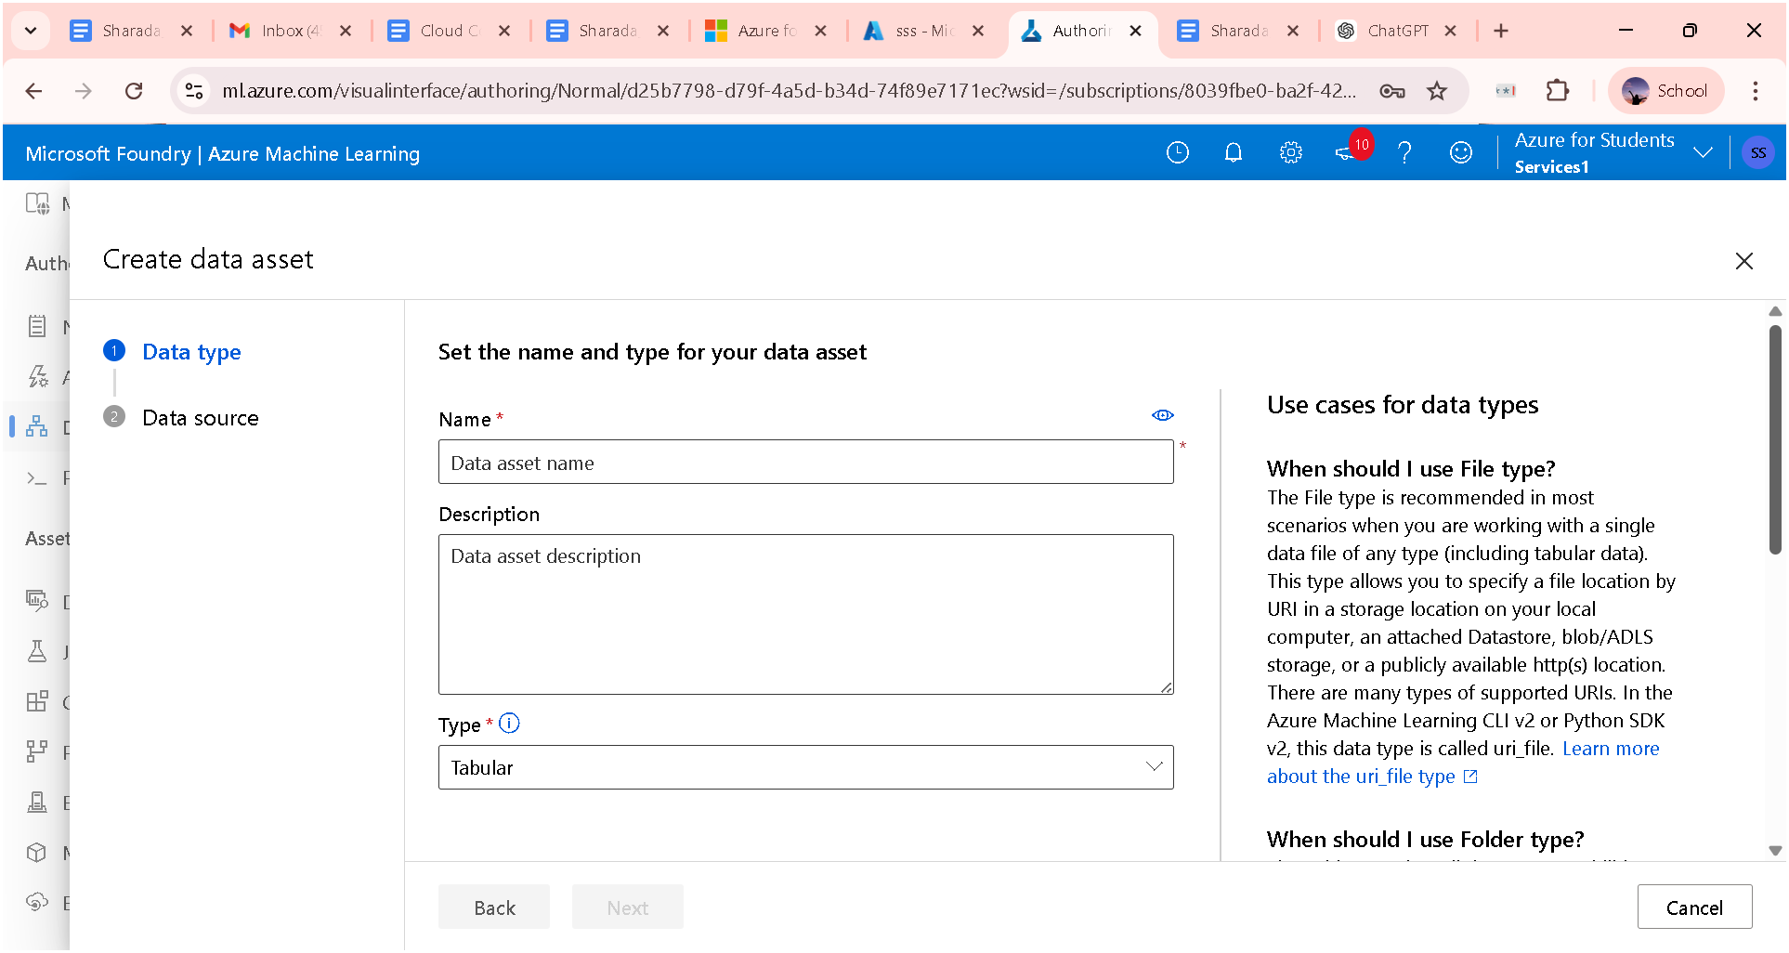

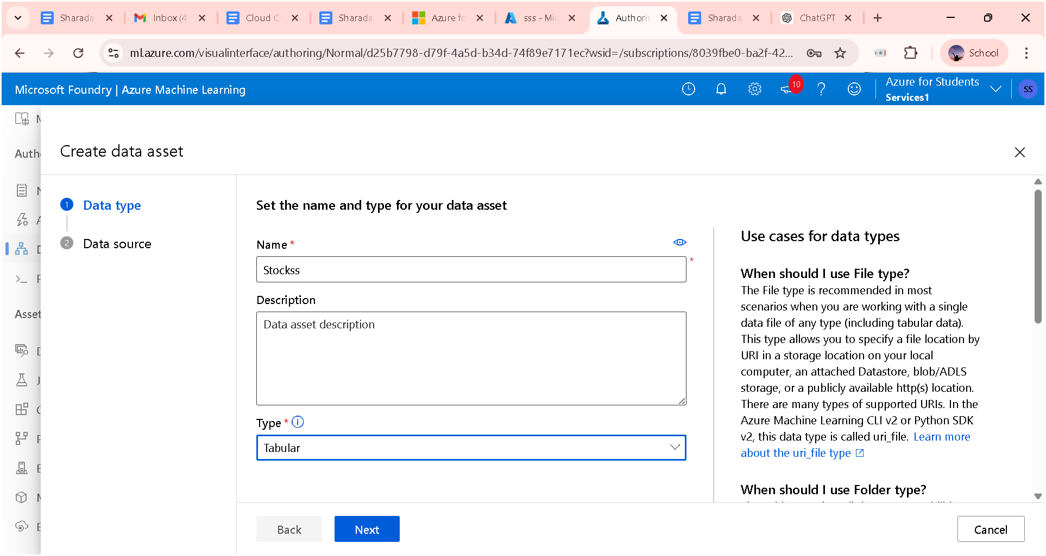
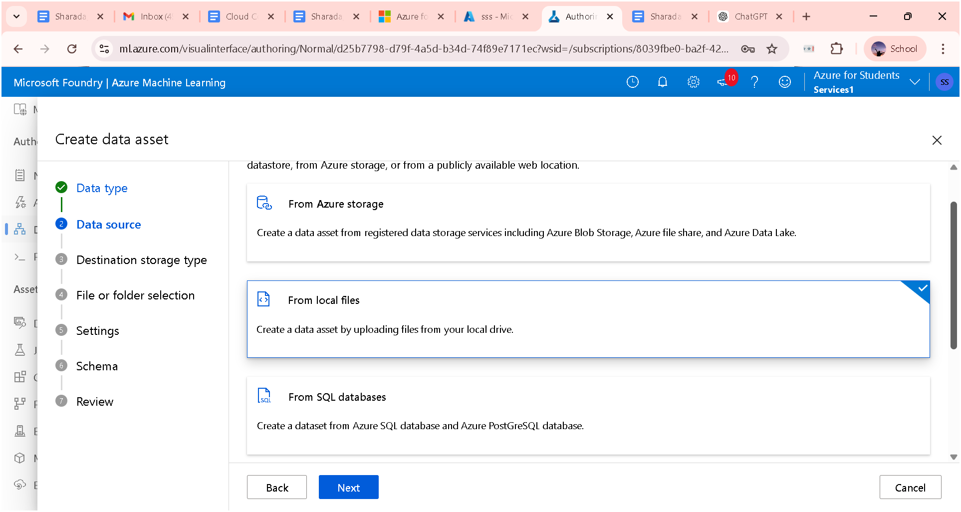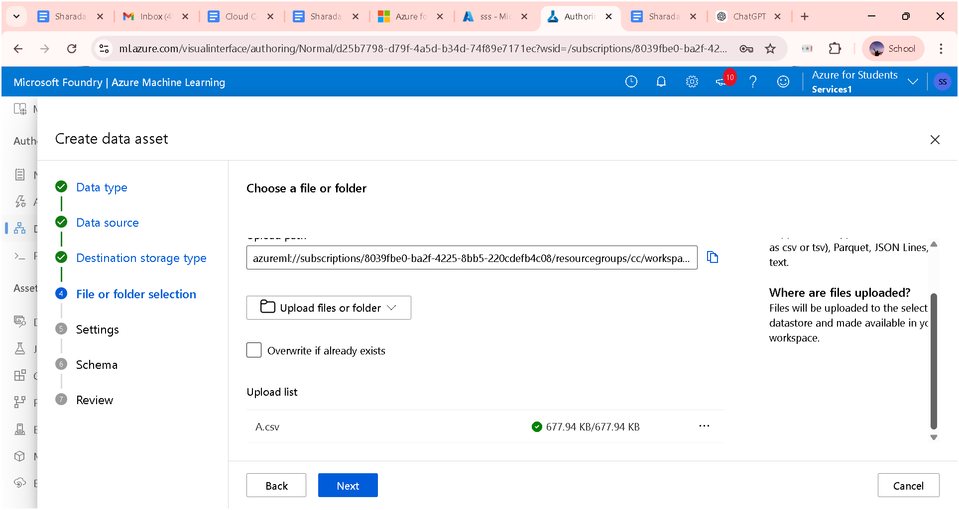
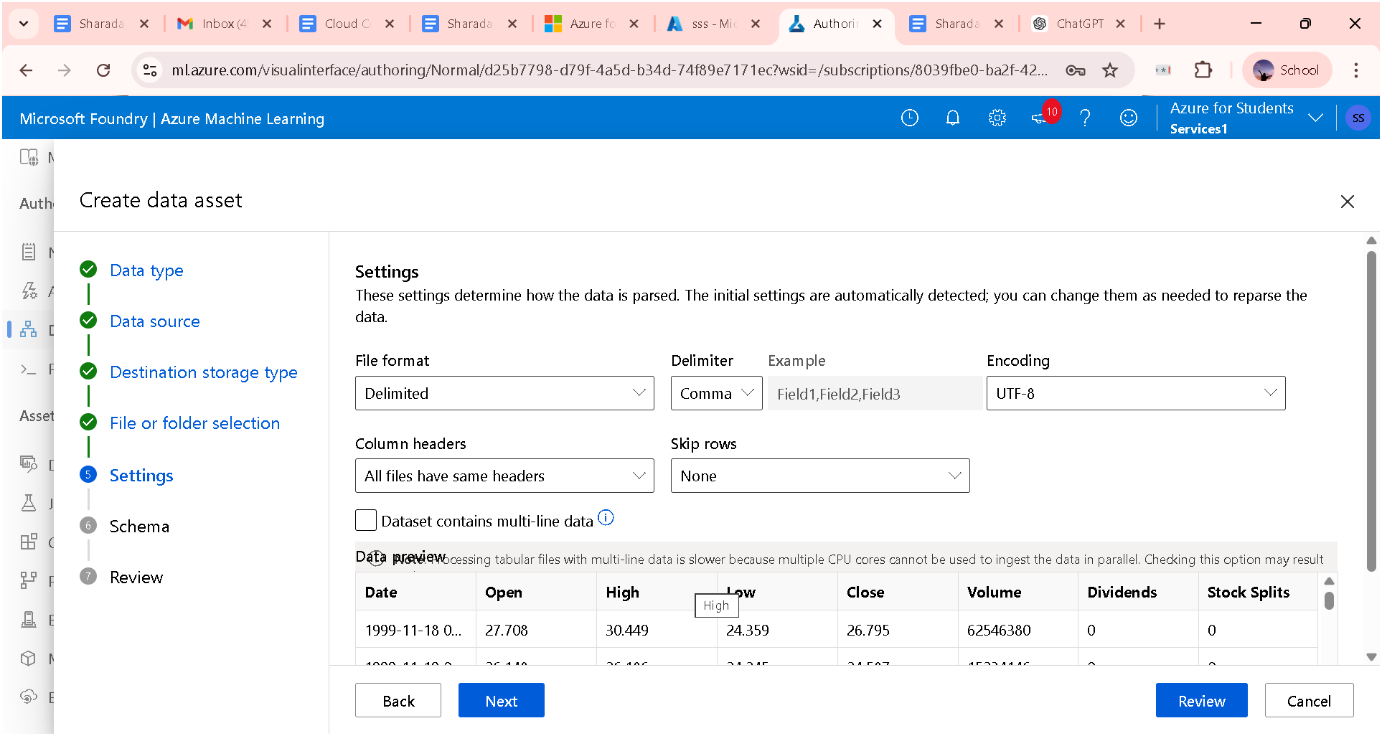

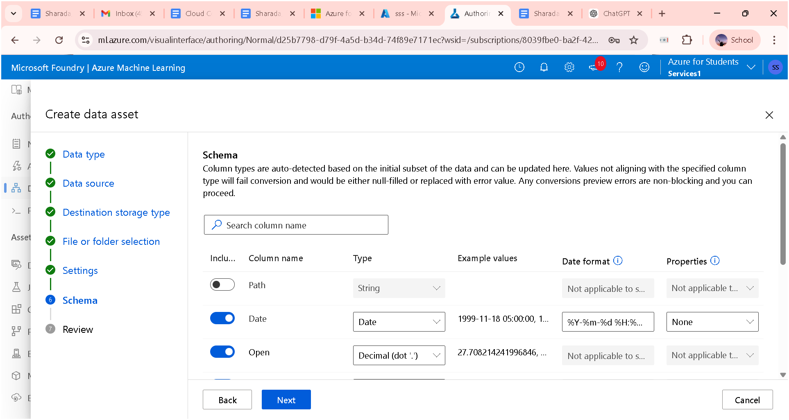

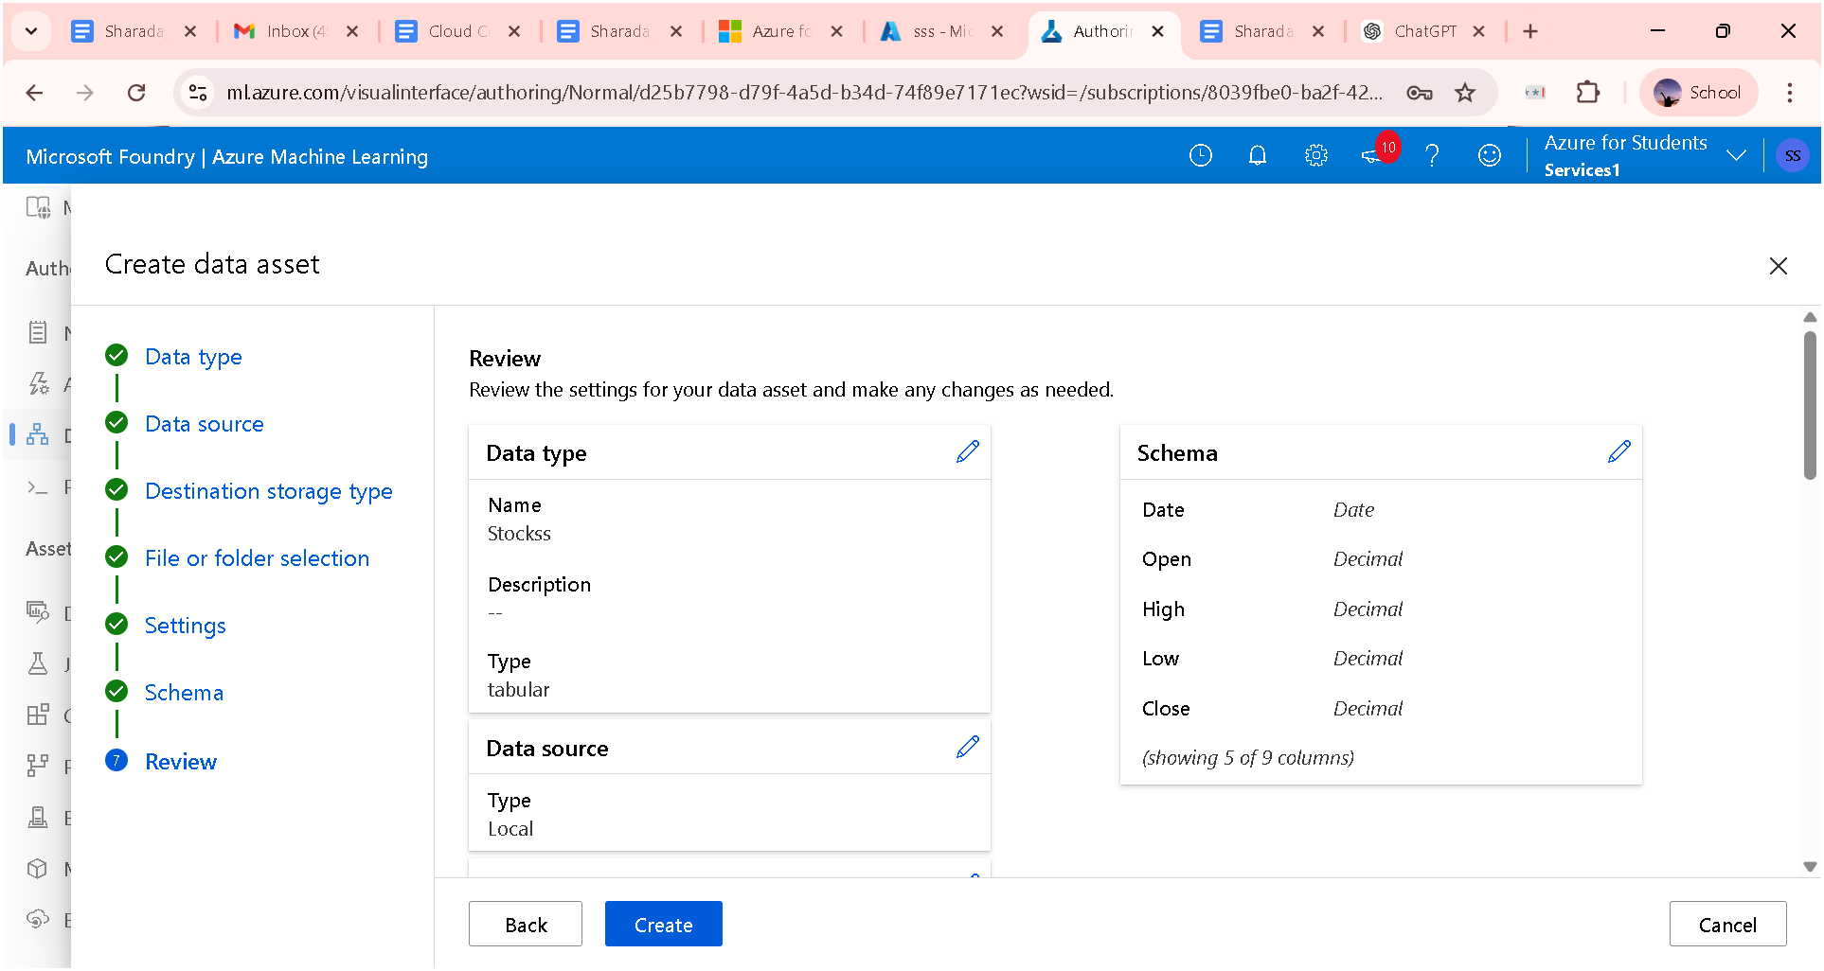

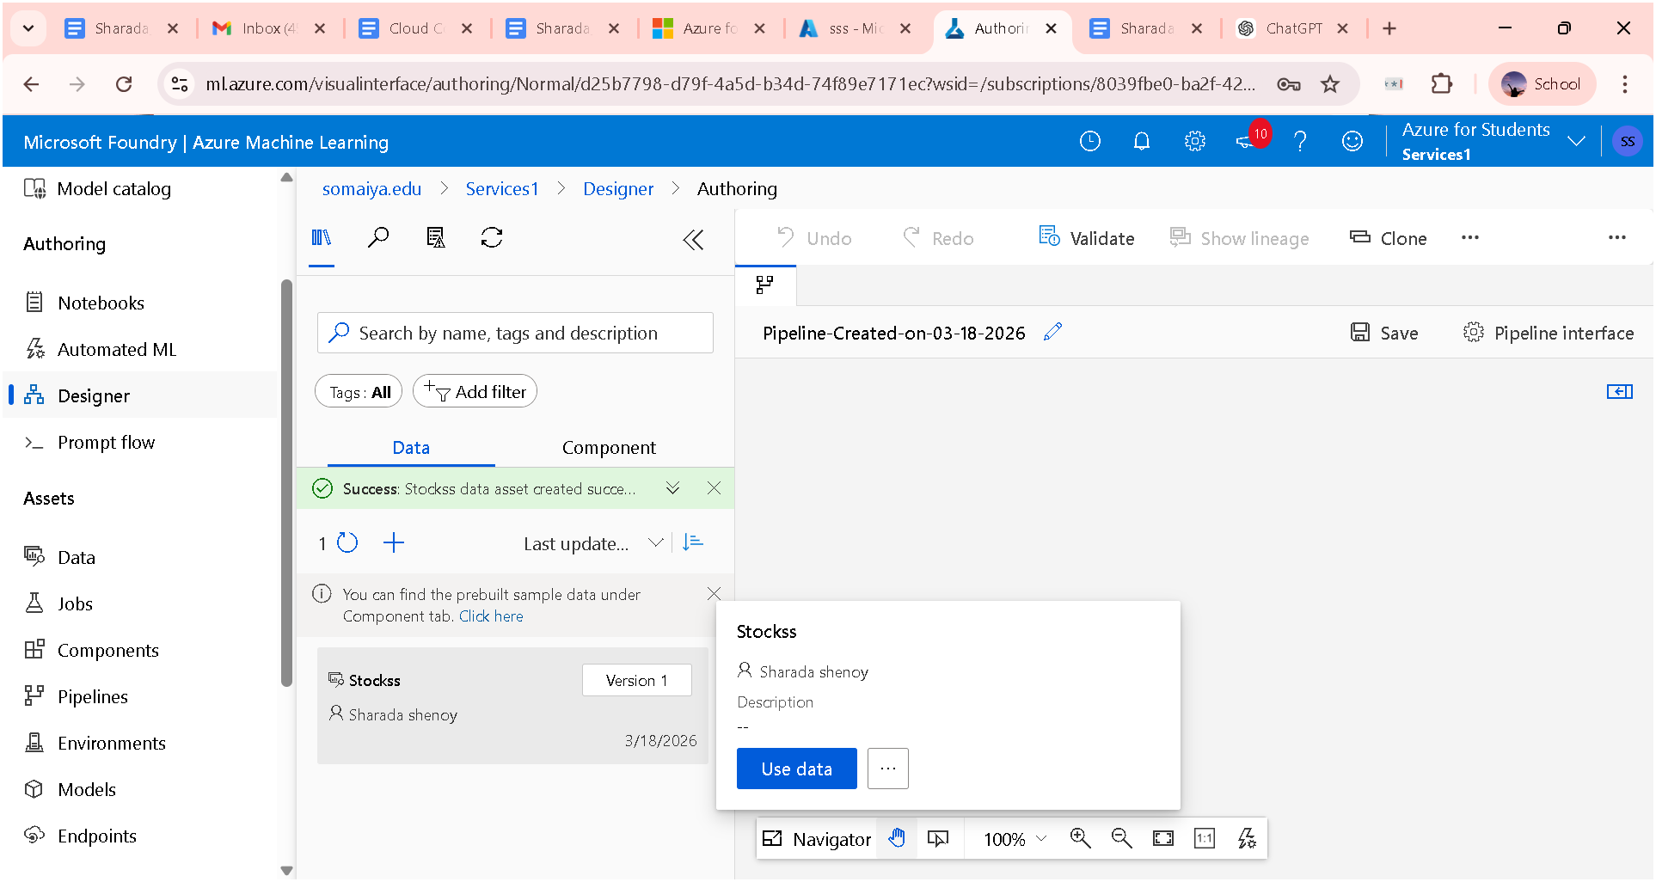

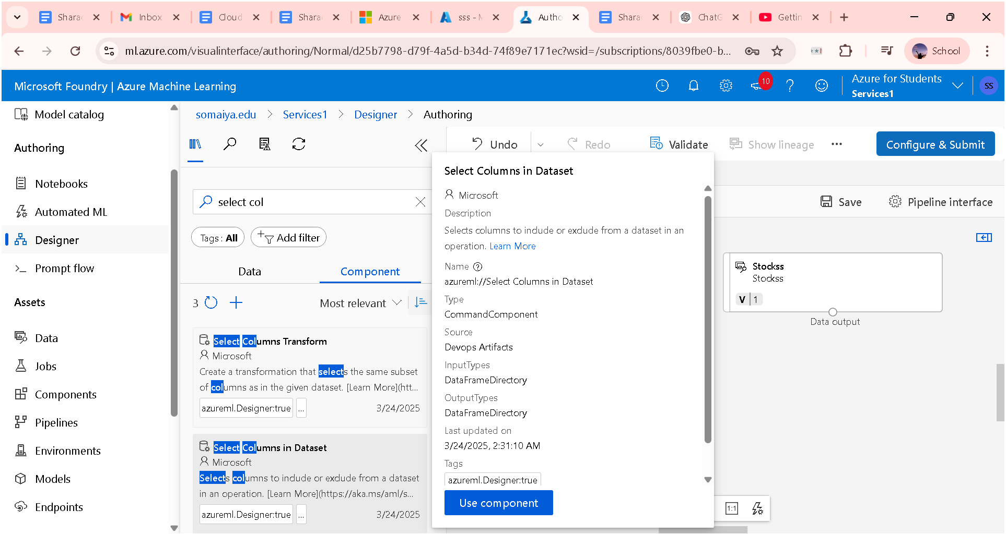

Practical 10 – Container (Docker)
Step 1: Click on the storage account in the microsoft azure account
Step 2: Fill the required fields.
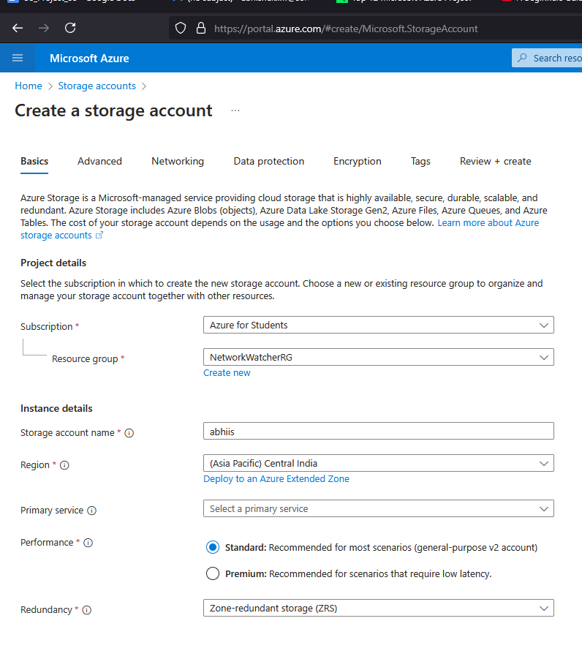

Step 3: Click on the data protection and select the enable soft delete for container
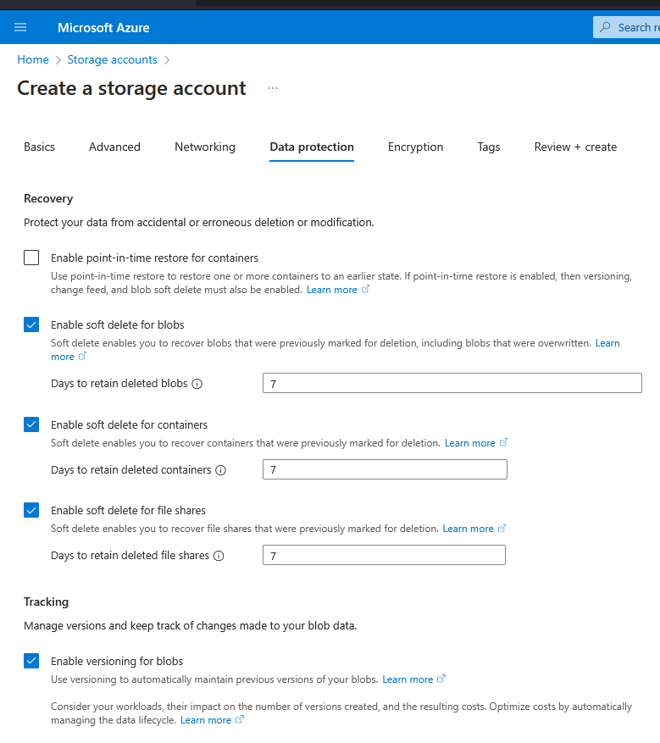
Step 4:- Review + create & deploy the project.
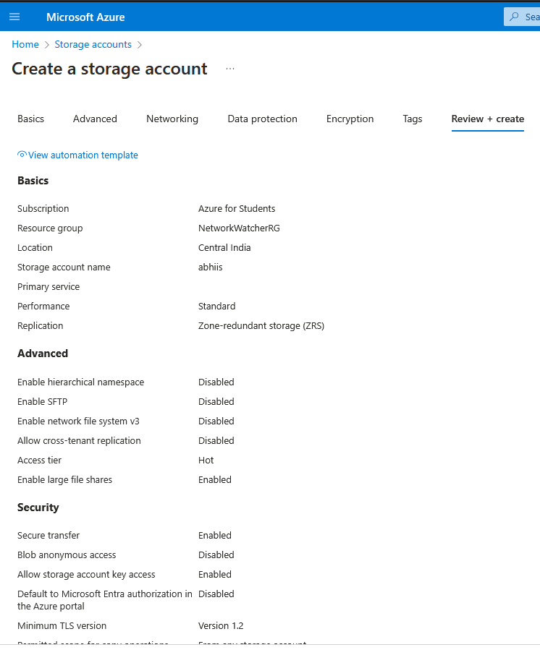

Step 5: Click on the resources and click on the data storage .
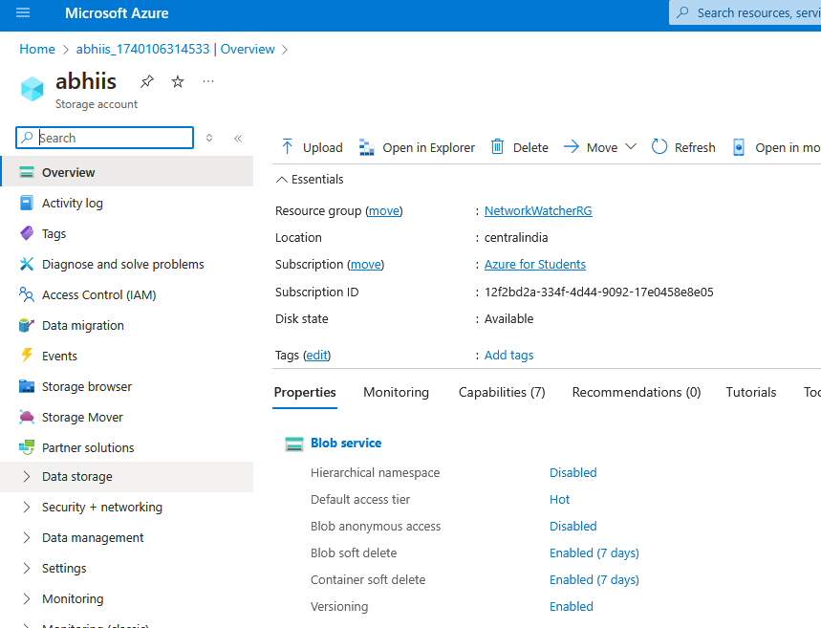
Step 6: Create an container with name as data and click on the create tab
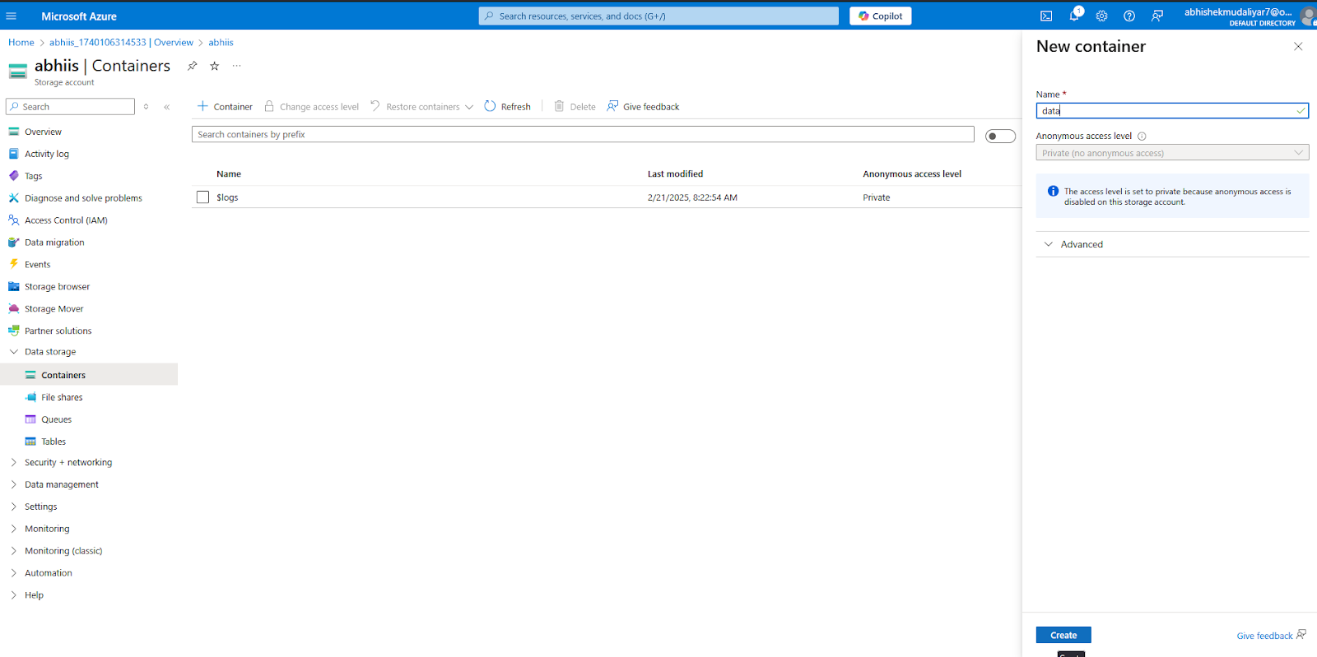

Step 7: To generate the SAS
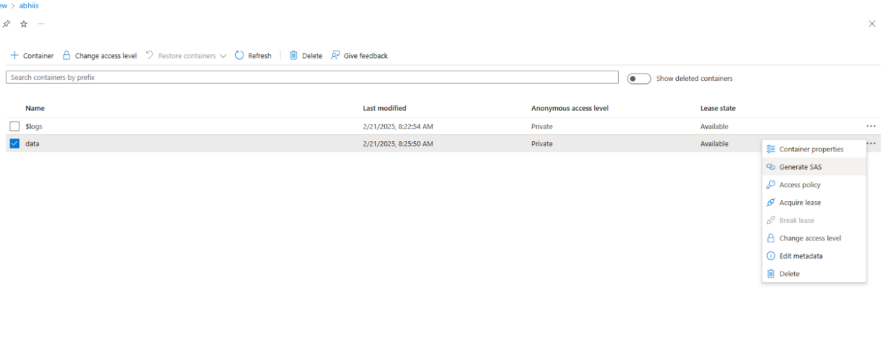
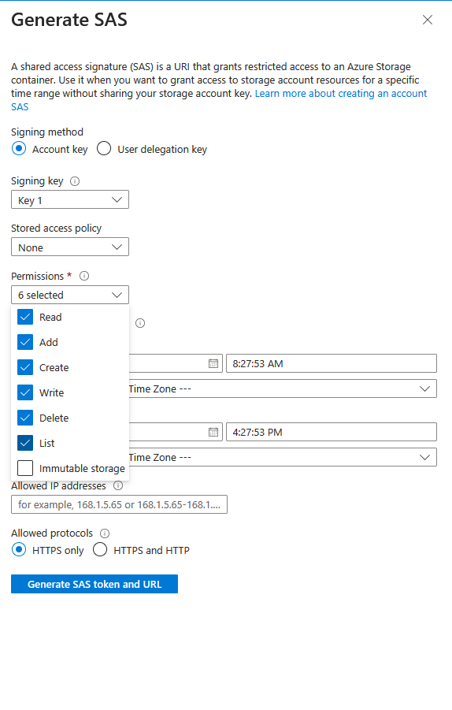
Click on the GENERATE SAS token and url
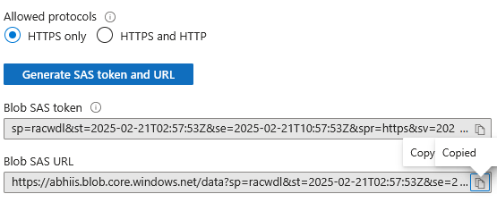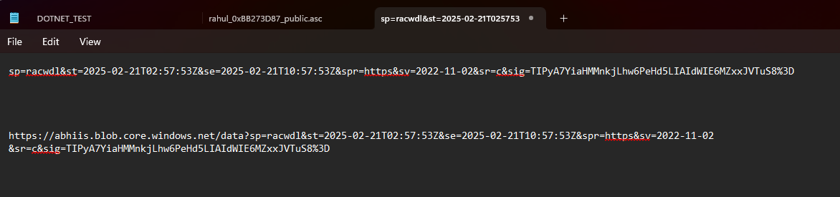

Step 8: Go to your cmd prompt
Before that change the environmental variables
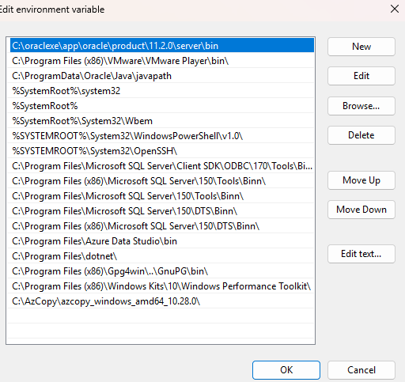
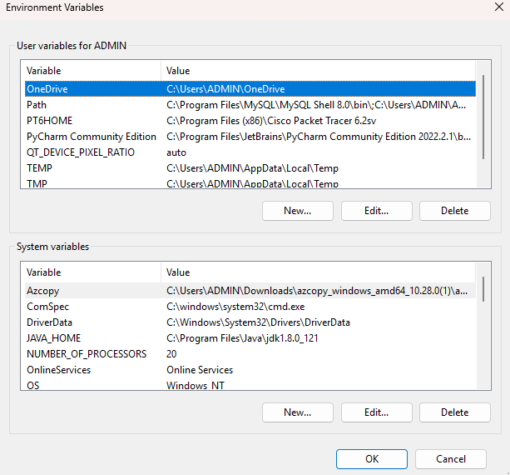
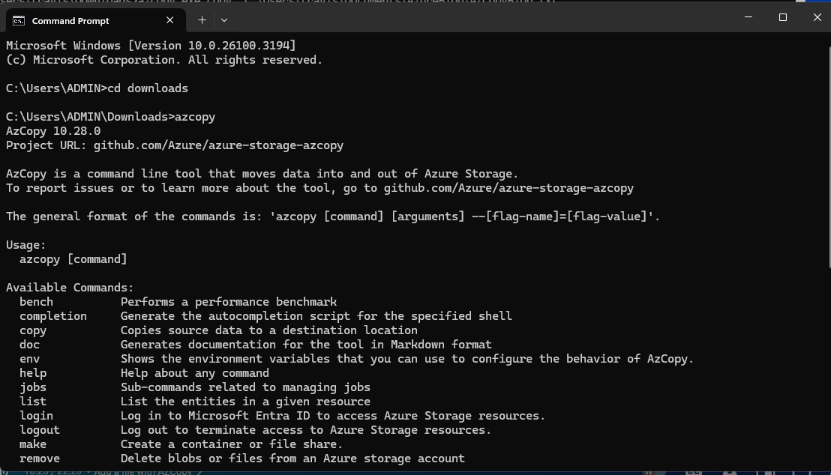
Step 9 :- Check the container to known whether the azcopy.exe is available
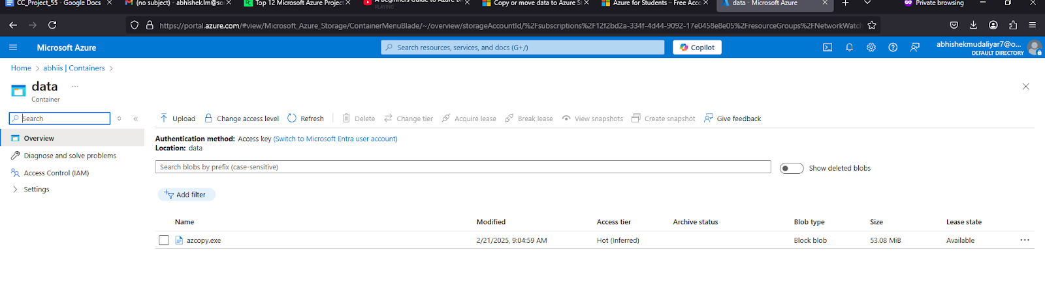
Step 10:- After that you have to download the azure storage explorer
https://learn.microsoft.com/en-us/azu…
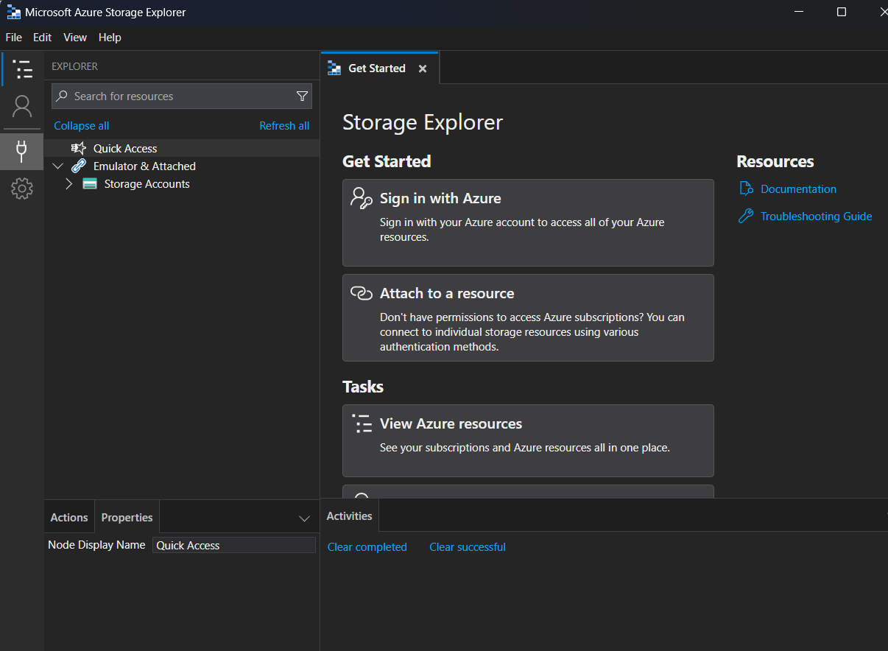

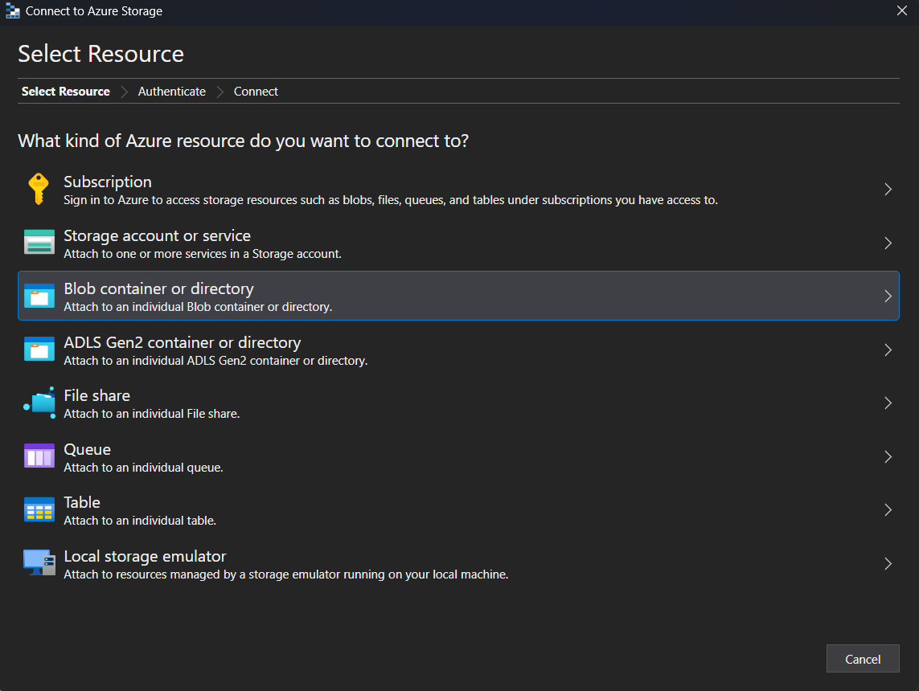
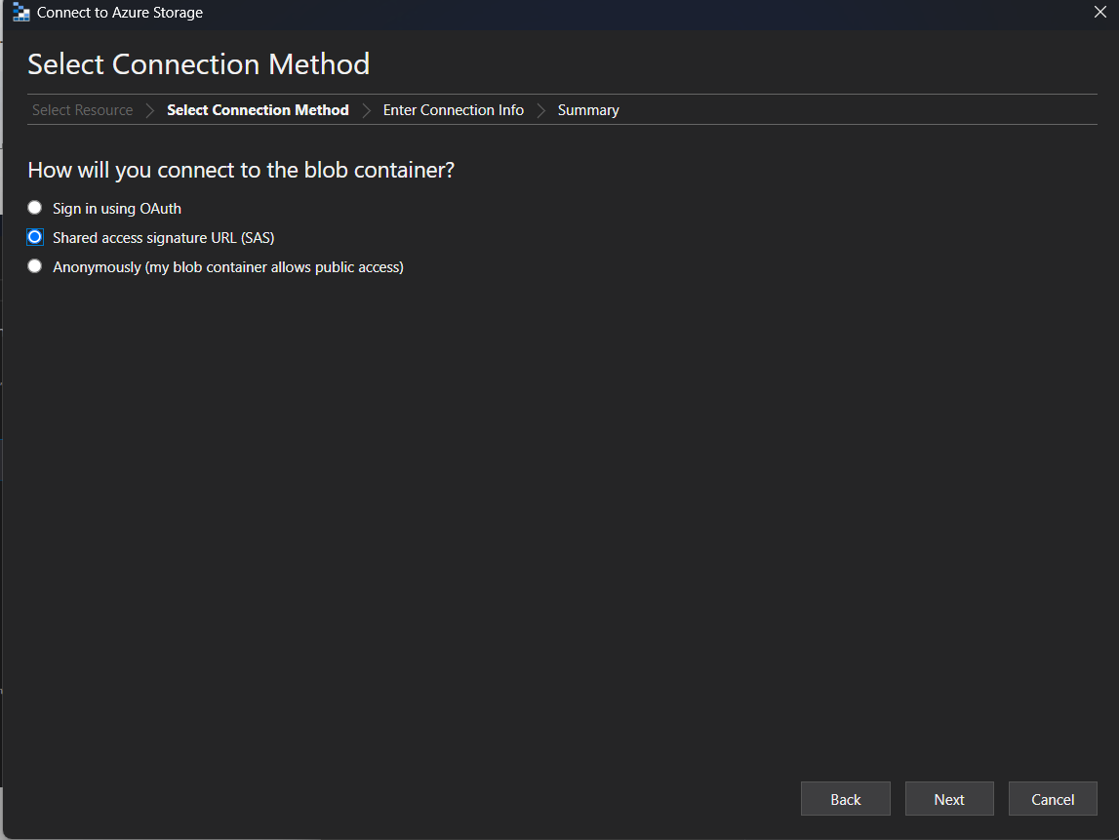
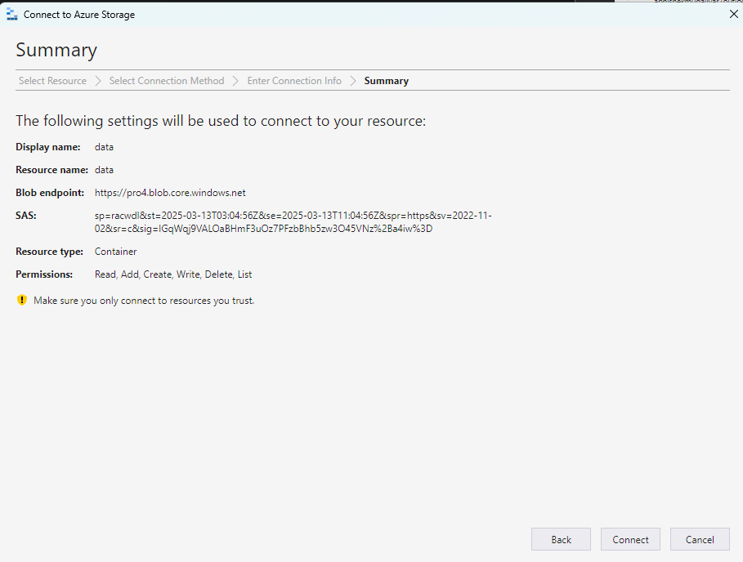
Enter your blob url
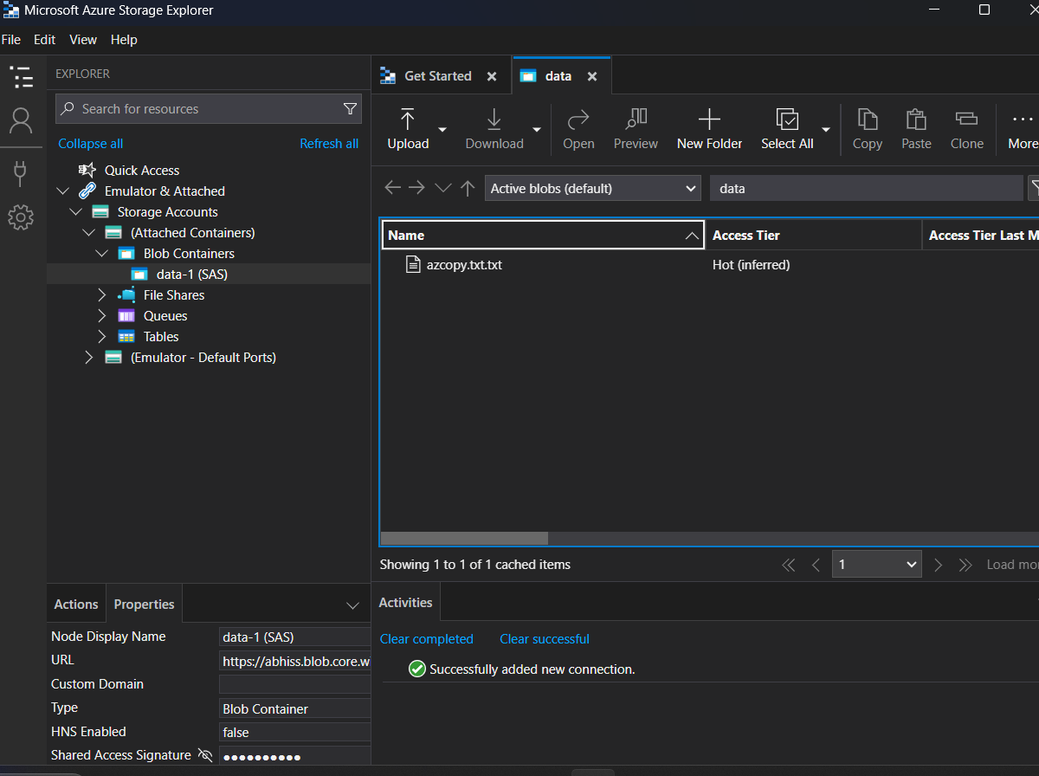
Go to action & then detach the container
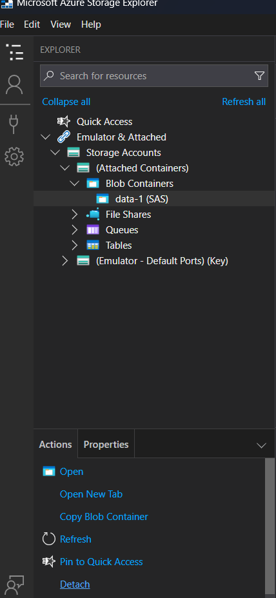

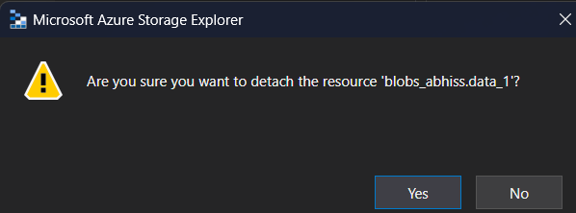
Sign in to your azure account
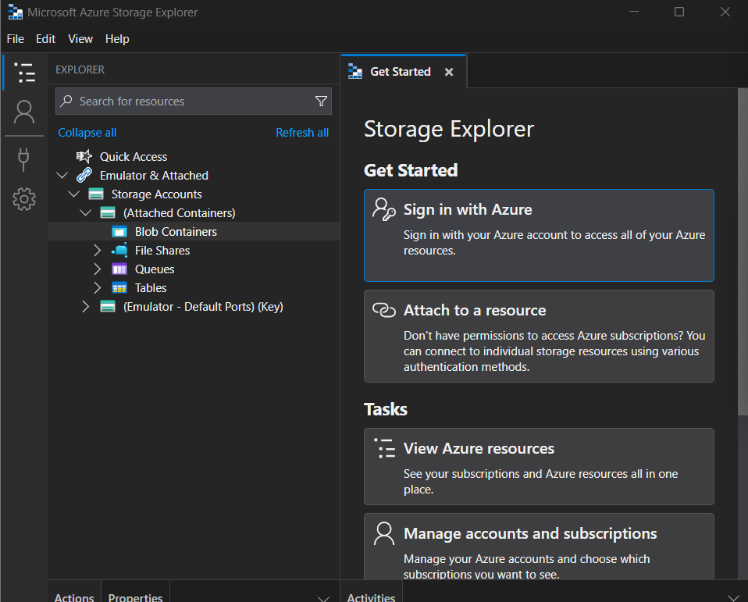

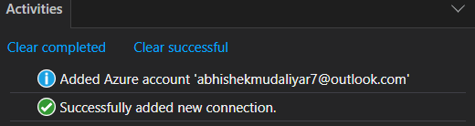
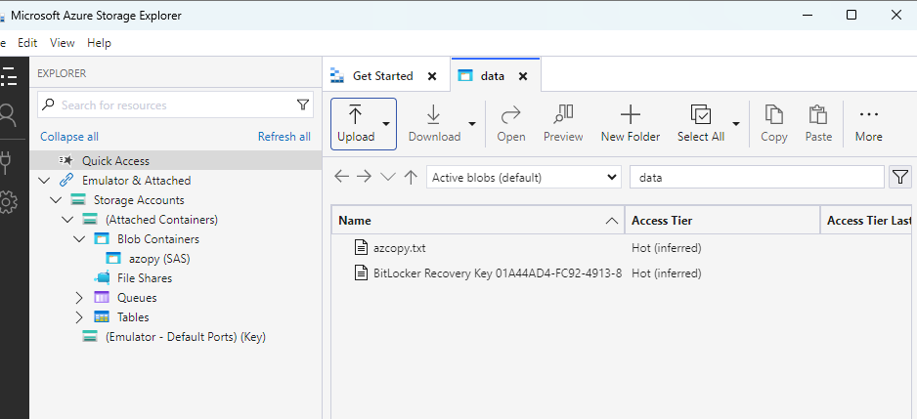
Upload another file from file storage app and see whether the file is been displayed in the Azure Website
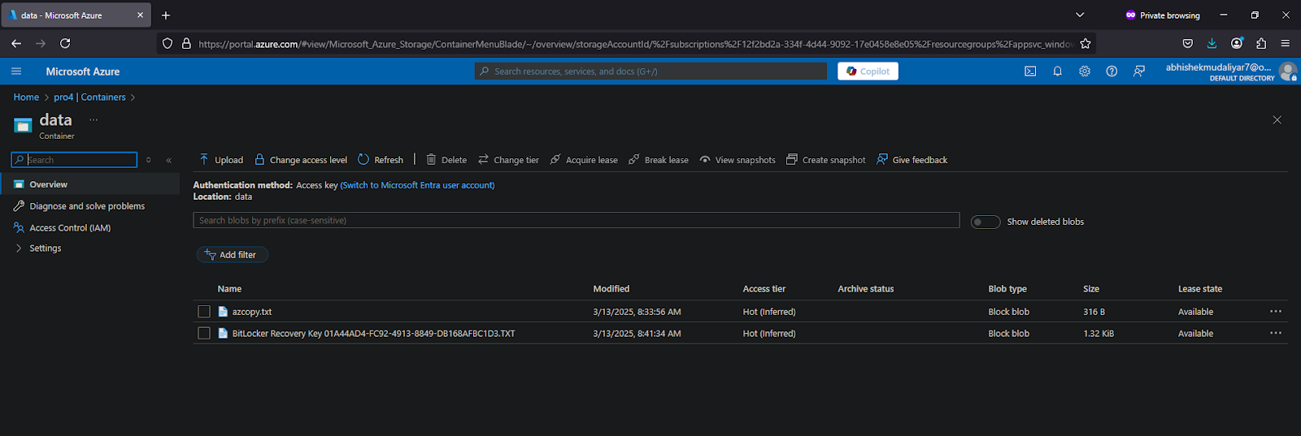

Practical 11
11A: Own Cloud
Step 1: Open and login to OwnCloud.
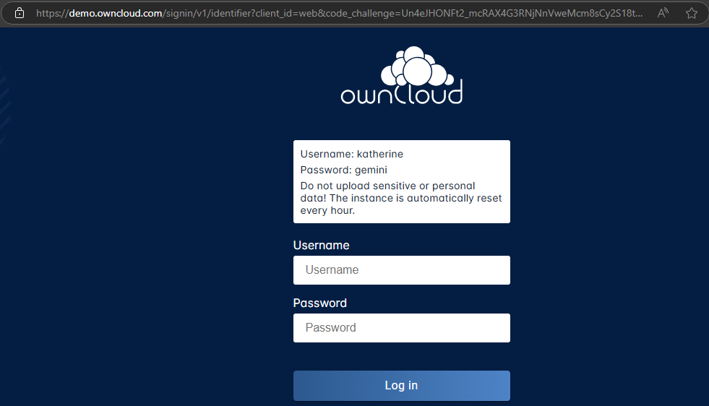
Step 2: Upload your files
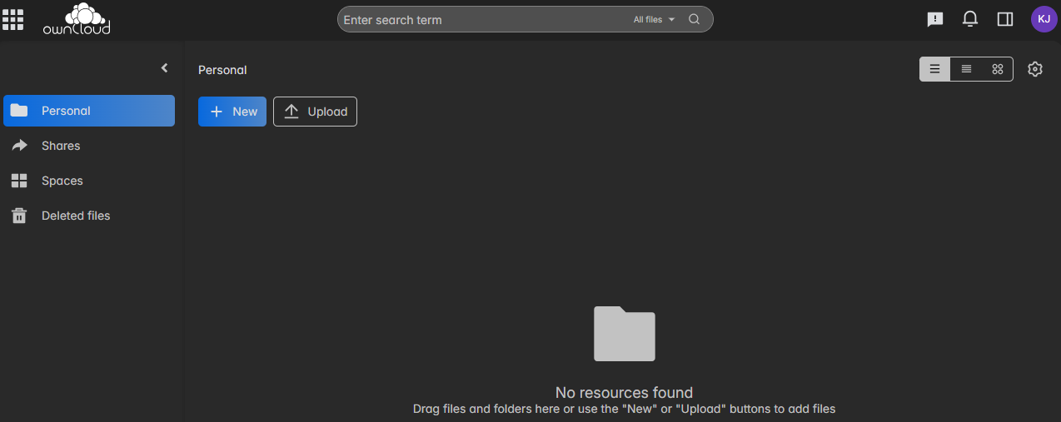
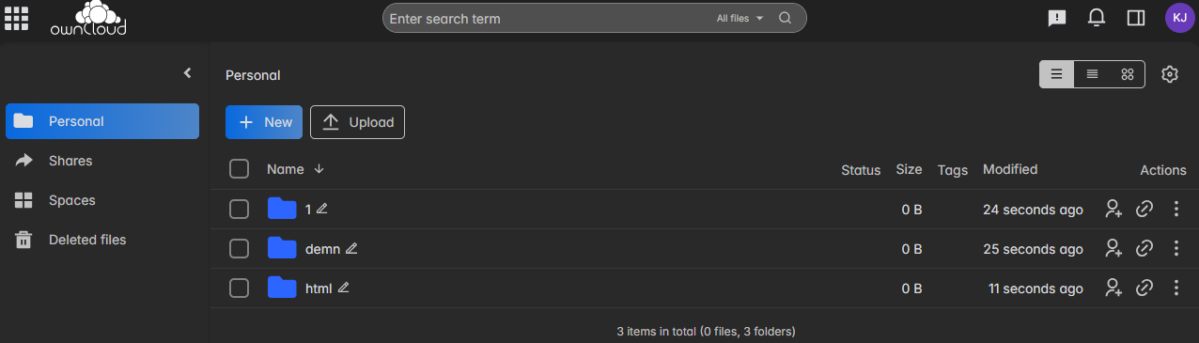

11B: Storage Blob
Step 1: Open Azure portal.
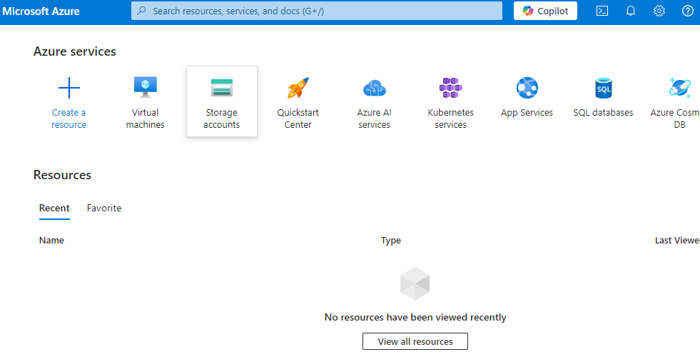

Step 2: Click on ‘Storage Accounts’. Click on ‘Create storage account’.
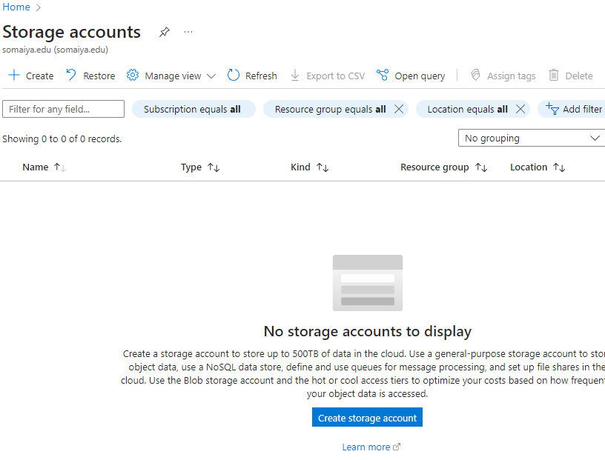
Step 3: Fill in required information.
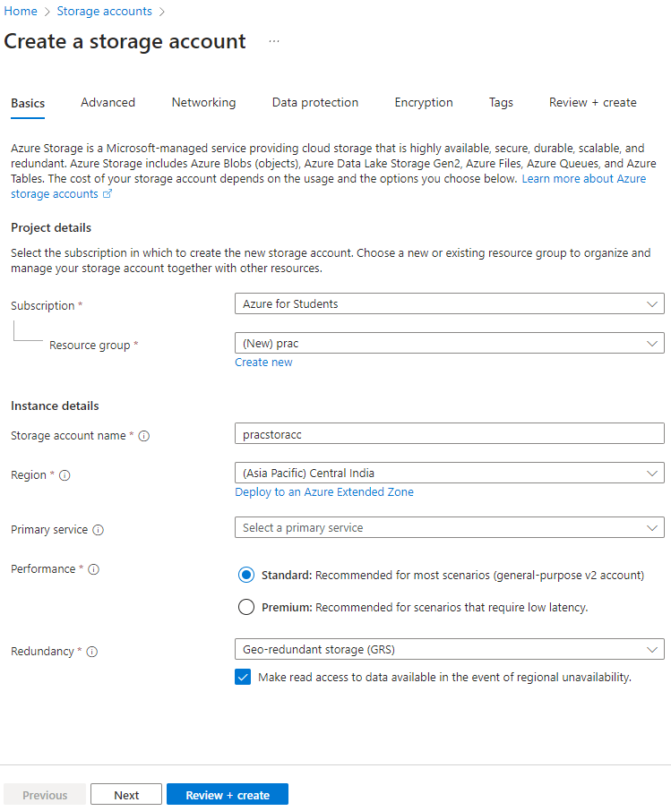

Step 4: Click on ‘Review + create’ and then on ‘Create’.
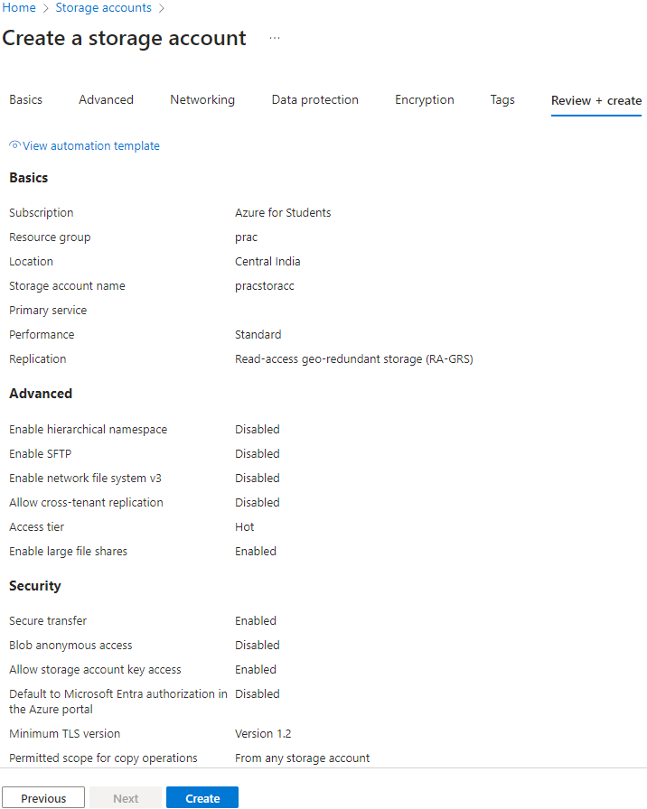

Step 5: Click on ‘Go to resource’.
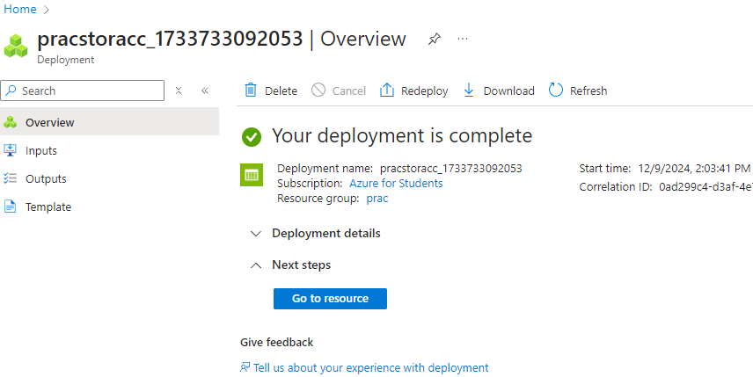

Step 6: In the left menu, click on ‘Containers’ in ‘Data Storage’.
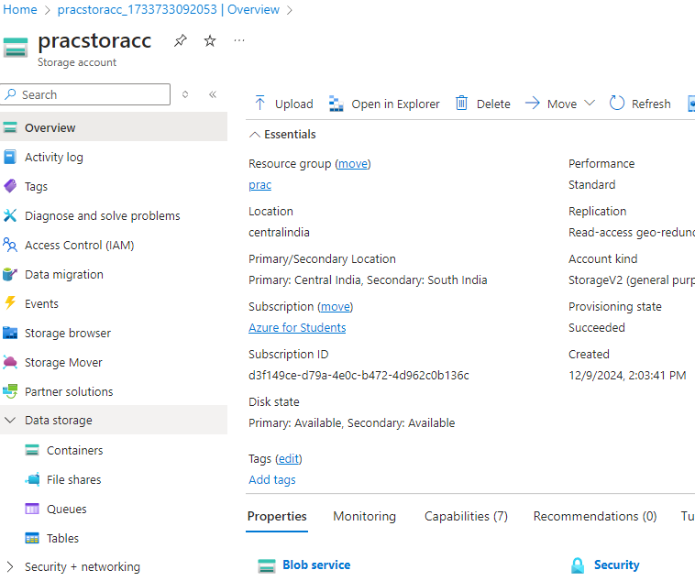
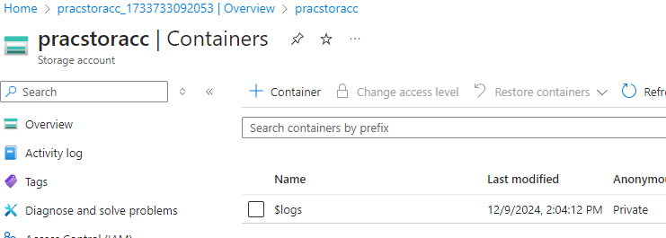

Step 7: Click on ‘+ Container’. Enter a name, click on ‘Create’.
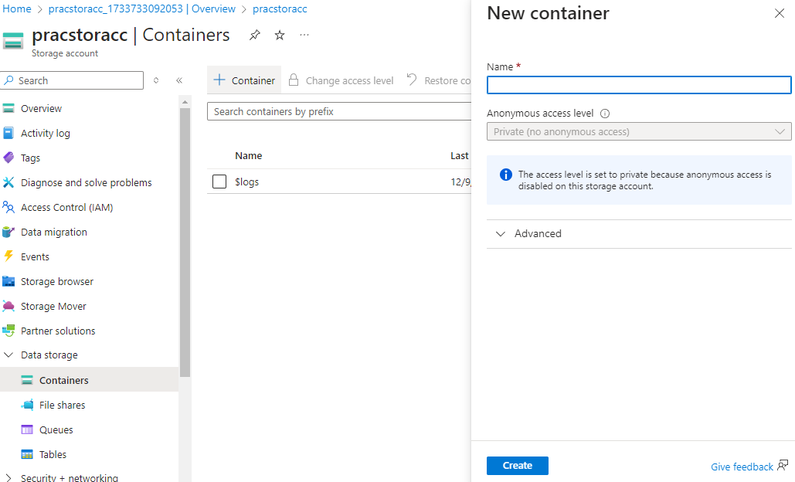

Step 8: Click on the container created. Click "Upload" to upload your file.
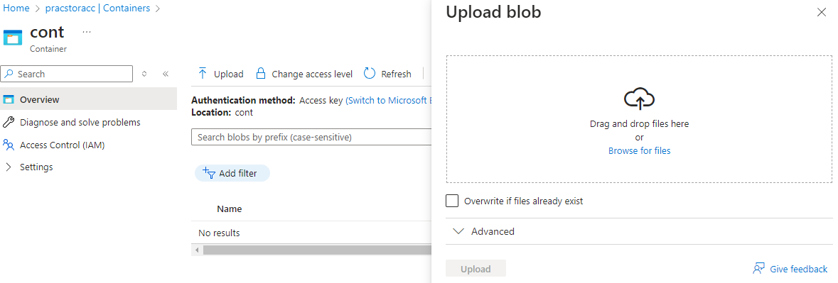
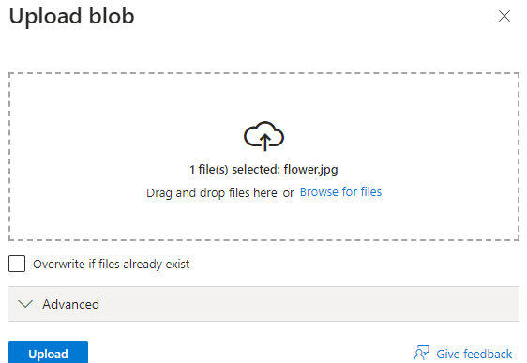

Practical 12 – Web Hosting
Step 1: Create an App Service Plan in Azure
Fill required details and click "Review + create"
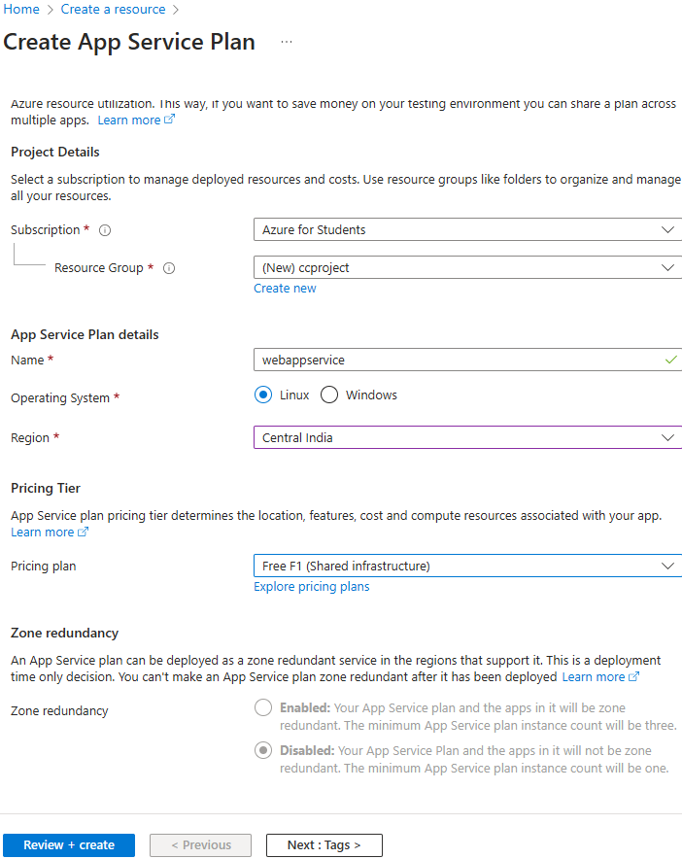

Step 2: Create a Web app service
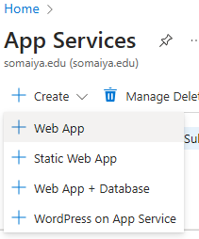
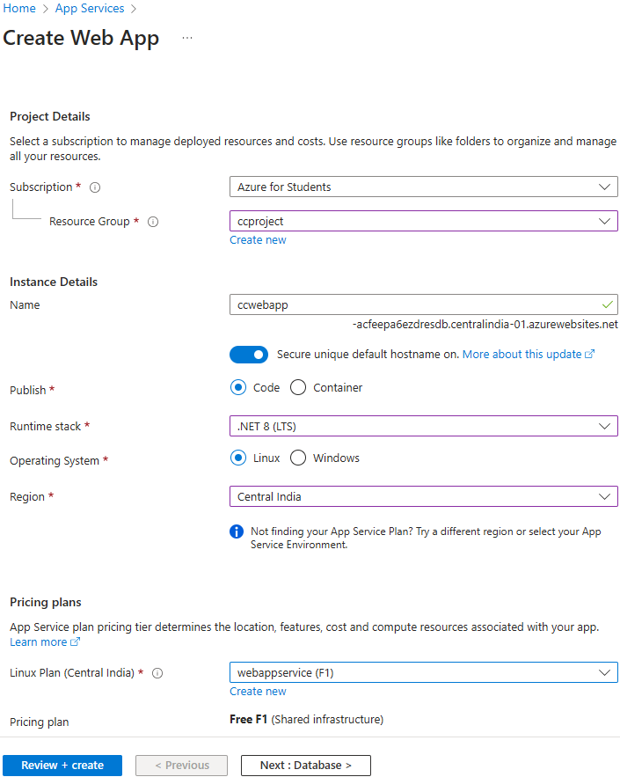

Step 3: Create a new file and then open it in Visual Studio Code
Run the command in terminal: dotnet new mvc
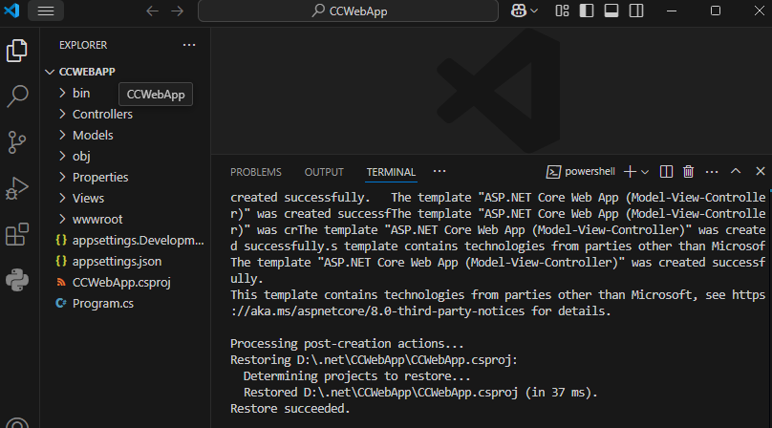

Step 4: Deploy the application to Azure App Service
Install the "Azure App Service" and "Azure resources" extension in Visual Studio Code.
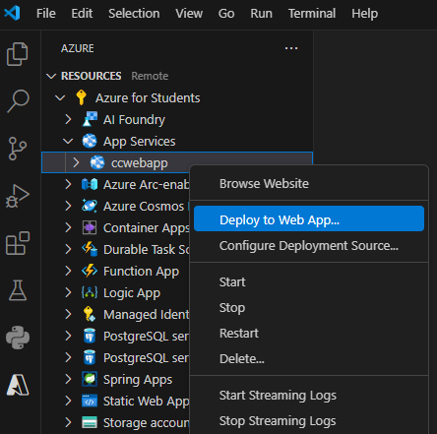
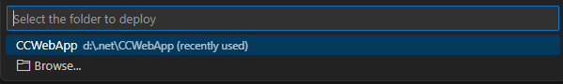

Step 5: Test the application
Once the app is deployed, go to the Web App resource and open the endpoint.
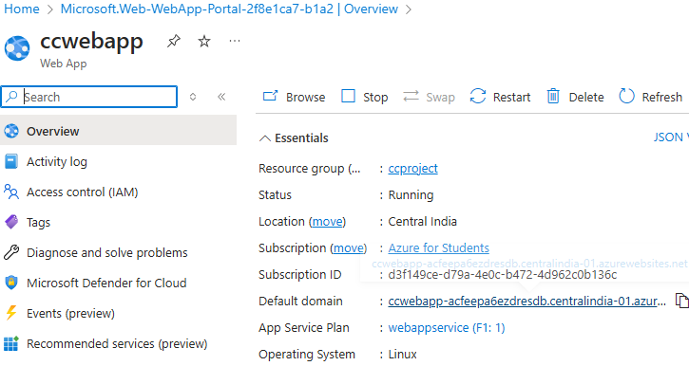
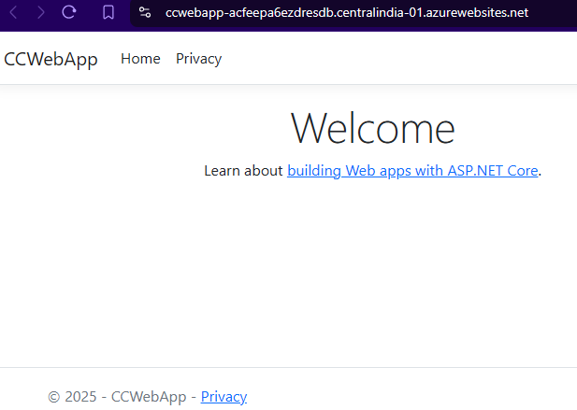

Practical 13 – Web Development
Search for Azure SQL Database
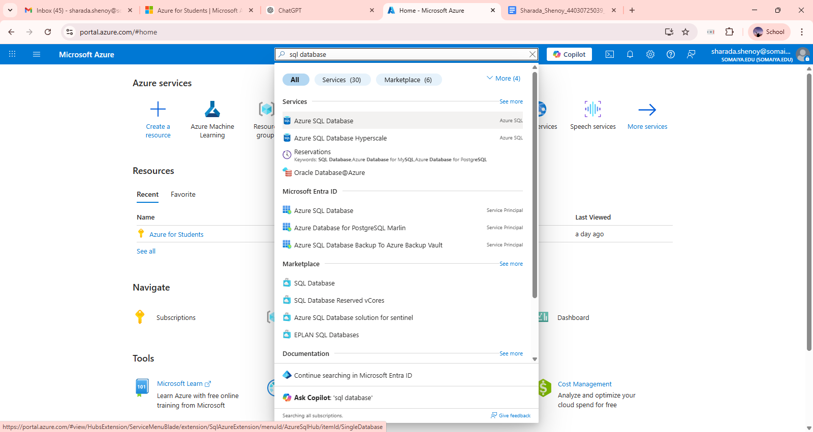

Select Azure SQL Database
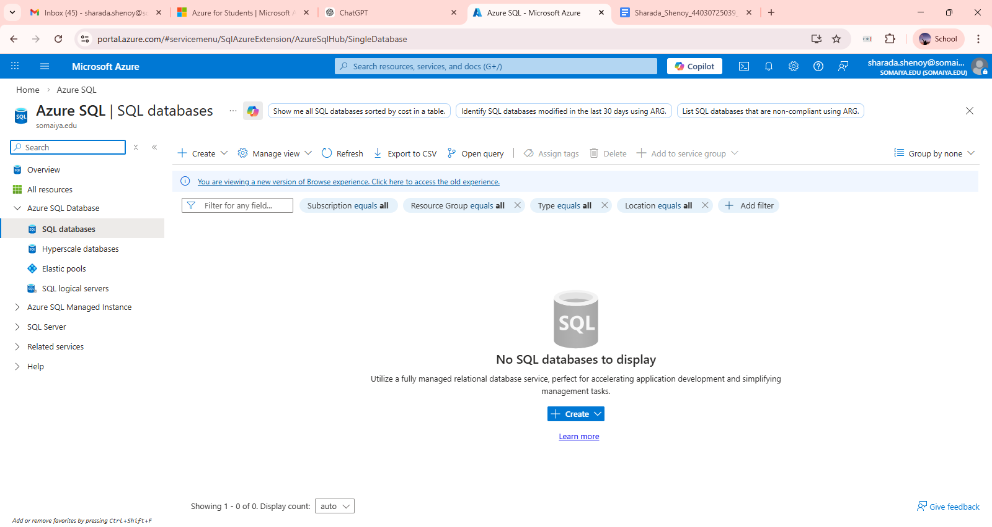

Create a instances of Azure SQL Database
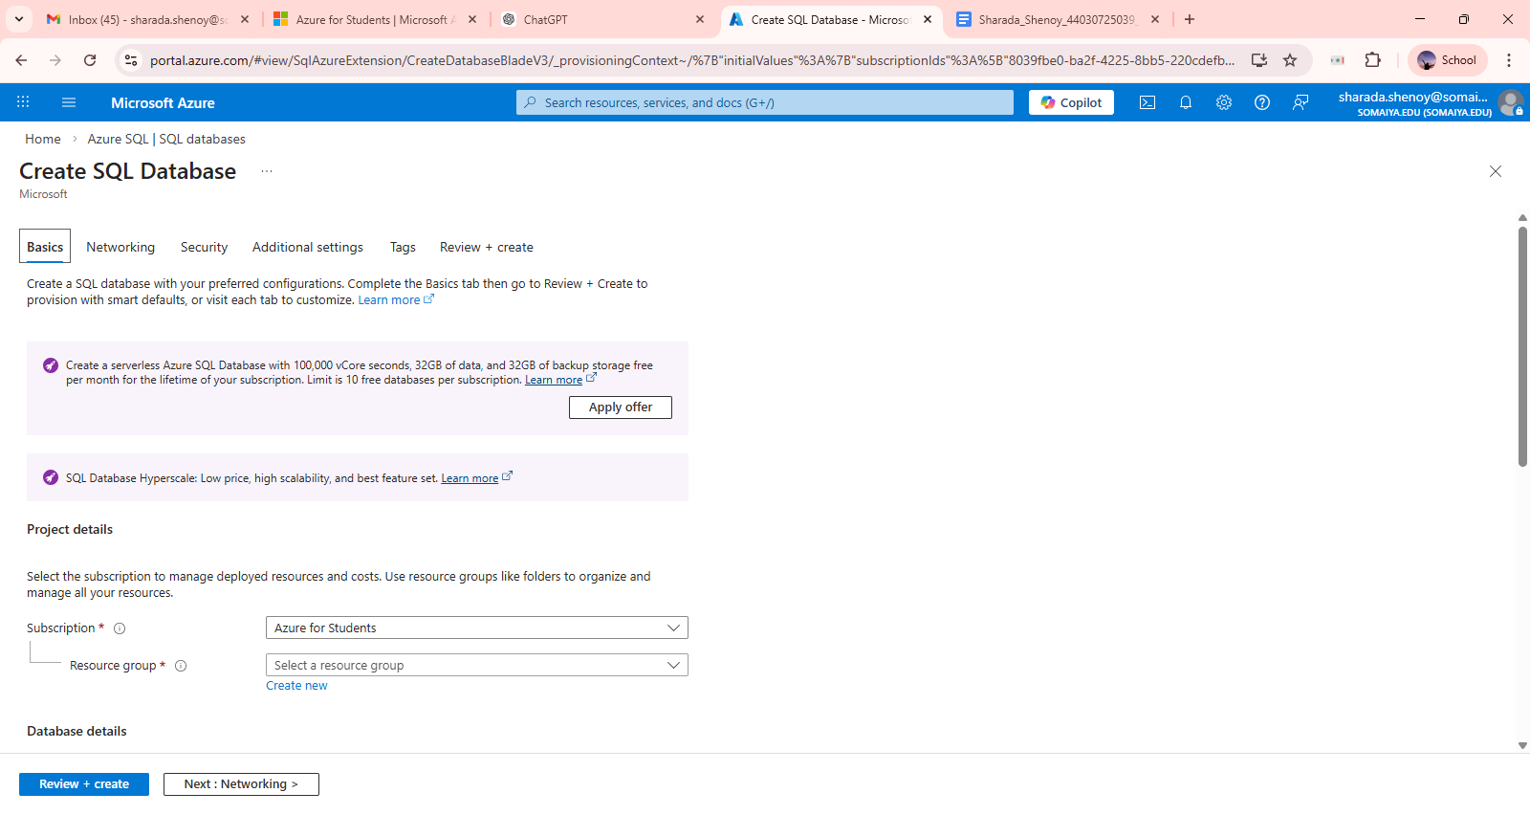

Fill required Details
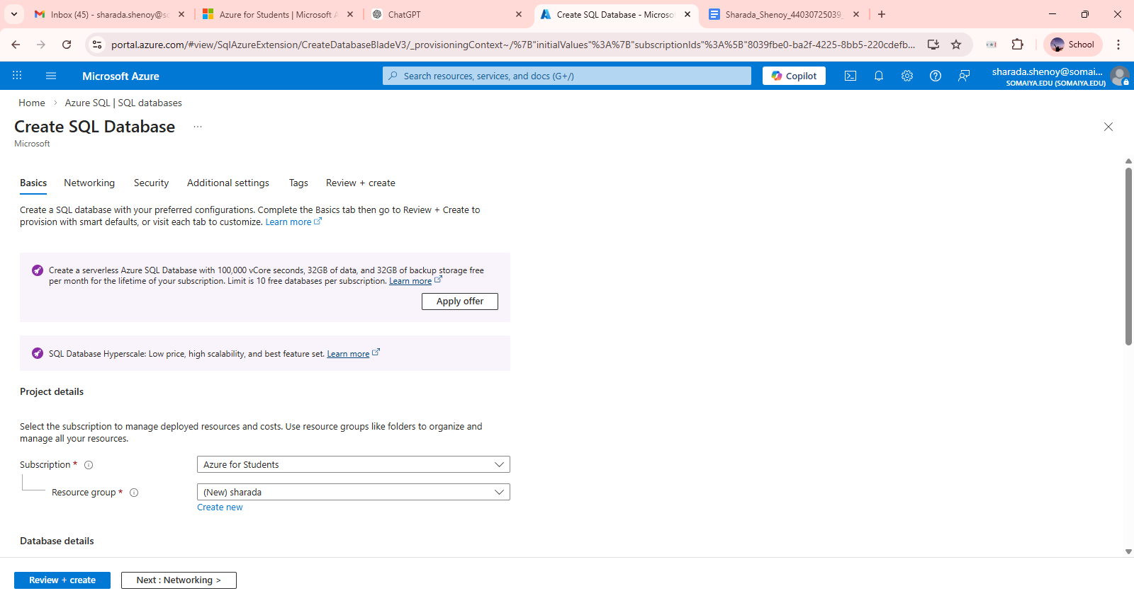

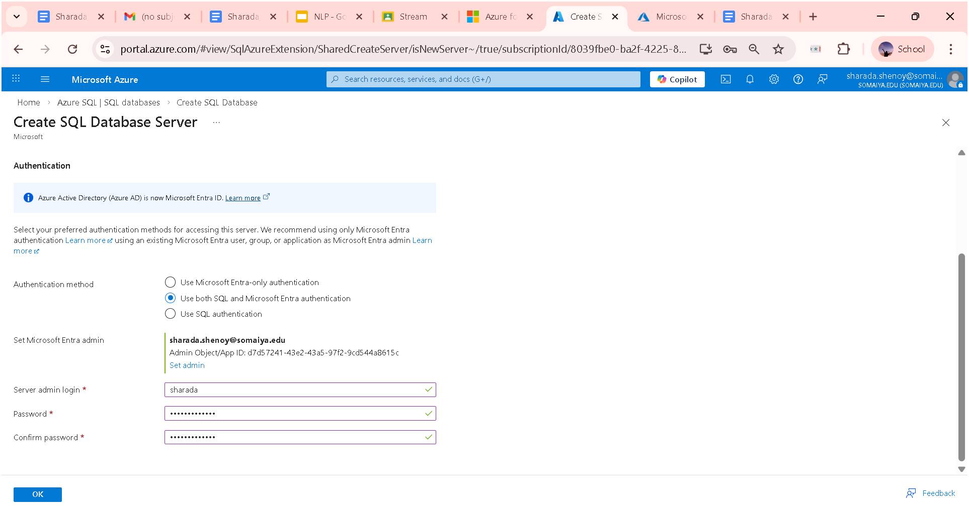
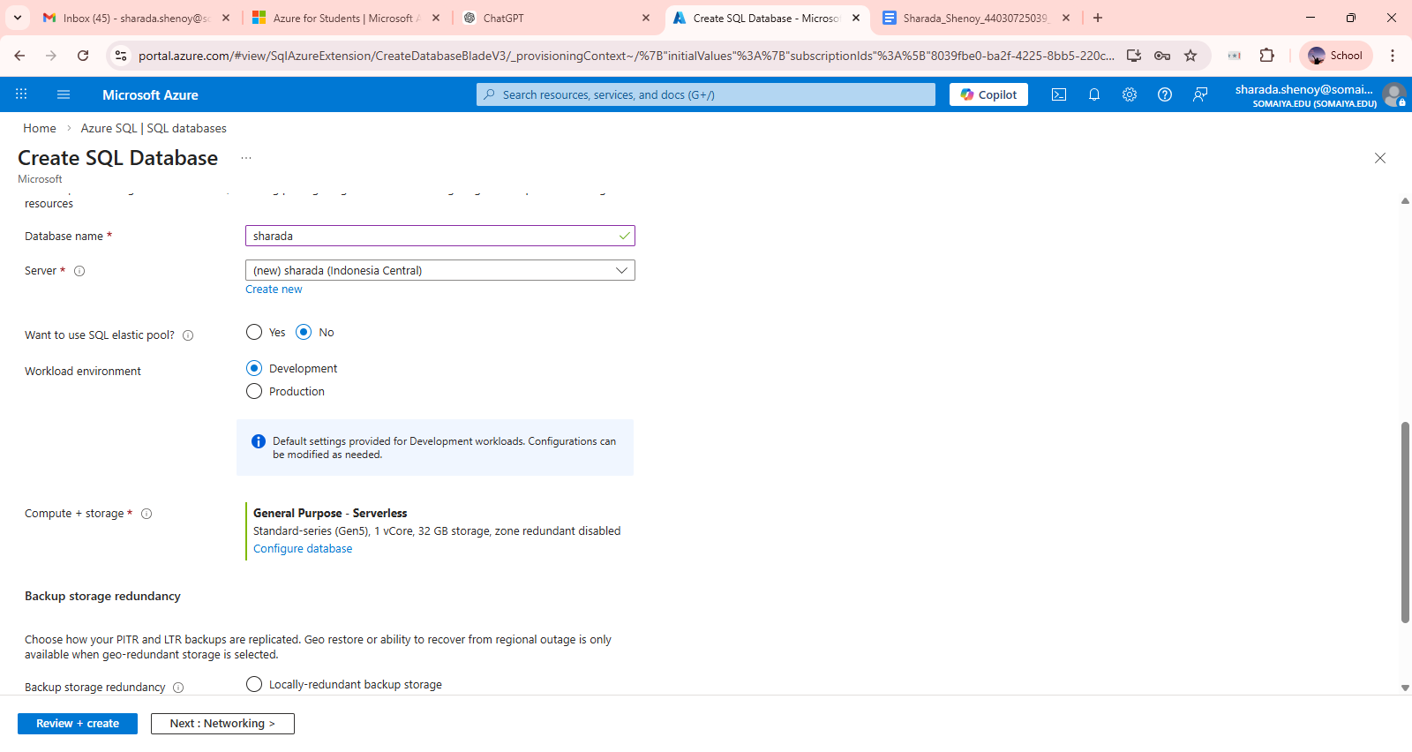

When all details are filled click on Review+Create

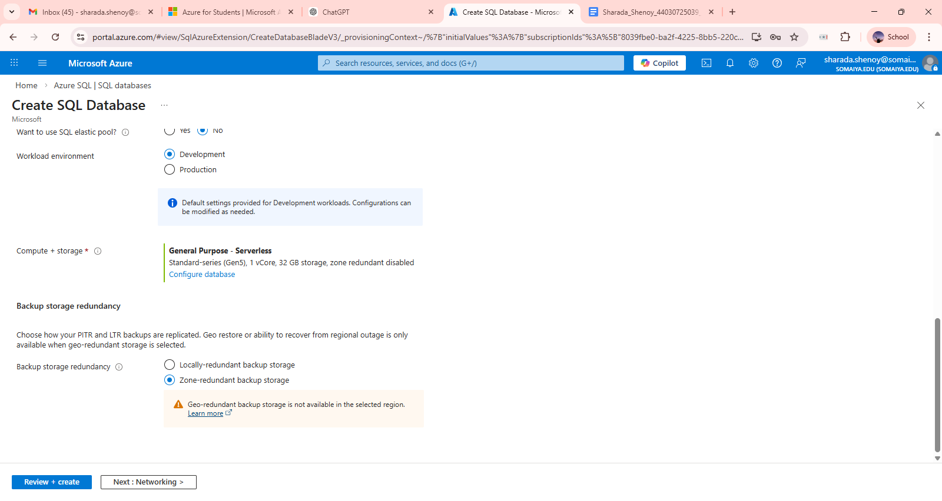

After that click on Create
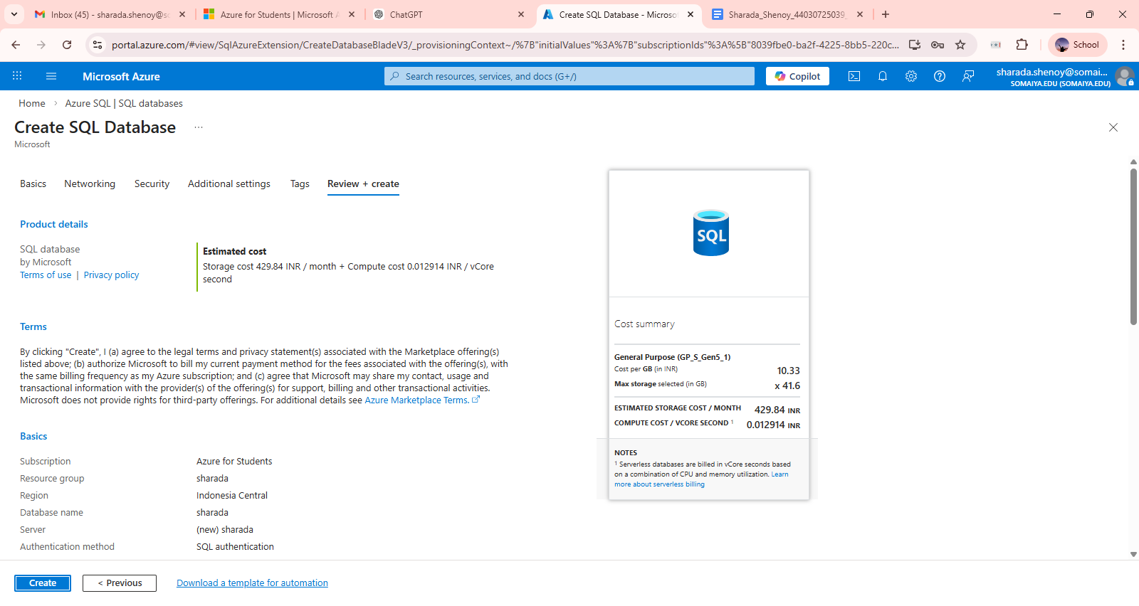
Wait for deployment
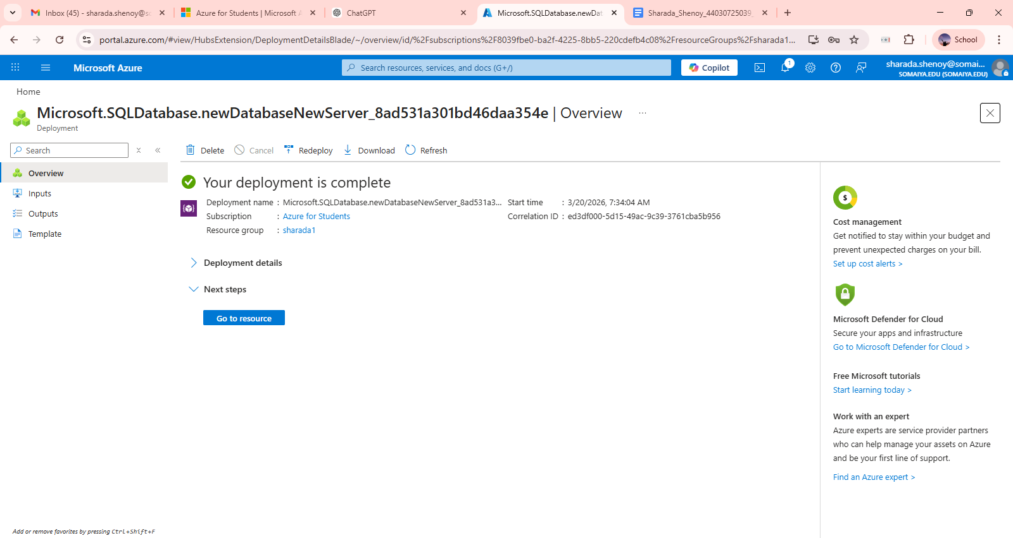

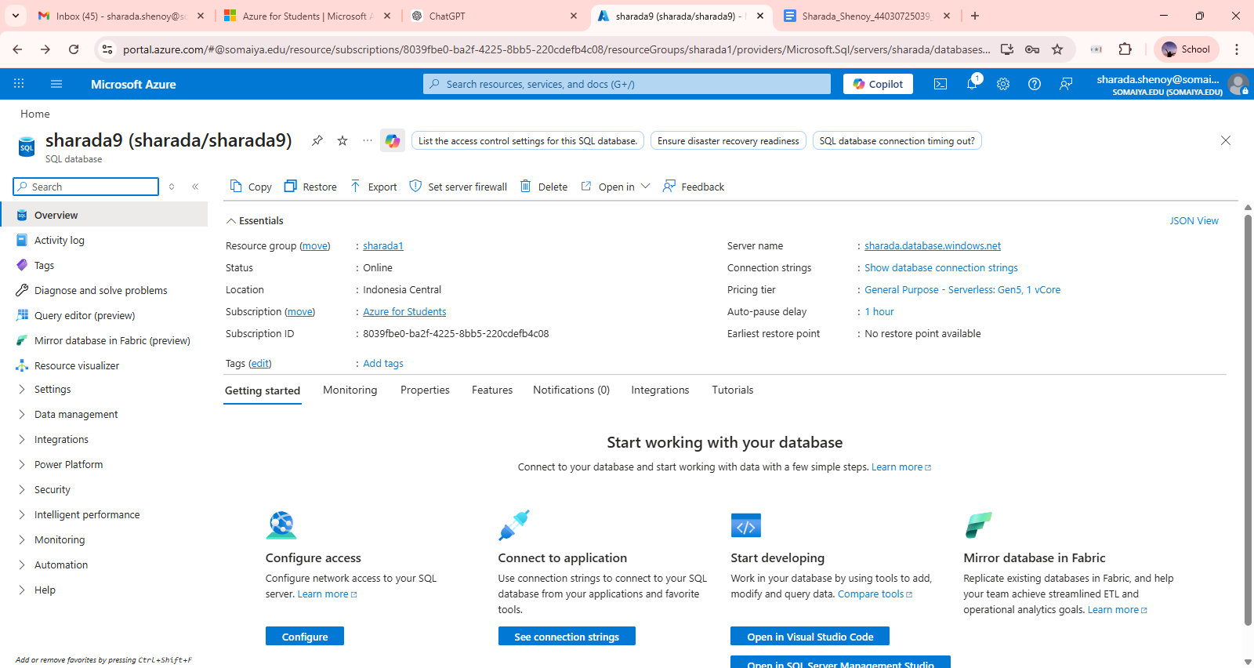
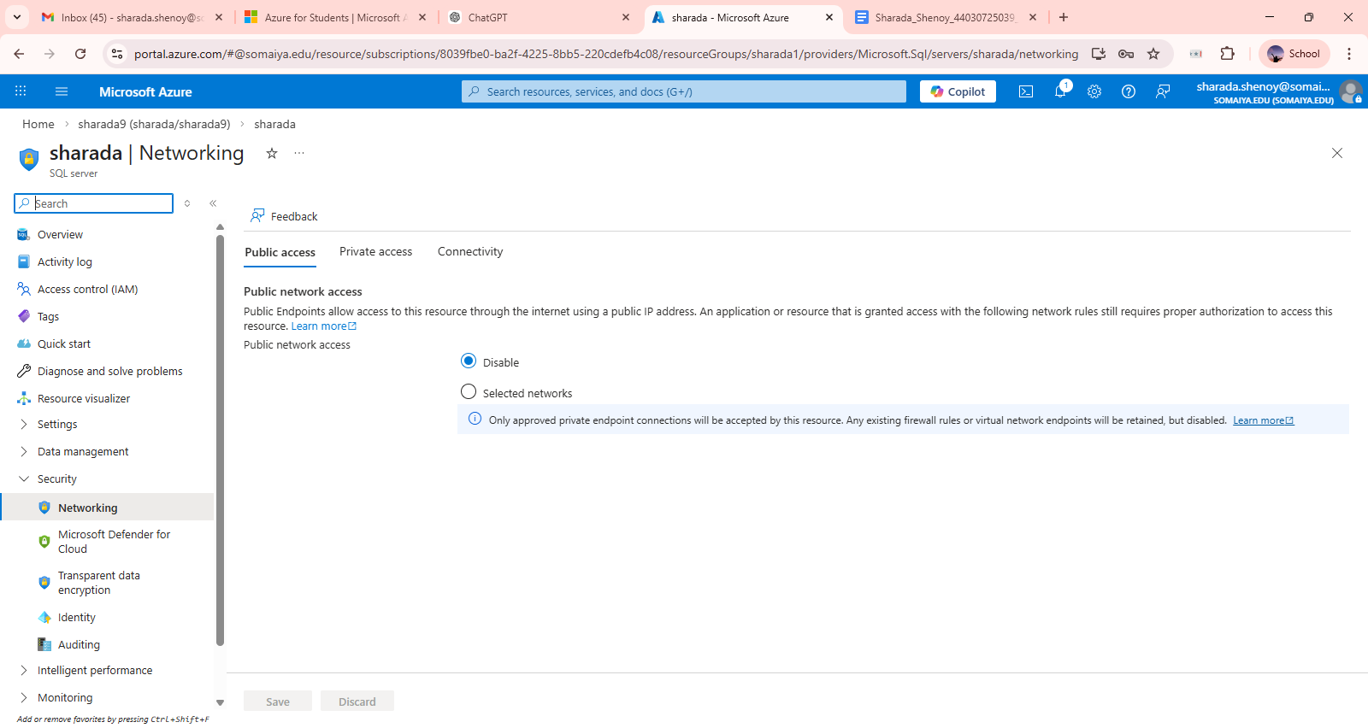

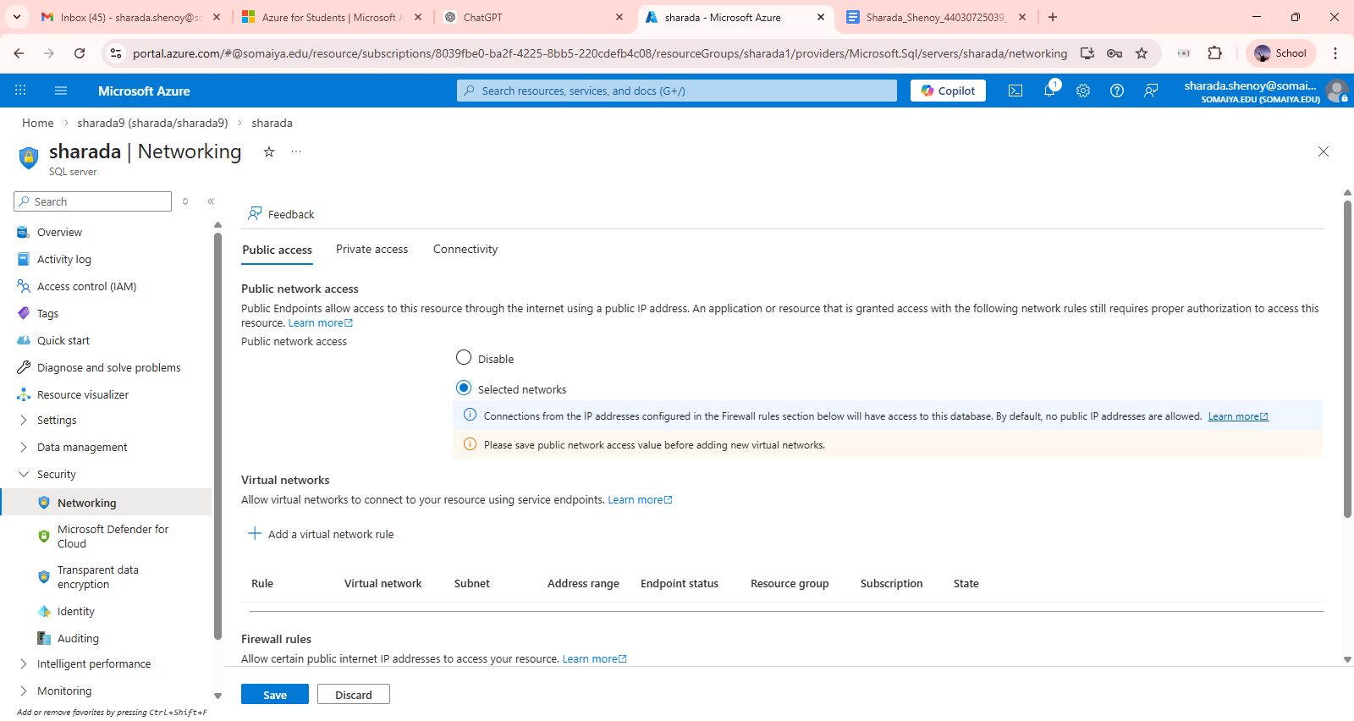

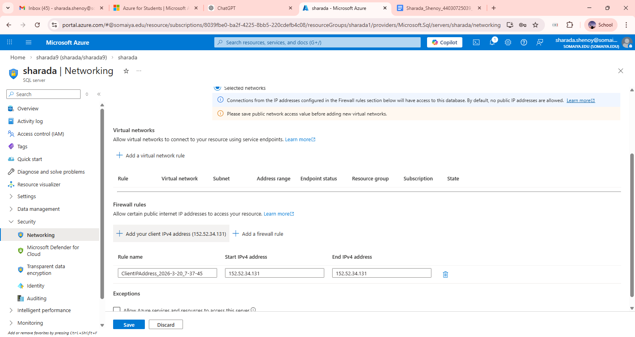

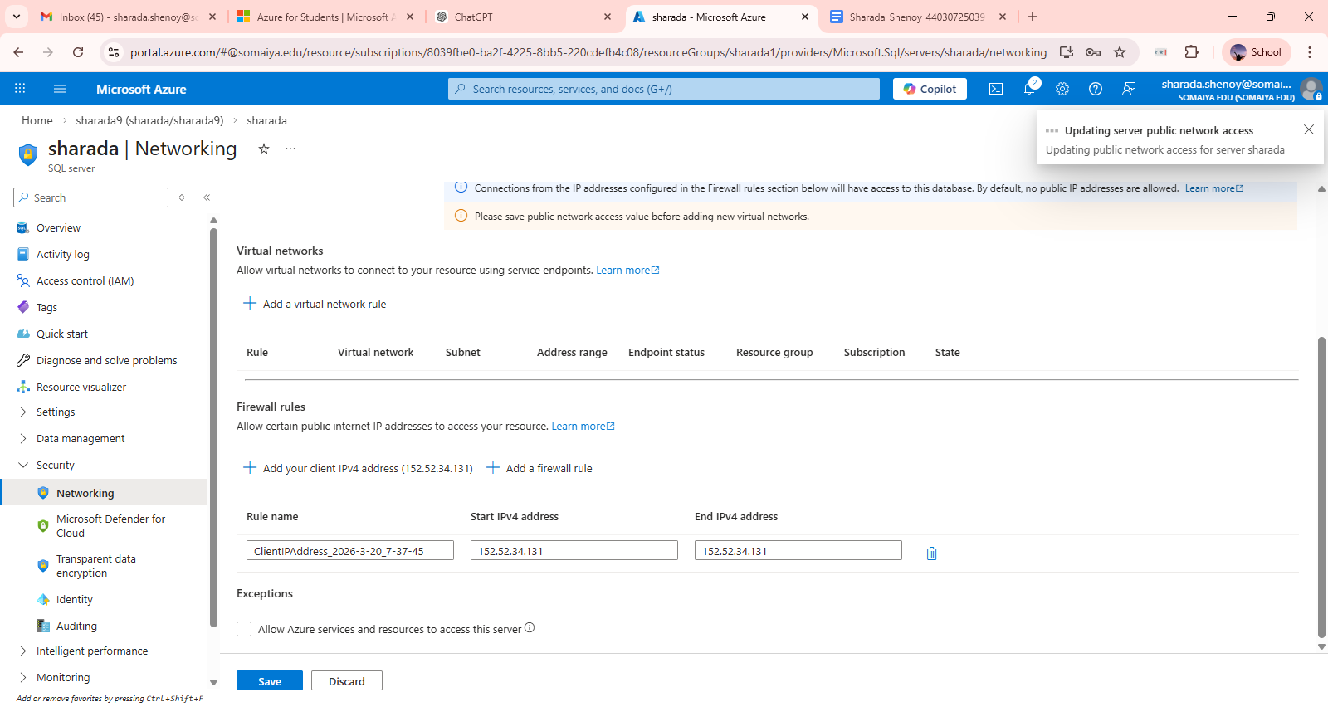

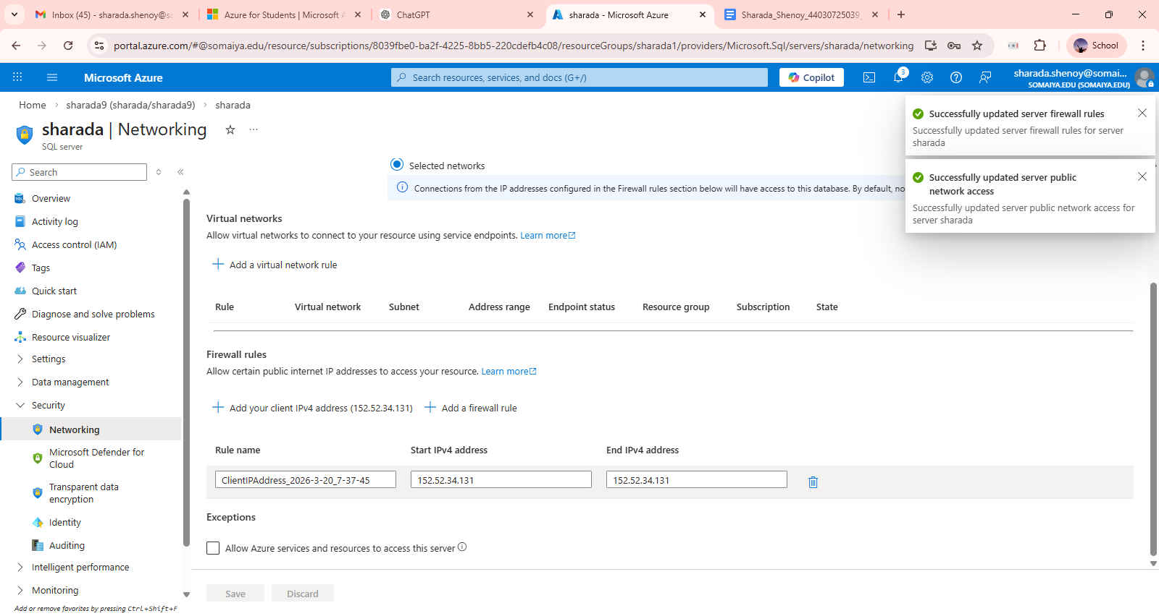

Open SSMS

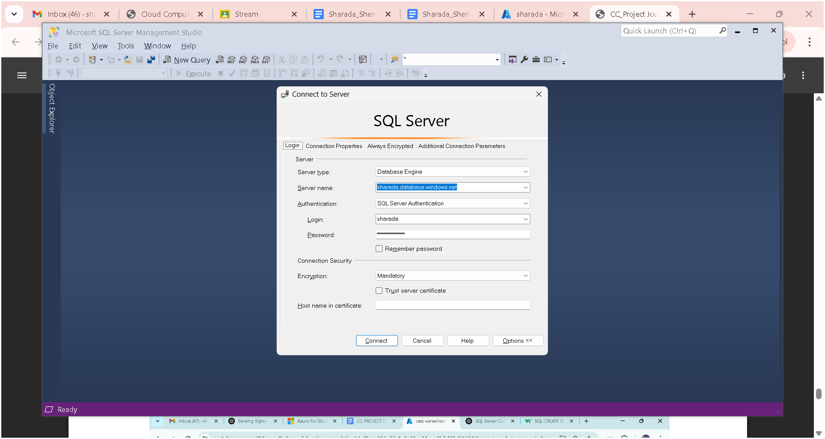

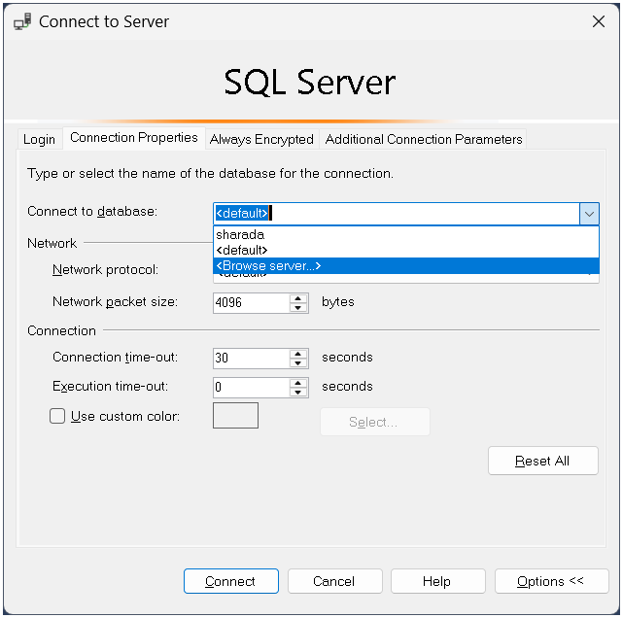

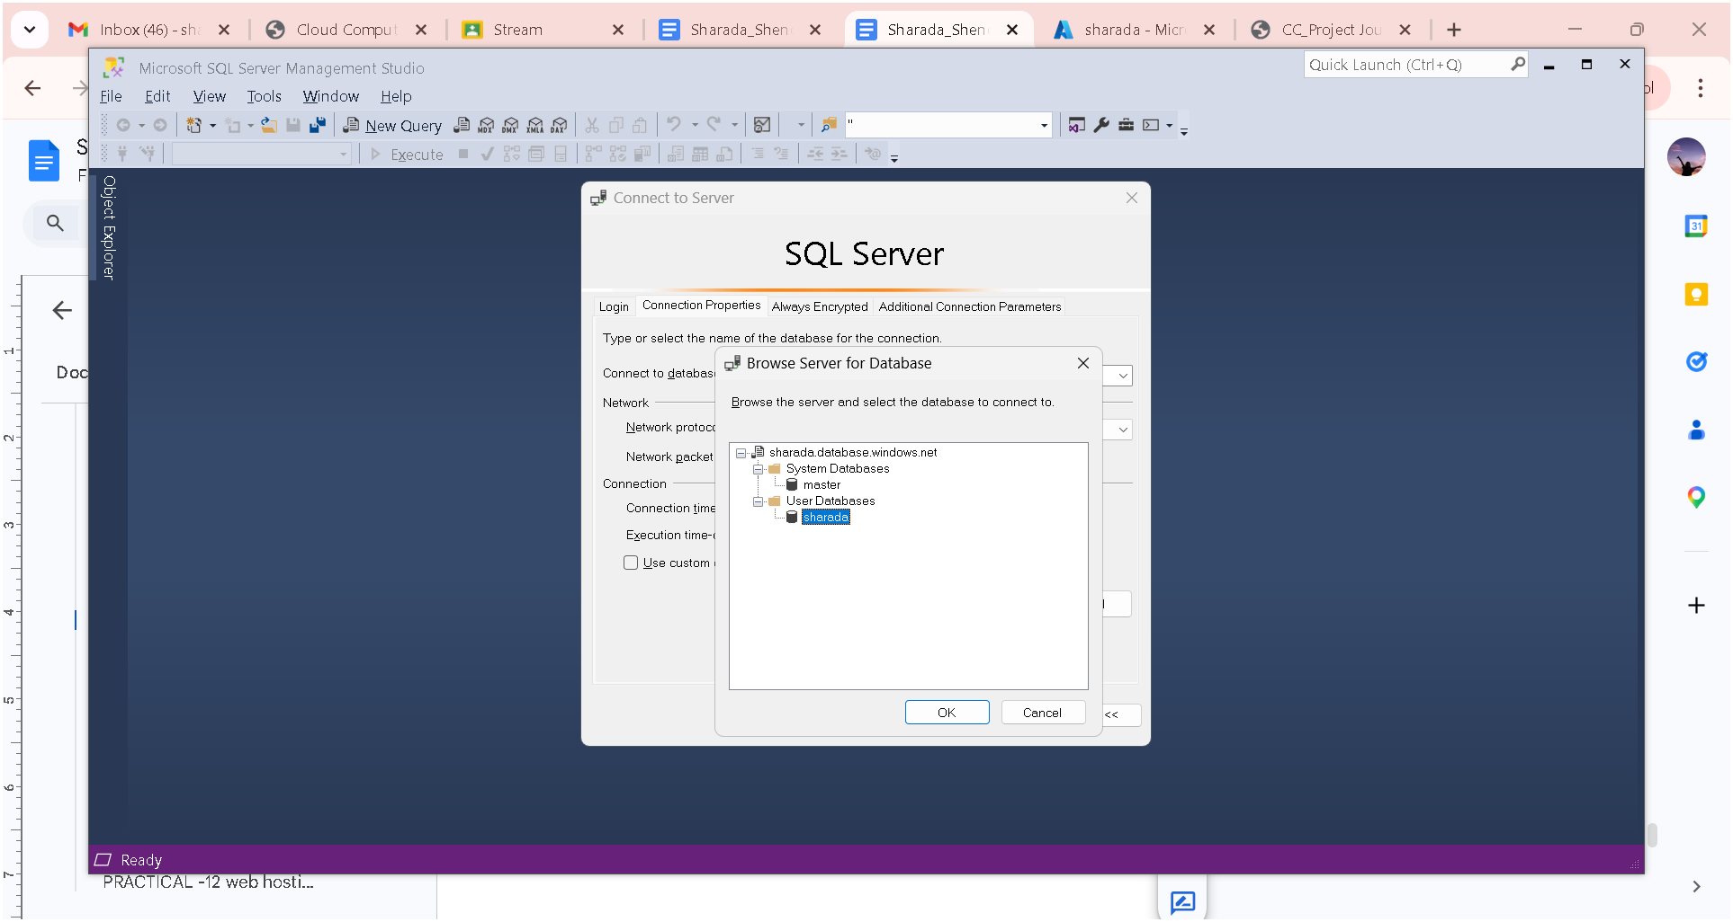

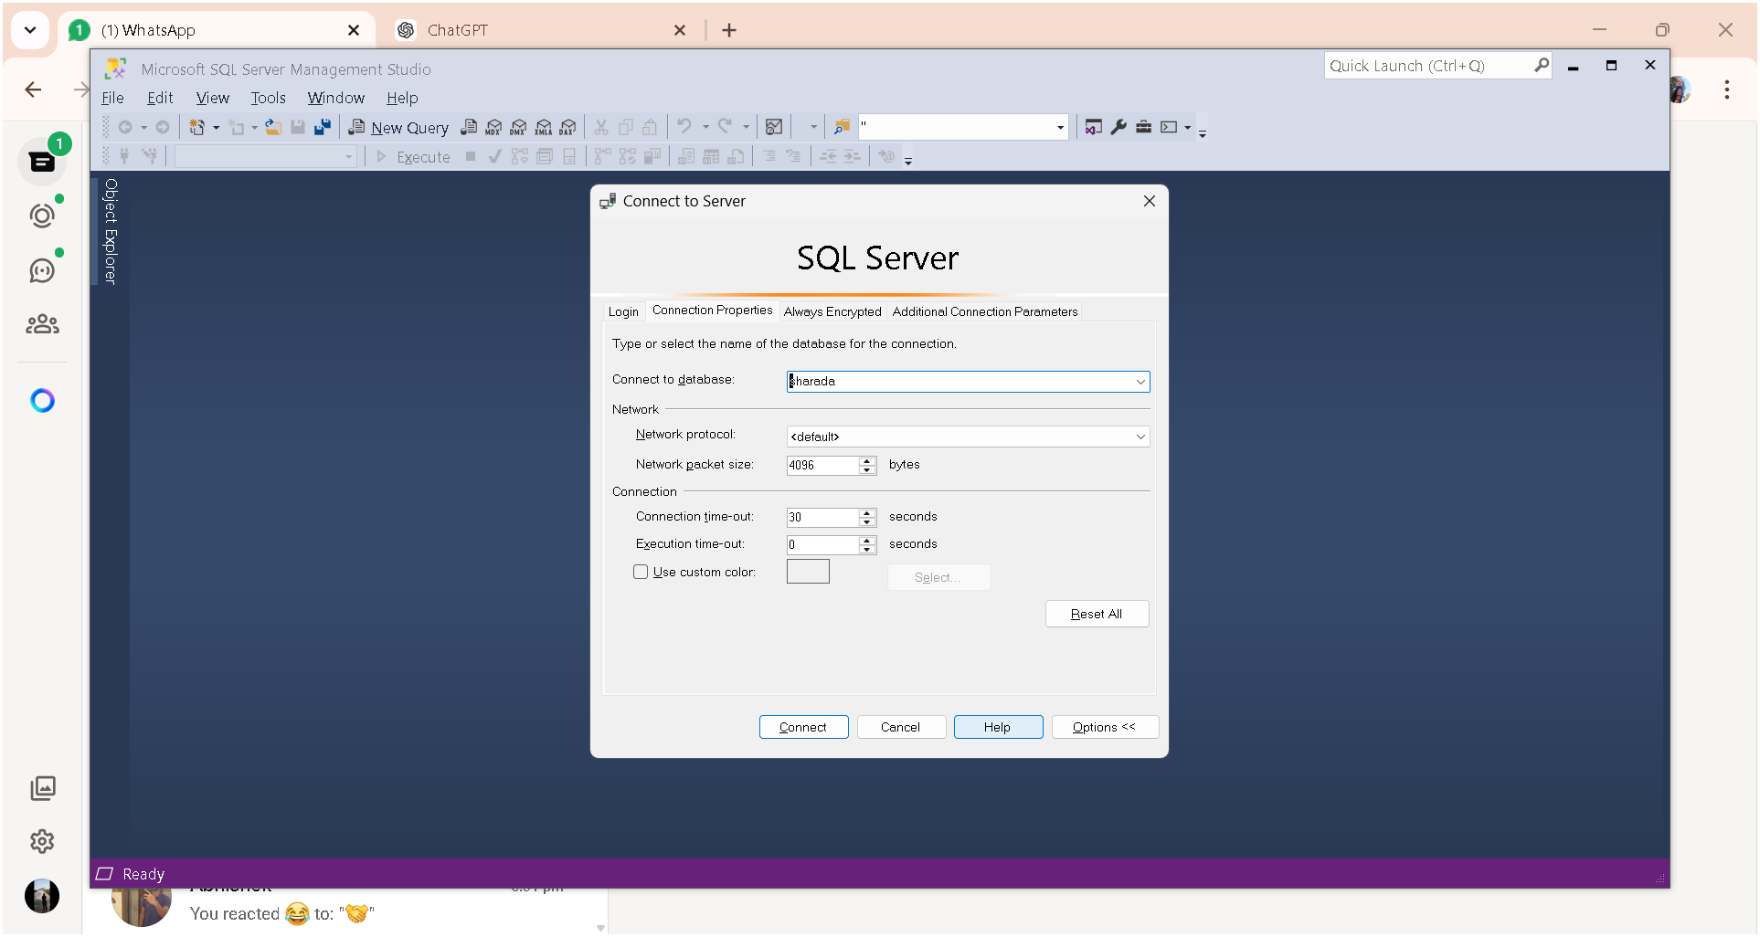

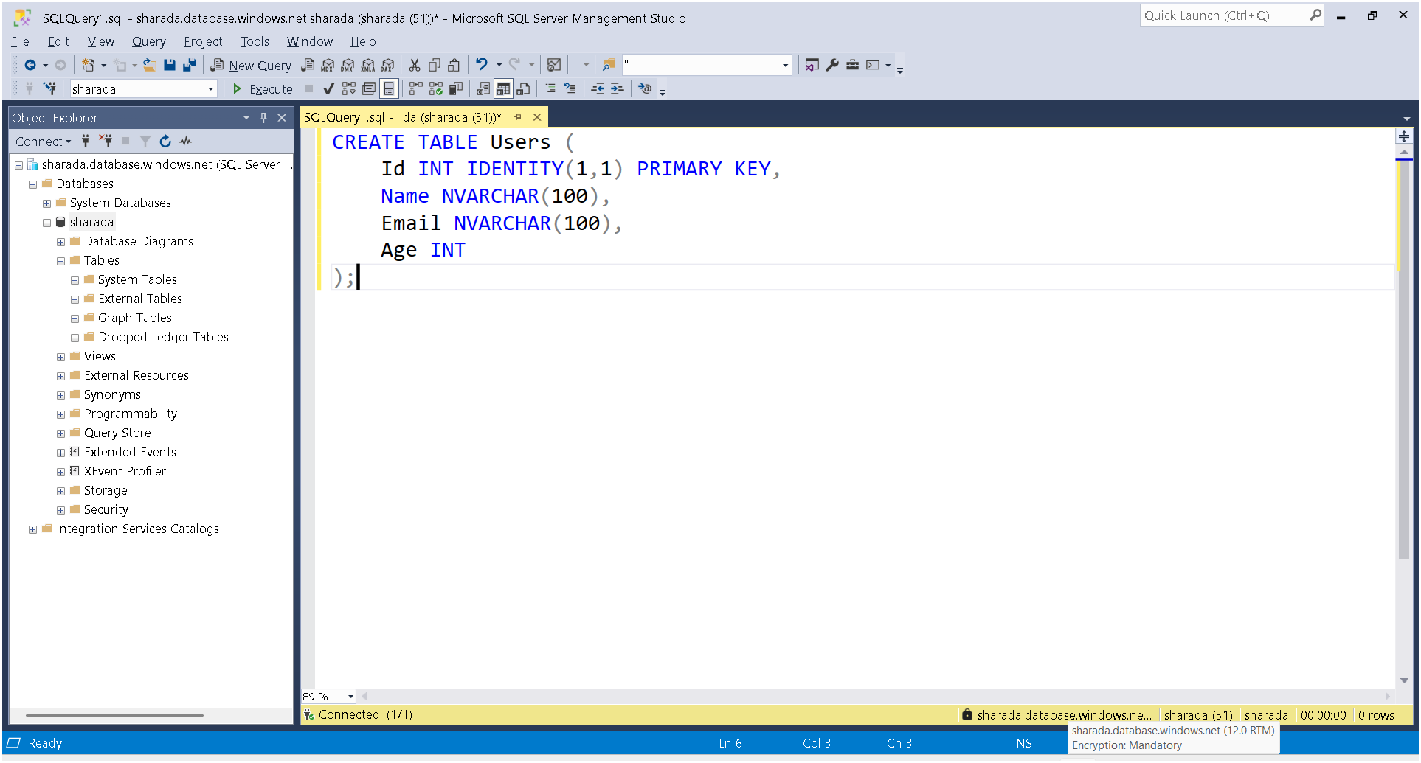

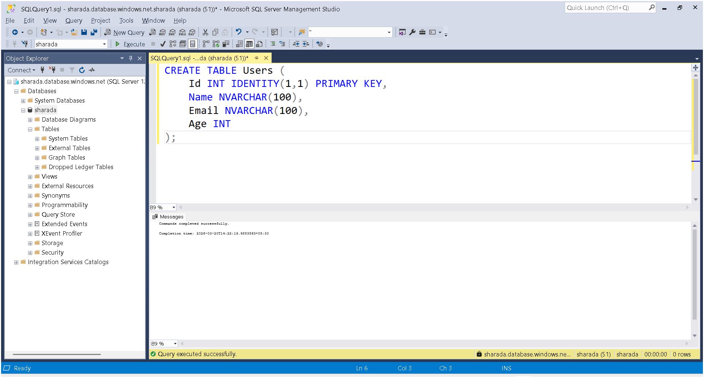
Done with ssms

Now create a new folder in desktop "azure-crud-app"

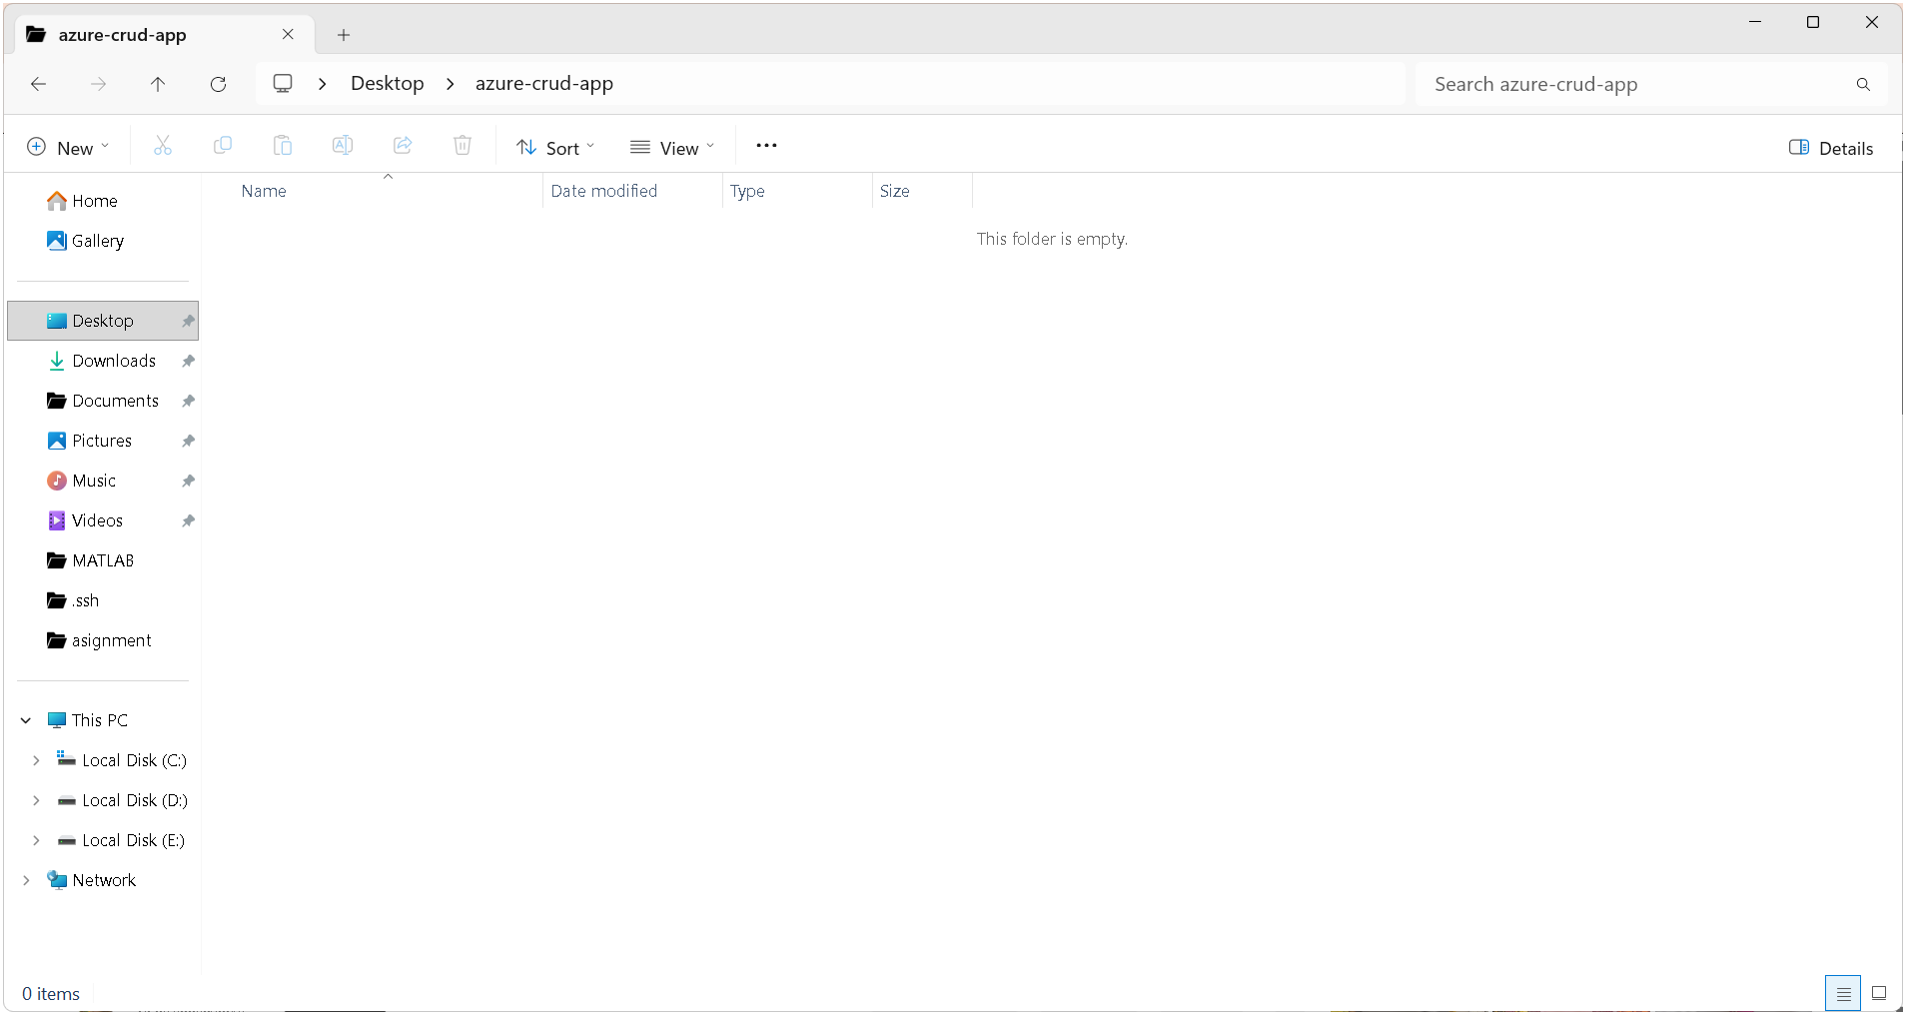

Now open vs code
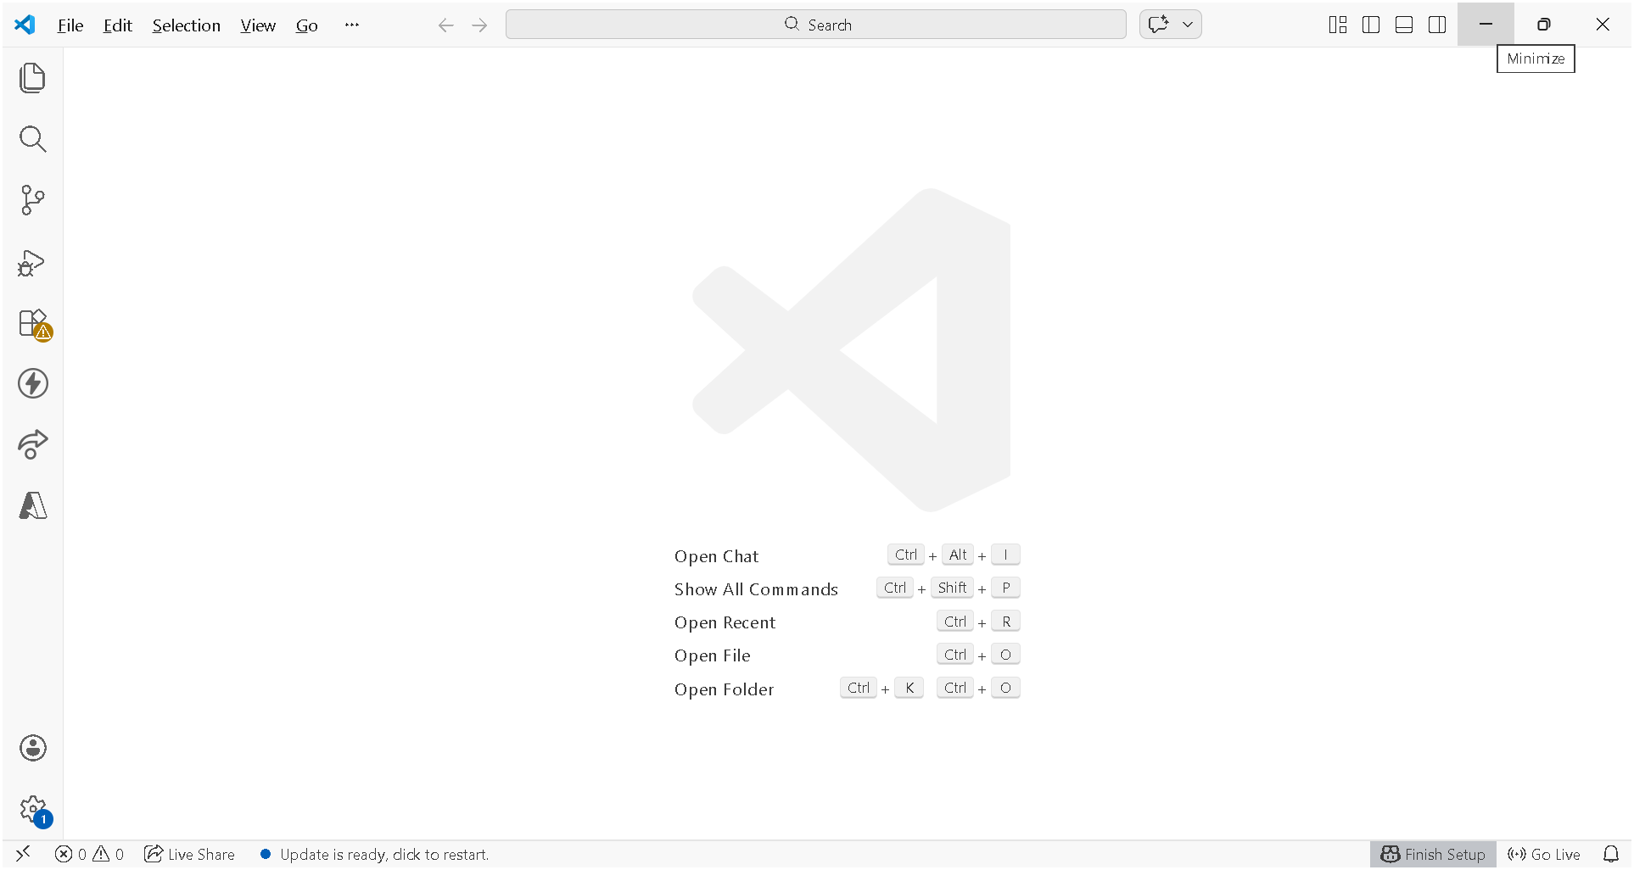

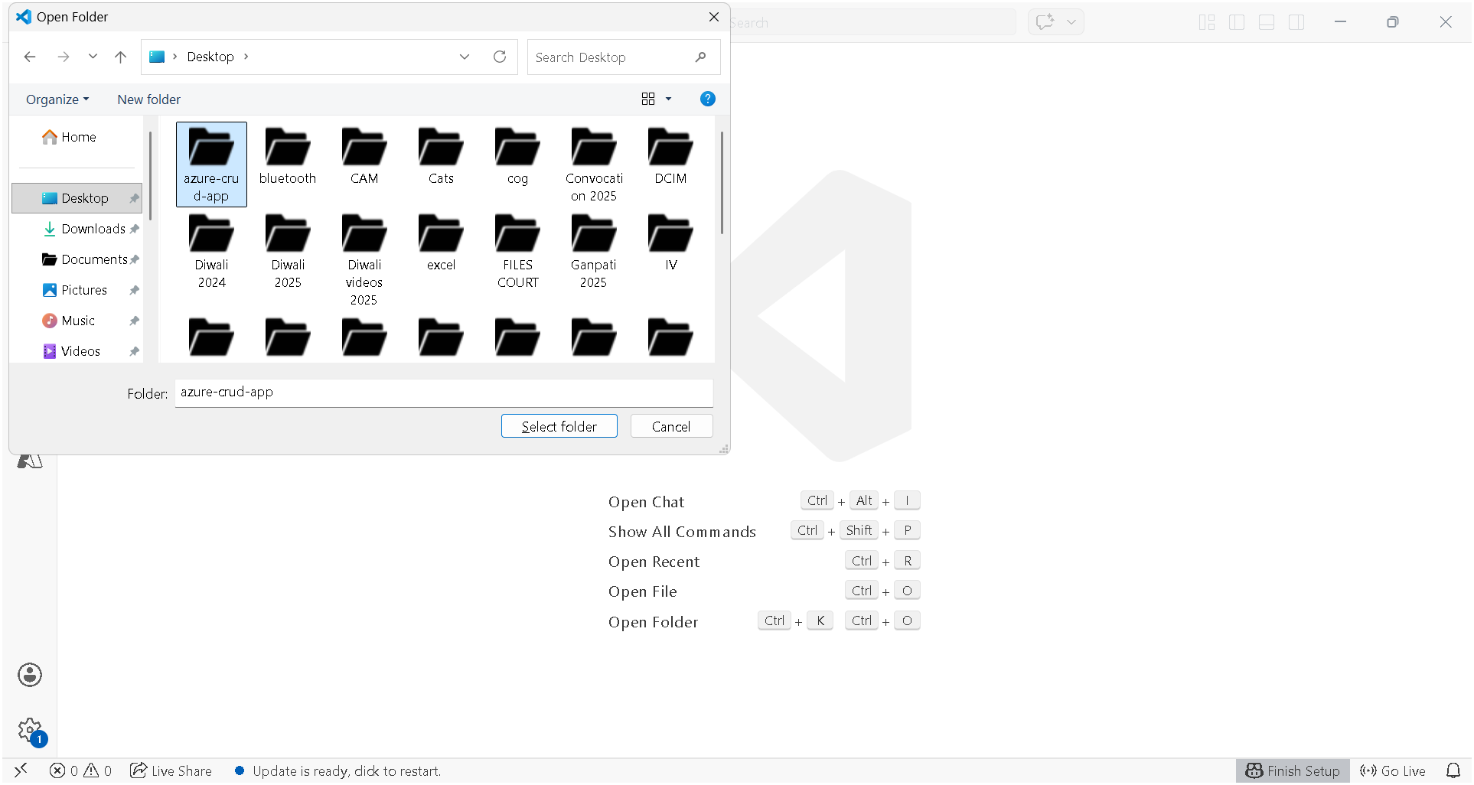

npm init -y
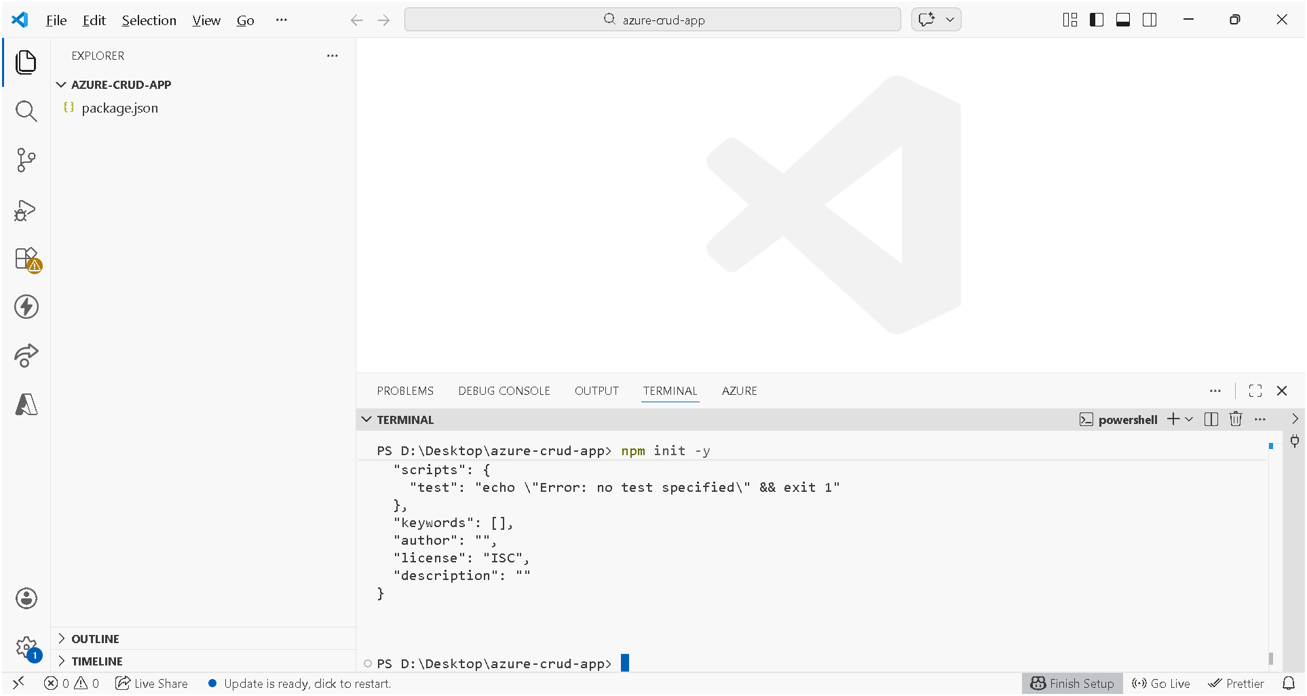

npm install express mssql body-parser cors
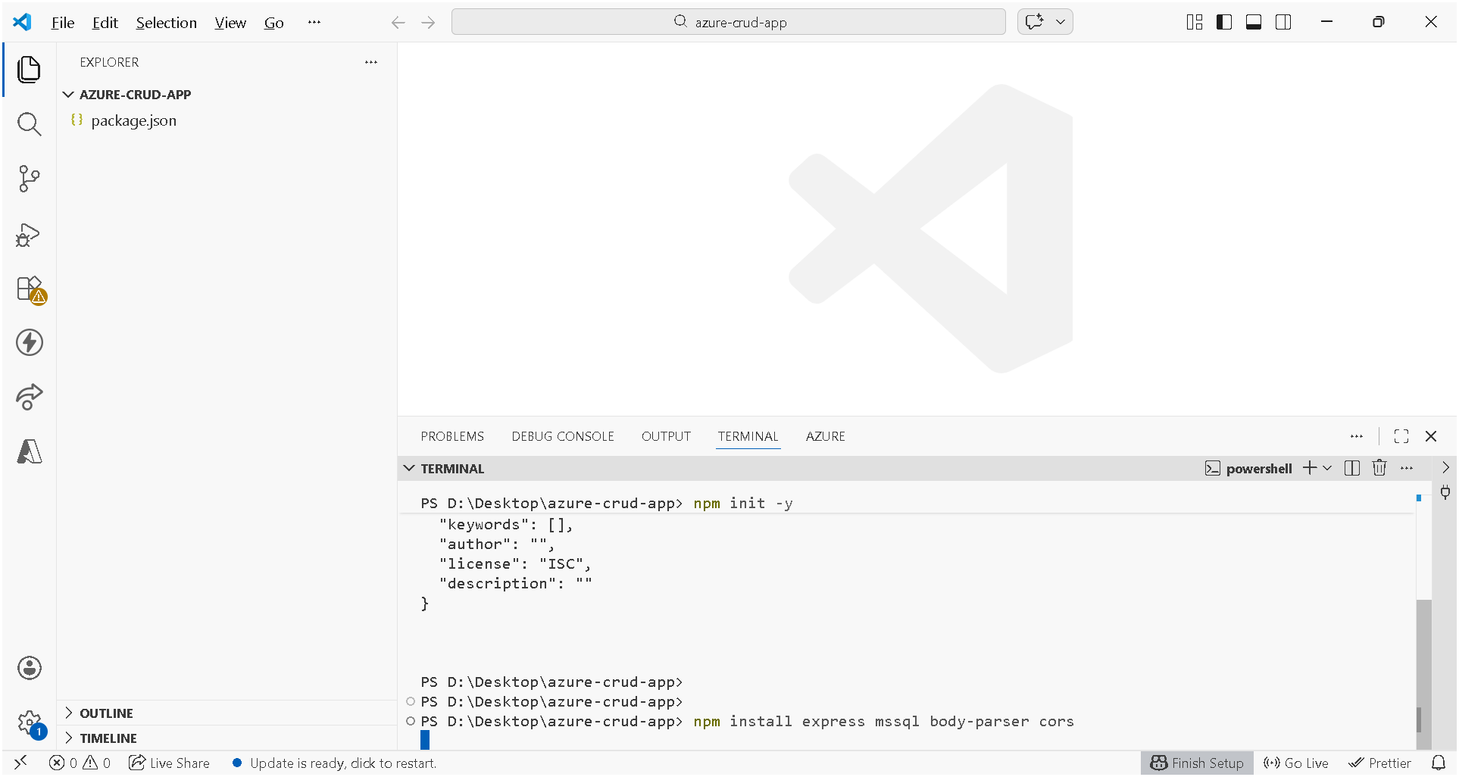

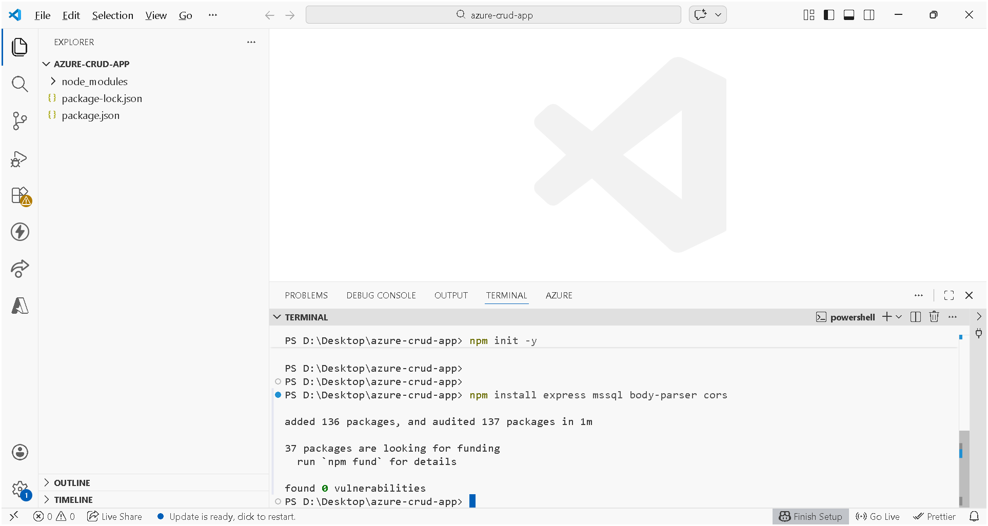

create a file server,js
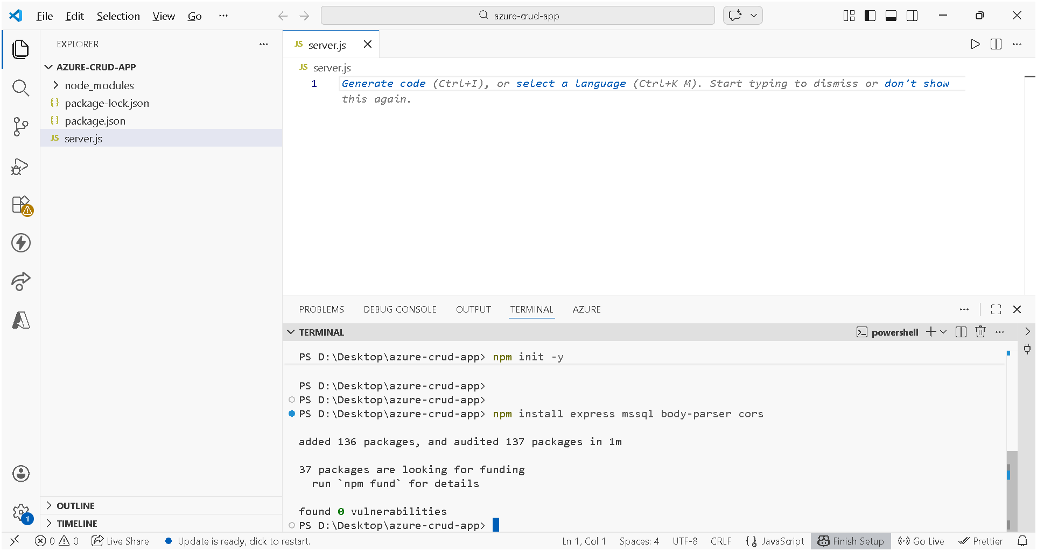

Code of server.js

const express = require('express');
const sql = require('mssql');
const cors = require('cors');

const app = express();
app.use(express.json());
app.use(cors());

// 🔑 Replace with YOUR Azure SQL connection string
const config = {
user: 'your_username',
password: 'your_password',
server: 'your_server.database.windows.net',
database: 'your_database',
options: {
encrypt: true,
trustServerCertificate: false
}
};

// CREATE (Insert data)
app.post('/addUser', async (req, res) => {
try {
let pool = await sql.connect(config);
let result = await pool.request()
.input('Name', sql.NVarChar, req.body.Name)
.input('Email', sql.NVarChar, req.body.Email)
.input('Age', sql.Int, req.body.Age)
.query('INSERT INTO Users (Name, Email, Age) VALUES (@Name, @Email, @Age)');

res.send("User added!");
} catch (err) {
res.send(err.message);
}
});

// READ (Get all users)
app.get('/users', async (req, res) => {
try {
let pool = await sql.connect(config);
let result = await pool.request().query('SELECT * FROM Users');
res.json(result.recordset);
} catch (err) {
res.send(err.message);
}
});

app.listen(3000, () => {
console.log('Server running on http://localhost:3000');
});

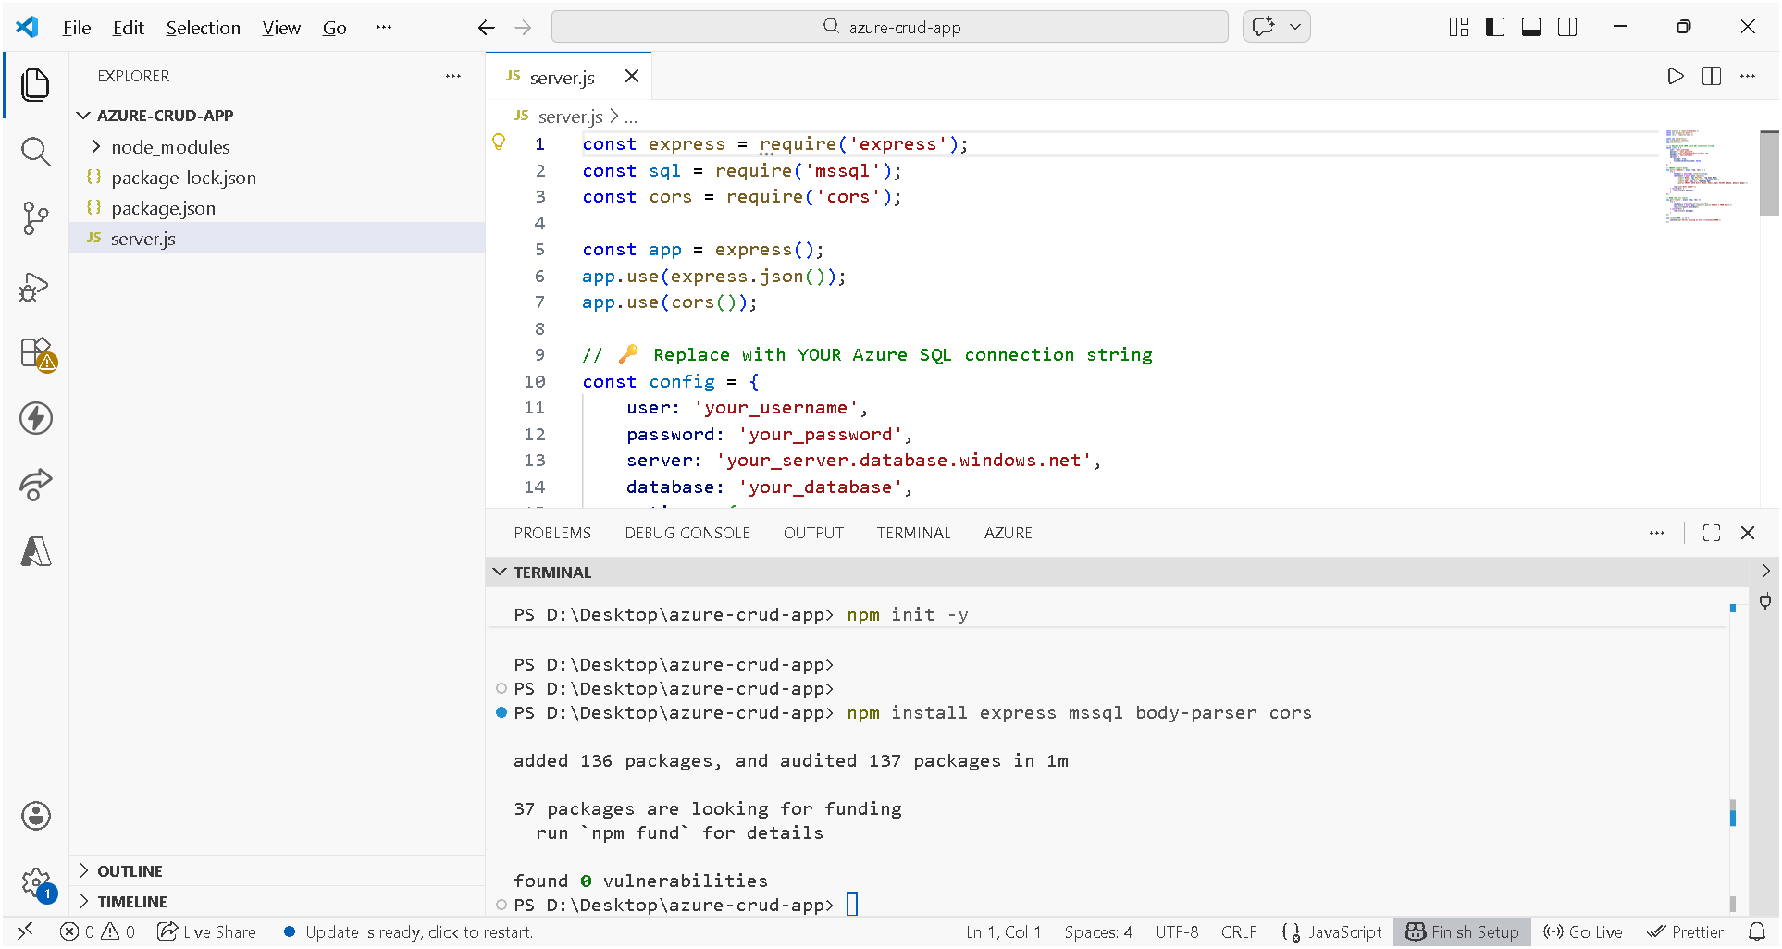

node server.js
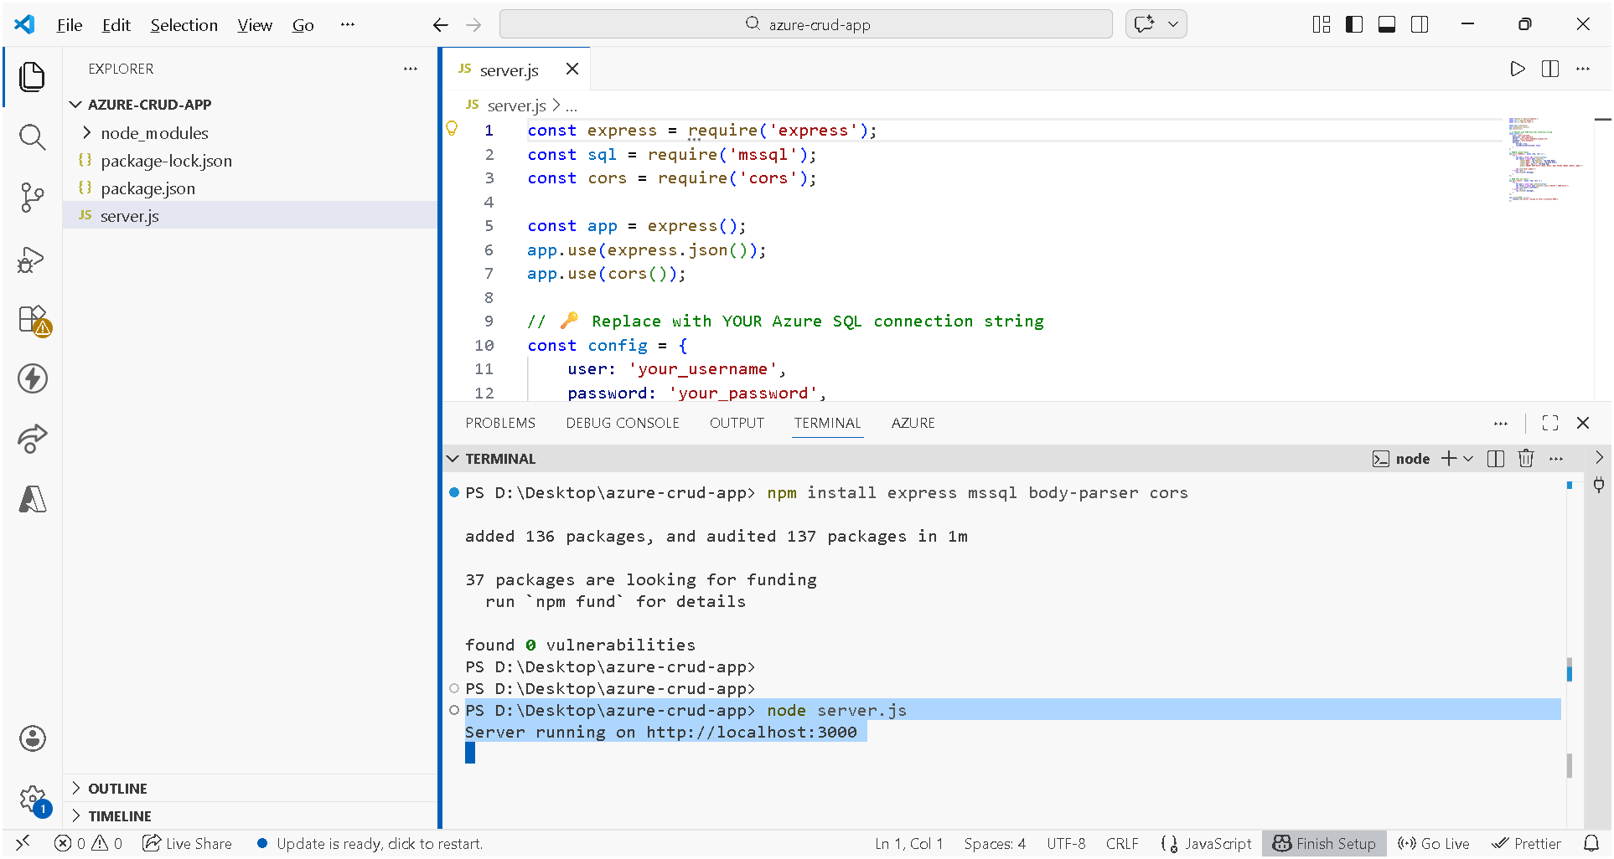

Create a html file "index.html "

Code
<!DOCTYPE html>
<html>
<head>
<title>Form</title>
</head>
<body>

<h2>User Form</h2>

<form id="userForm">
<input type="text" id="name" placeholder="Name" required><br><br>
<input type="email" id="email" placeholder="Email" required><br><br>
<input type="number" id="age" placeholder="Age" required><br><br>
<button type="submit">Submit</button>
</form>

<script>
document.getElementById("userForm").addEventListener("submit", async function(e) {
e.preventDefault();

const data = {
Name: document.getElementById("name").value,
Email: document.getElementById("email").value,
Age: parseInt(document.getElementById("age").value)
};

await fetch("http://localhost:3000/addUser", {
method: "POST",
headers: {
"Content-Type": "application/json"
},
body: JSON.stringify(data)
});

alert("User added!");
});
</script>

</body>
</html>

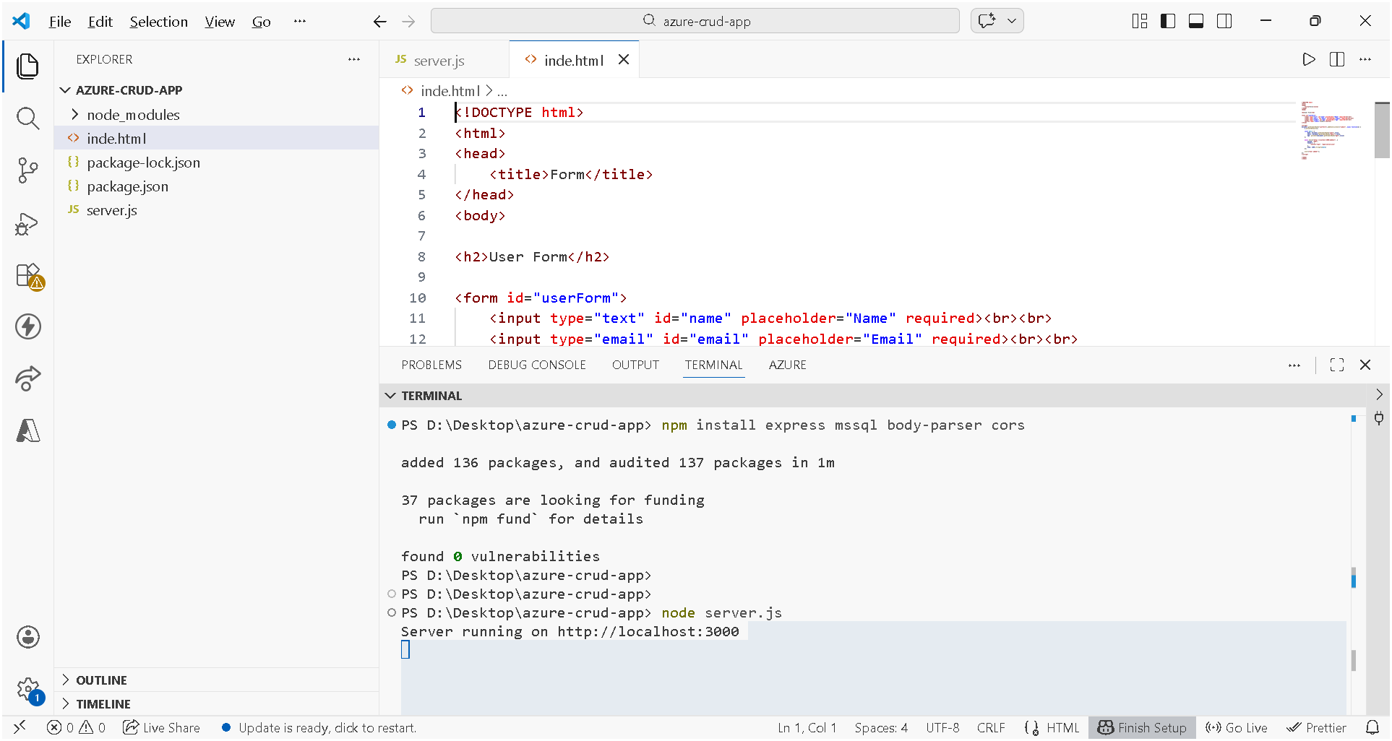

Run html
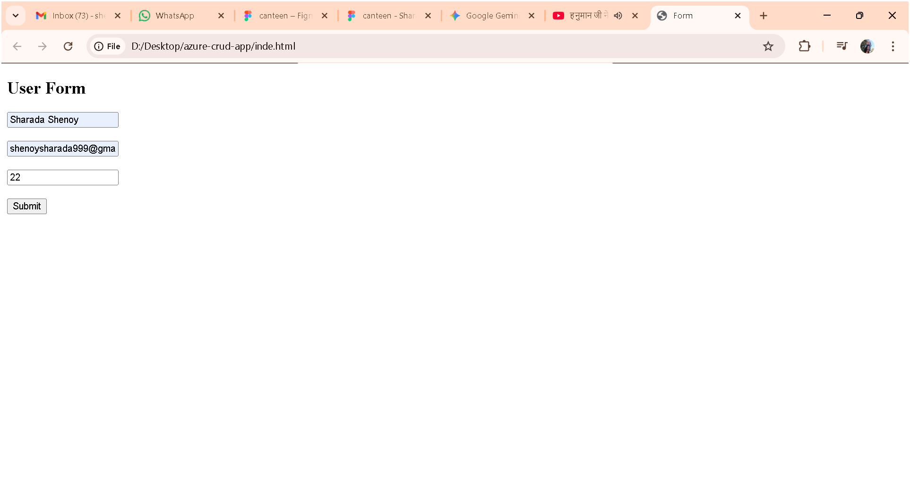

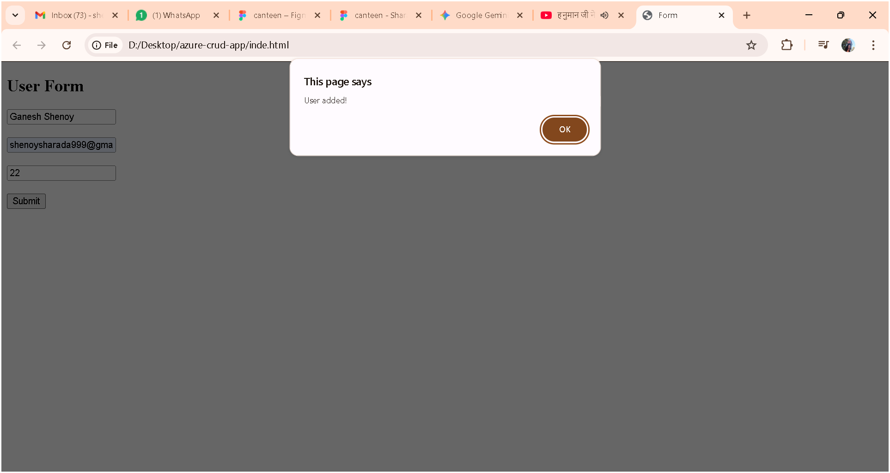

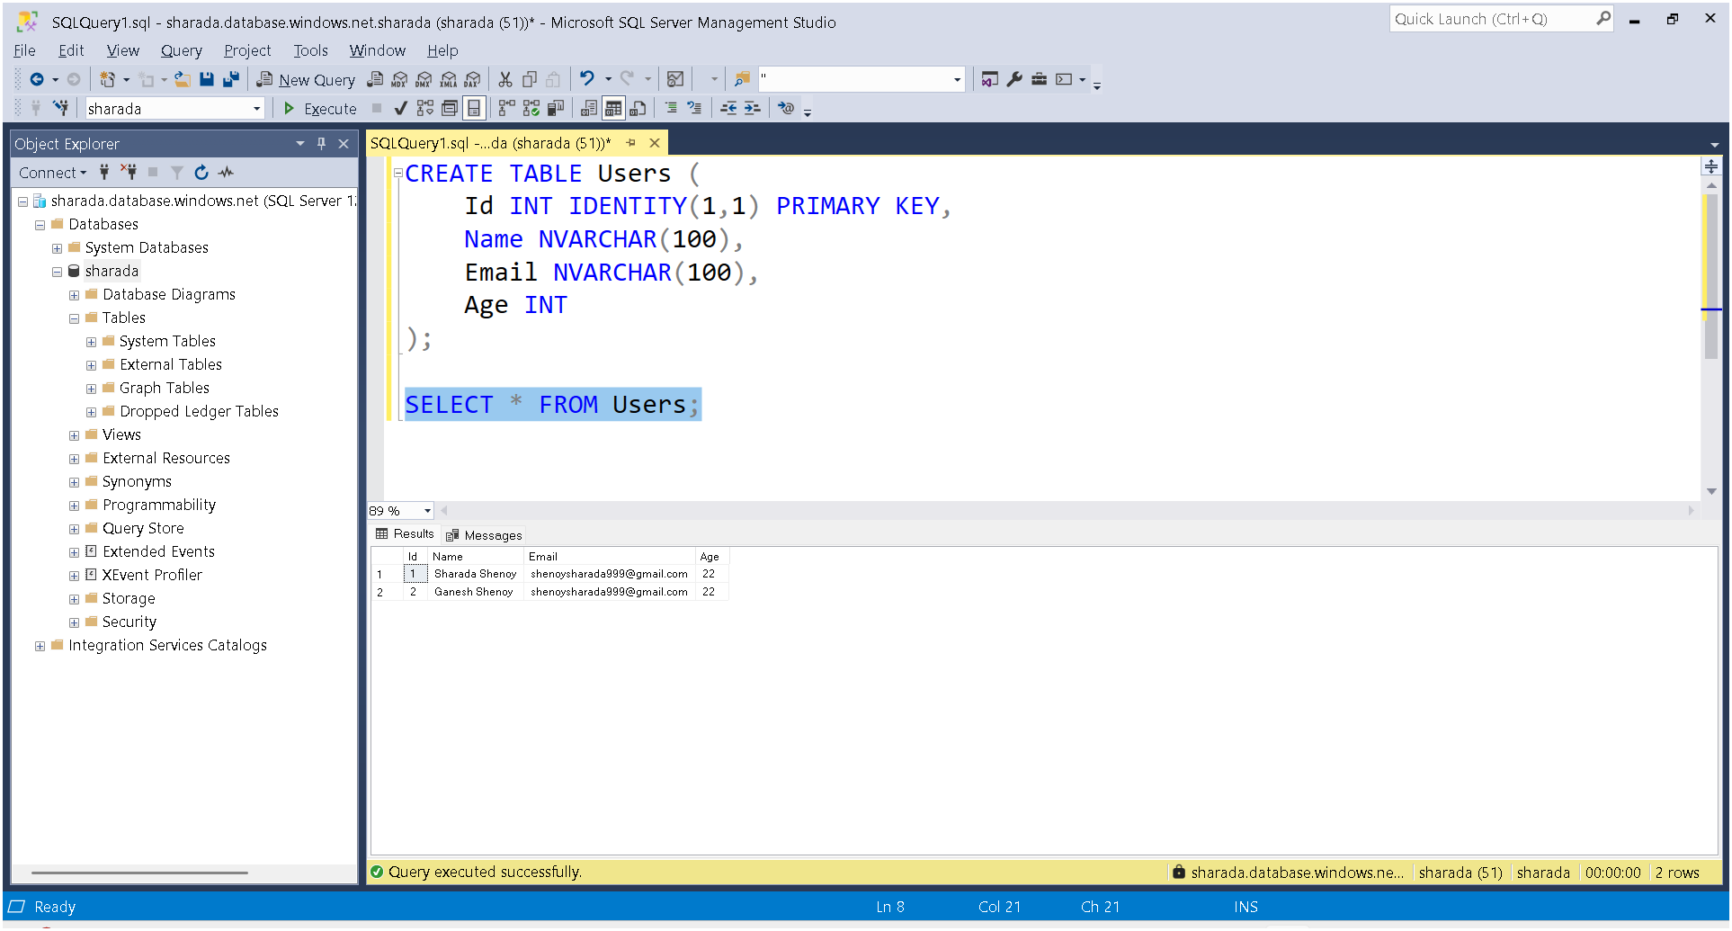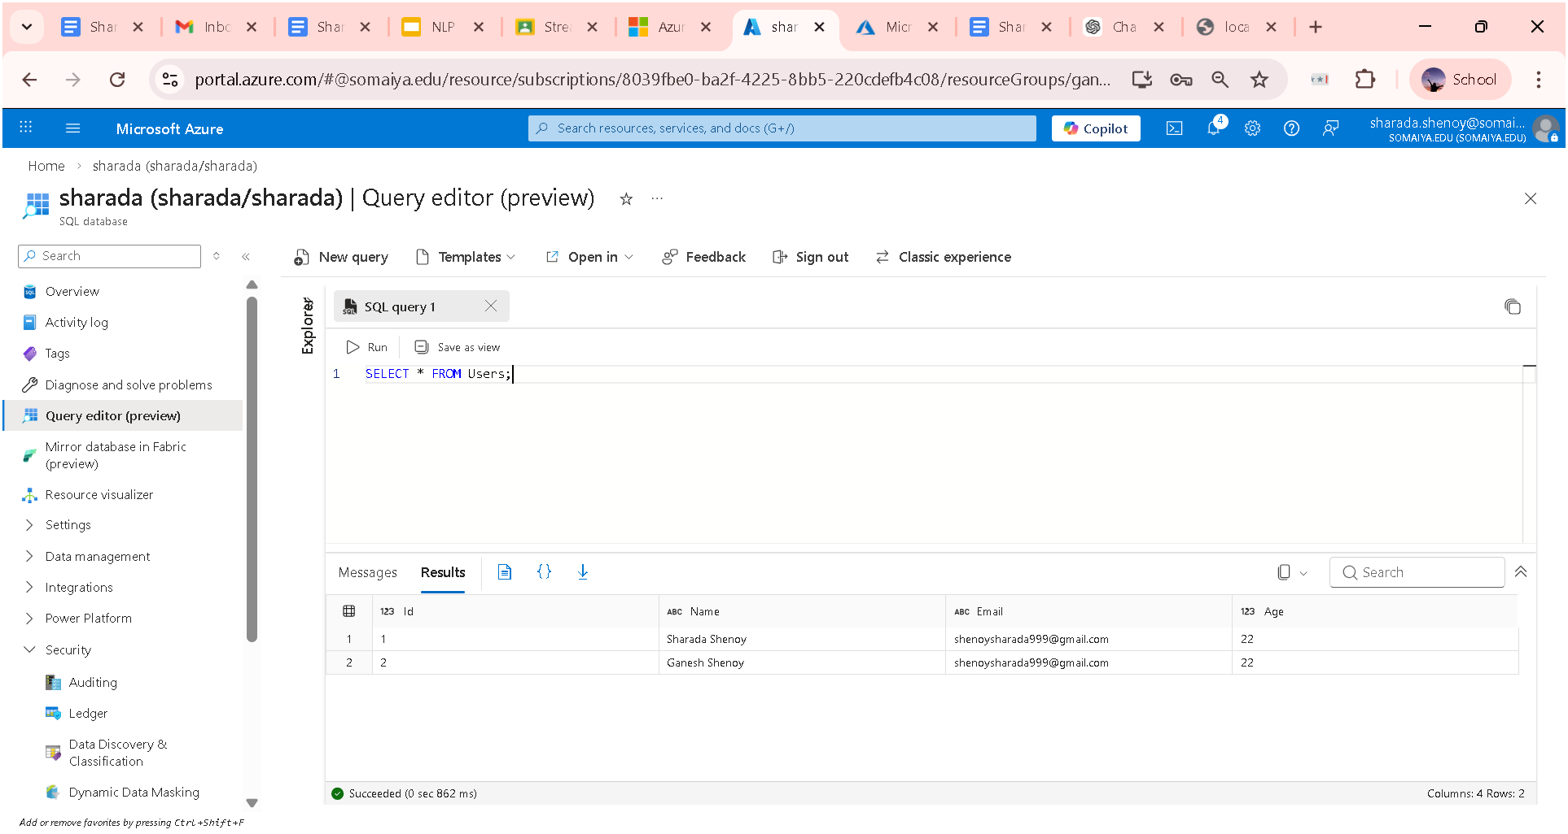

Making it shareable

Create a new app services
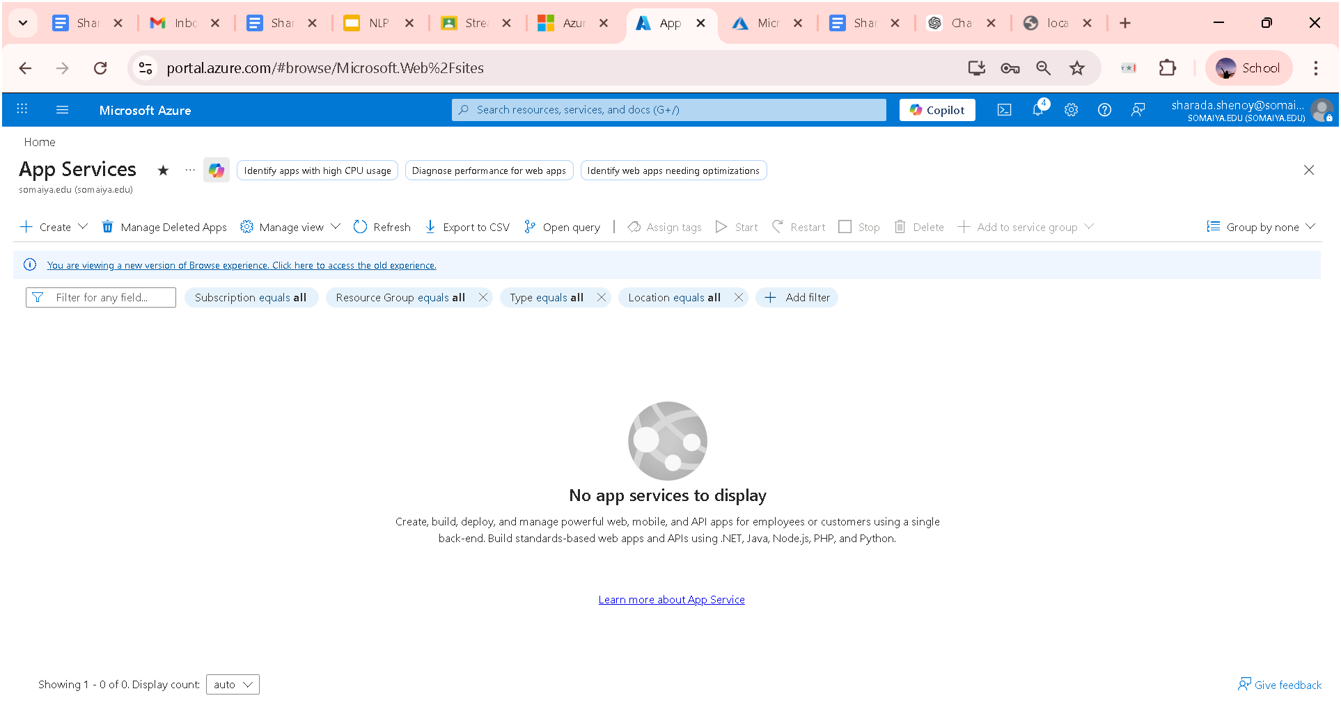

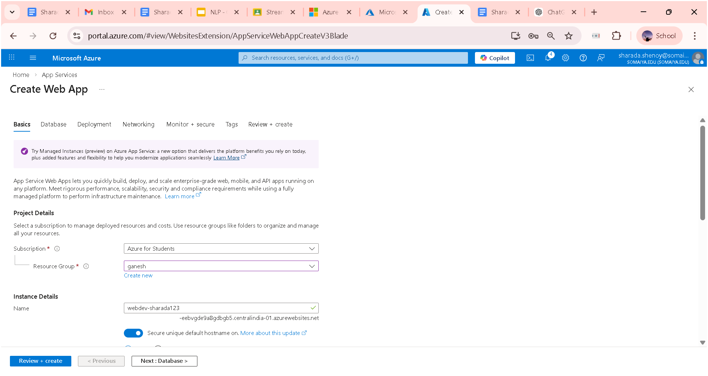

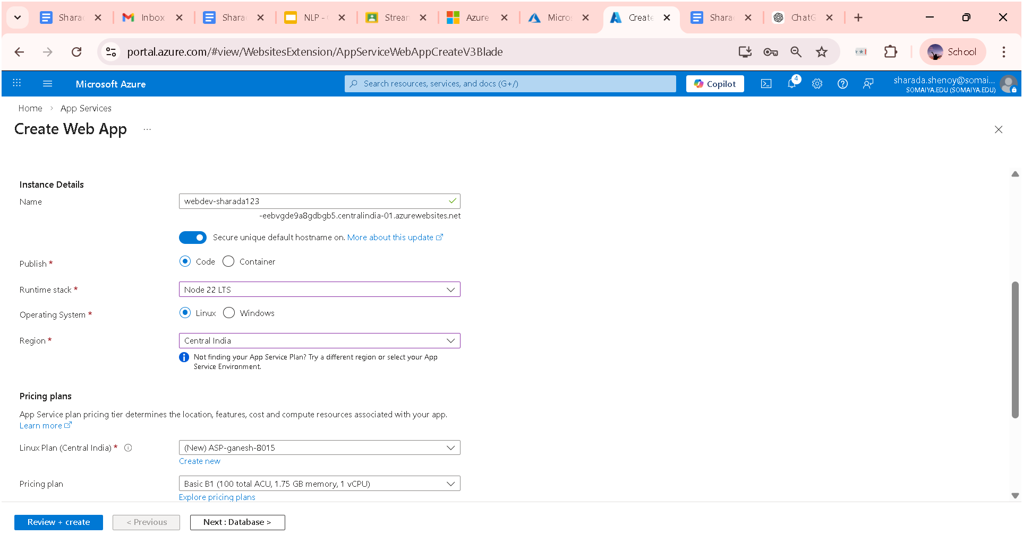

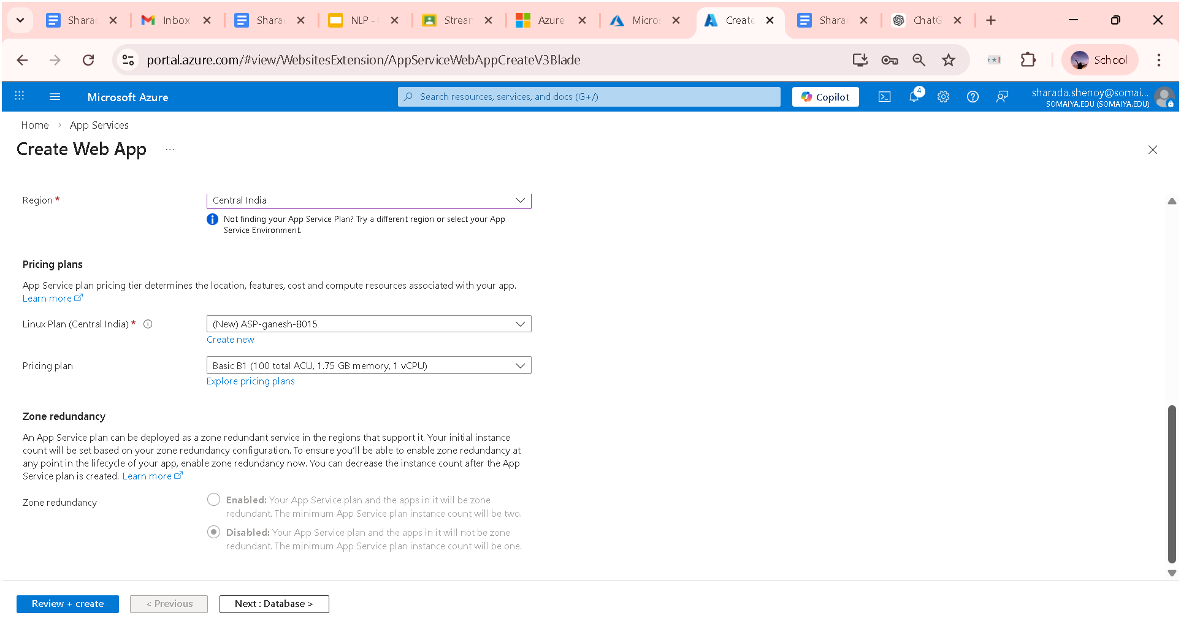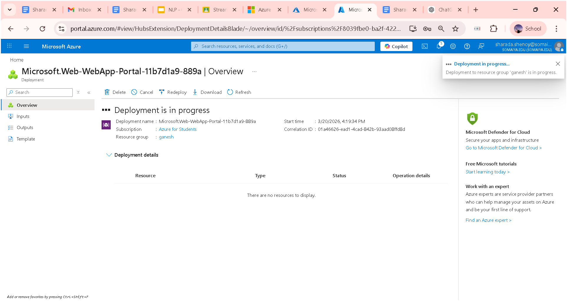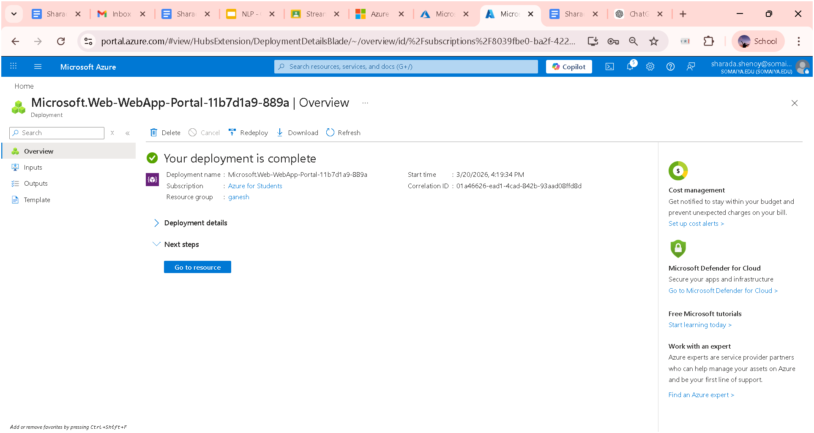
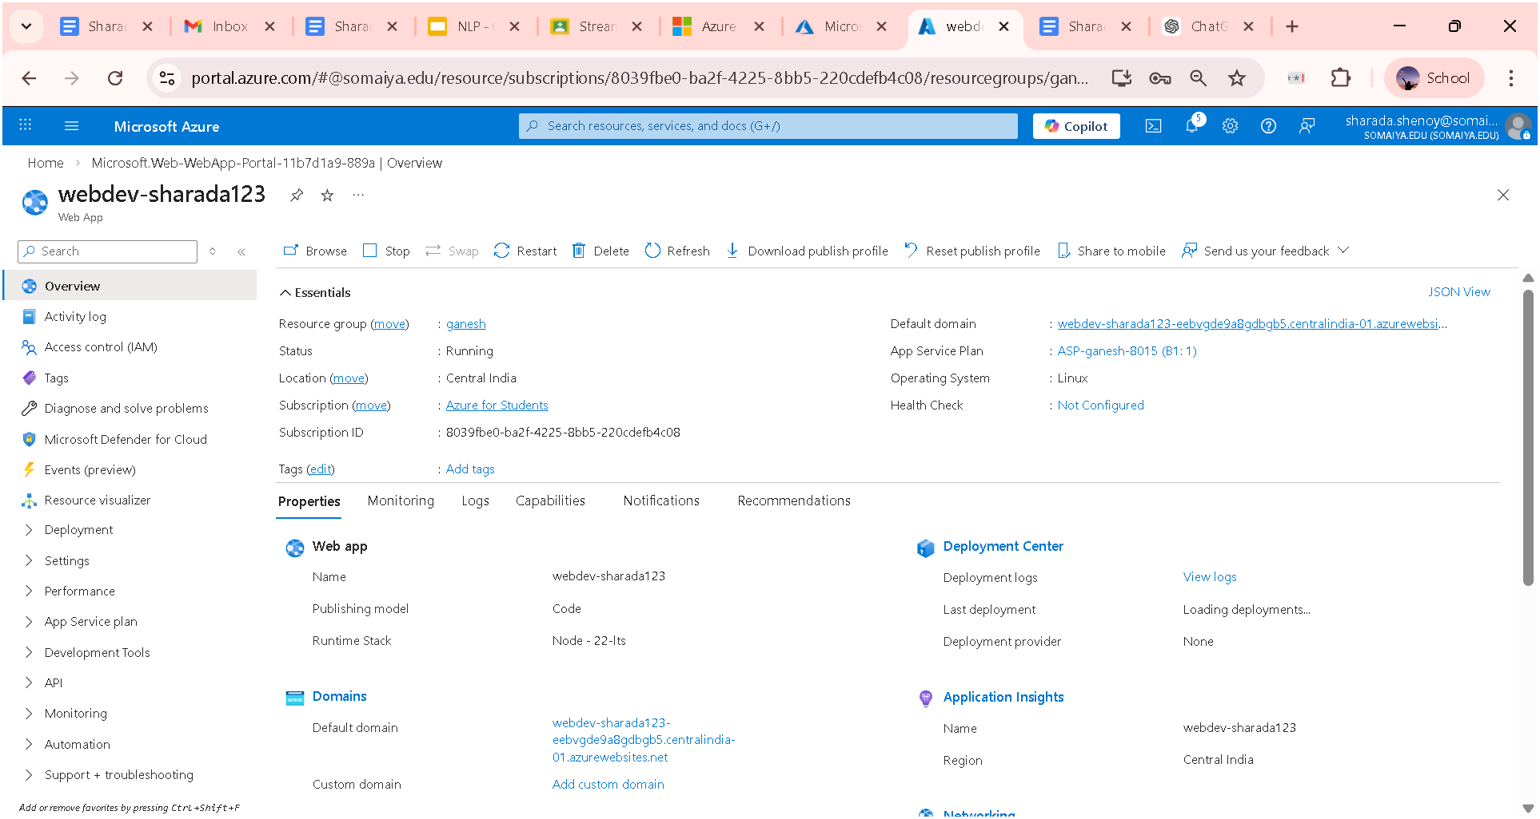

Make changes in server.js file in vs code

Replace this with

app.listen(3000, () => {
console.log("🚀 Server running on http://localhost:3000");
});

With :

const PORT = process.env.PORT || 3000;
app.listen(PORT, () => {
console.log("Server running on port " + PORT);
});

So, serer.js is
const express = require('express');
const sql = require('mssql');
const cors = require('cors');

const app = express();
app.use(express.json());
app.use(cors());

// 🔑 Your Azure SQL config
const config = {
user: 'sharada',
password: 'GANESHA@2008s',
server: 'sharada.database.windows.net',
database: 'sharada',
options: {
encrypt: true,
trustServerCertificate: false
}
};

// 🔌 Create global connection pool
let pool;

sql.connect(config)
.then(p => {
pool = p;
console.log("✅ Connected to Azure SQL");
})
.catch(err => {
console.log("❌ DB Connection Error:", err);
});

// 🟢 CREATE (Insert user)
app.post('/addUser', async (req, res) => {
try {
console.log("📥 Incoming data:", req.body);

if (!req.body.Name || !req.body.Email || !req.body.Age) {
return res.status(400).send("Missing fields");
}

await pool.request()
.input('Name', sql.NVarChar, req.body.Name)
.input('Email', sql.NVarChar, req.body.Email)
.input('Age', sql.Int, req.body.Age)
.query('INSERT INTO Users (Name, Email, Age) VALUES (@Name, @Email, @Age)');

console.log("✅ User inserted");

res.send("User added!");
} catch (err) {
console.log("❌ ERROR:", err);
res.status(500).send(err.message);
}
});

// 🔵 READ (Get all users)
app.get('/users', async (req, res) => {
try {
const result = await pool.request().query('SELECT * FROM Users');
res.json(result.recordset);
} catch (err) {
console.log("❌ ERROR:", err);
res.status(500).send(err.message);
}
});

// 🟡 UPDATE (optional)
app.put('/updateUser/:id', async (req, res) => {
try {
await pool.request()
.input('Id', sql.Int, req.params.id)
.input('Name', sql.NVarChar, req.body.Name)
.input('Email', sql.NVarChar, req.body.Email)
.input('Age', sql.Int, req.body.Age)
.query("
UPDATE Users
SET Name=@Name, Email=@Email, Age=@Age
WHERE Id=@Id
");

res.send("User updated!");
} catch (err) {
console.log("❌ ERROR:", err);
res.status(500).send(err.message);
}
});

// 🔴 DELETE (optional)
app.delete('/deleteUser/:id', async (req, res) => {
try {
await pool.request()
.input('Id', sql.Int, req.params.id)
.query('DELETE FROM Users WHERE Id=@Id');

res.send("User deleted!");
} catch (err) {
console.log("❌ ERROR:", err);
res.status(500).send(err.message);
}
});

// 🚀 Start server
const PORT = process.env.PORT || 3000;

app.listen(PORT, () => {
console.log("Server running on port " + PORT);
});

Replace the entire package.json file with
{
"name": "azure-crud-app",
"version": "1.0.0",
"description": "Simple CRUD app with Azure SQL",
"main": "server.js",
"scripts": {
"start": "node server.js"
},
"author": "",
"license": "ISC",
"dependencies": {
"body-parser": "^2.2.2",
"cors": "^2.8.6",
"express": "^5.2.1",
"mssql": "^12.2.1"
}
}

Now just zip the two files , server.js and package.json and index.html

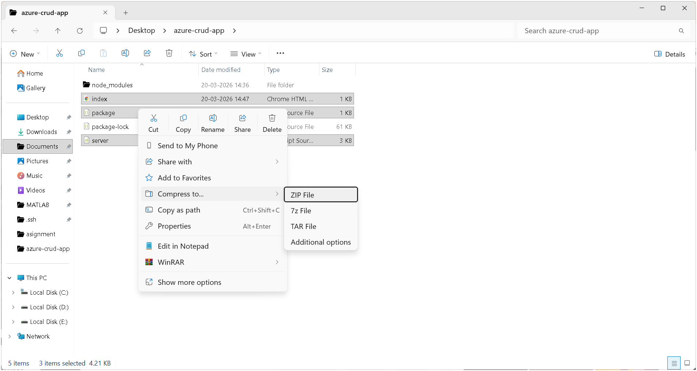

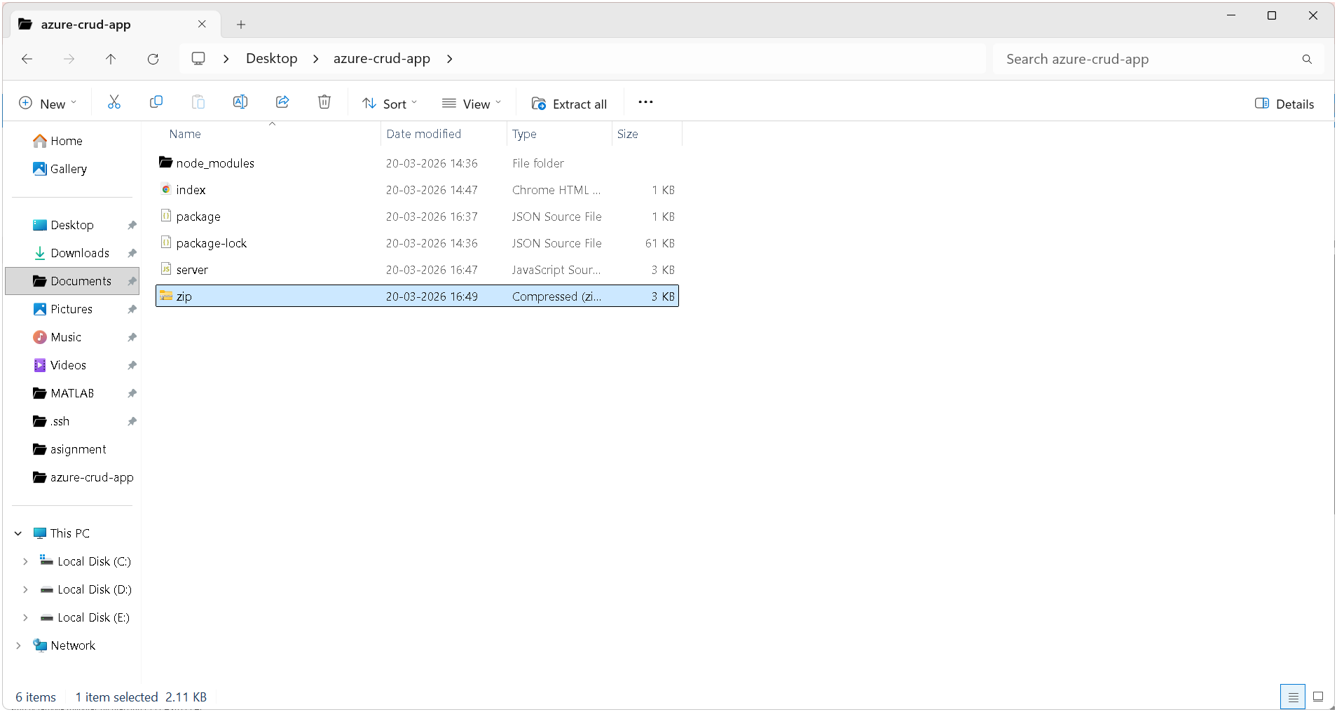

Nw go to azure -> deployment -> deployment center